Press Release

25 July 2025

**The Sainsbury Centre unveils a new commission by Ryan Gander**

*Ms Modern Classical Conceptualist, or Their Shadows Obscured (Dramaturgical framework for structure and stability)* is on long-term display in the Living Area

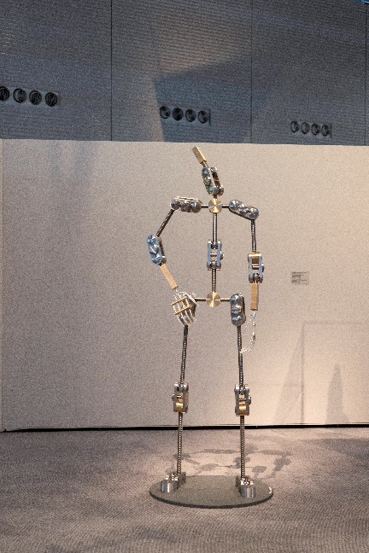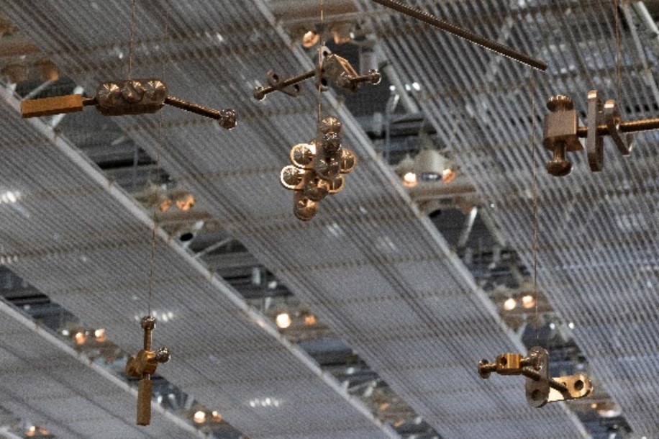

The Sainsbury Centre today unveils a newly commissioned artwork by celebrated artist Ryan Gander OBE RA, *Ms Modern Classical Conceptualist, or Their Shadows Obscured (Dramaturgical framework for structure and stability)* (2025). Gander’s extraordinary installation, an intrigued human armature made up of stainless steel, brass, aluminium and plastic, looks up at a copy of themselves disarticulated, their limbs gently circling around the ceiling, high above the Sainsbury Centre's iconic Living Area gallery.

Following its radical relaunch in 2023, the Sainsbury Centre became the first museum in the world to formally recognise the living lifeforce of art, enabling people to build relationships with living art across its dynamic museum landscape. Gander’s installation invites us to think about what makes us human; how we position ourselves in the world, and in turn, how we see and study others.

*Ms Modern Classical Conceptualist, or Their Shadows Obscured (Dramaturgical framework for structure and stability)* is alife-size figure, upscaled from an animator’s moveable desktop armature – a highly engineered manmade construction, developed with the objectives of structure, stability and skeletal articulation – which stands looking up towards an abstract mobile, constructed from the same components as themselves, and suspended from the ceiling. Devoid of distraction, the armature enables us to investigate singular emotions and positions of power, individually, one at a time.

Jago Cooper, Director of the Sainsbury Centre, said: “What gives us our existence? This is the question that swirls around when you stand within the conversation of this art installation. If you quickly glance the right way, you might even glimpse the answer.”

Ryan Gander works across sculpture, film, installation, and performance; and his work is often reminiscent of a puzzle, a network with multiple connections, the fragments of a story, or a huge set of hidden clues to be deciphered. This new work explores the artist’s reflections on qualities like empathy and humility in which, in his own words, he contrasts strength and power as opposing states. These tensions are central to the generic, and non-specific form of Gander’s work – which is itself extremely politicised, though “without political motivation” – commenting on the nature of power, without that power being for any given position. The armature person becomes a finely adjustable milieu which invites the viewer’s projections, and reflects their strengths, and weaknesses, as well as morality, humility and empathy.

Critical references acknowledged by Gander in the genesis of the work include Erving Goffman’s in *The Presentation of Self in Everyday Life* (1956), where dramaturgical analysis is defined as the study of social interaction in theatrical performance. Positioned in the Sainsbury Centre’s Living Area, the figure is reminiscent of a person waiting in a public place alone – evoking familiar, even universal feelings on the performative nature of living, and the experience of being observed. For Gander, there are always multiple realities, and variations on projections of the self. Beyond the multiplicity of individuals in the world, there are many more still when the individual interpretations of others are accounted for.

In turn, the armature person takes a solipsistic metaphysical position, embracing the idea that a common world and other minds do not exist – only individuals, functionally living in a dream of their own construction. In Gander’s work, examination of the complexities of physical human action and interaction, as in sociology and anthropology, is compared to the study of visual language and semiotics – seeking a codification of non-verbal communication.

**NOTES TO EDITORS**

**For more information and interviews:**

Kate Wolstenholme

PR and Media Officer at the Sainsbury Centre

k.wolstenholme@uea.ac.uk

01603 592470

**[VIEW THE IMAGE PRESS PACK HERE](https://www.dropbox.com/scl/fo/dbh05k46nfan68l7rma4u/AGA00-Qws87EwHvlrM_tcyw?rlkey=xbz4e28gcjxo3zuo0307xldwh&st=qikxv6id&dl=0)**

Ryan Gander, *Ms Modern Classical Conceptualist, or Their Shadows Obscured (Dramaturgical framework for structure and stability)*, 2025, stainless steel, brass, aluminium, plastic, rotating motor (4620 x 5880 x 3325 mm). Commissioned for Sainsbury Centre, 2025.

Arriving 25 July 2025

Sainsbury Centre,

University of East Anglia,

Norfolk Road,

Norwich NR4 7TJ

**Ryan Gander** lives and works in Suffolk. He studied at Manchester Metropolitan University, UK, the Rijksakademie van Beeldende Kunsten, Amsterdam, NL and the Jan van Eyck Akademie, Maastricht, NL. The artist has been a Professor of Visual Art at the Universities of Huddersfield and Suffolk and holds an honorary Doctor of the Arts at the Manchester Metropolitan University and the University of Suffolk. In 2017 he was awarded an OBE for services to contemporary arts. In 2019 he was awarded the Hodder Fellowship at Princeton University. In 2022, he was made RA for the category of Sculpture. Since 2024, he has held the position of Professor of Perspective at the Royal Academy Schools, London, UK.

**Opening times**

Tuesday – Friday 9am-6pm (exhibitions open 9.30am)

Saturday – Sunday 10am-5pm

Closed Mondays, including bank holidays

**Entry**

Tickets operate on a ‘Pay Only If and What You Want’ basis, so you can choose the price from free through to full membership. A Universal Ticket grants access to the permanent collection, Lower and Mezzanine Galleries, and Sculpture Park.

**The Sainsbury Centre** is a world-class art museum with a unique perspective on how art can foster cultural dialogue and exchange. Following a radical relaunch in 2023 the Sainsbury Centre is the first museum in the world to formally recognise the living lifeforce of art, enabling people to build relationships across an arts landscape.

The art of the Sainsbury Centre can help reframe and answer the most important questions people have in their lives. It is not a museum to only learn more about artists, cultures or movements like Francis Bacon, the Tang Dynasty or Modernism, it is a place of experience, where collections are animate, and visitors are emotionally connected.

One of the first museums in the world to display art from all around the globe and from all time periods equally and collectively, Sir Robert and Lady Lisa Sainsbury created one of the most sought after yet non-conformist art collections. In 1973 they donated their collection, which transcended traditional barriers between art, architecture, archaeology and anthropology, to the University of East Anglia, and created an entirely new type of museum. Housed in Sir Norman Foster’s revolutionary first ever public building, the space aimed for an interactive relationship between people, object and landscape, where art was placed within an open yet intimate ‘living area’.

Visit www.sainsburycentre.ac.uk and follow @sainsburycentre on Facebook, X, Instagram, TikTok and LinkedIn, as well as @TheSainsburyCentre on YouTube.