Press Release
14 July 2025

VisitNorwich and Fabbrica Media win big at The Travel Marketing Awards 2025

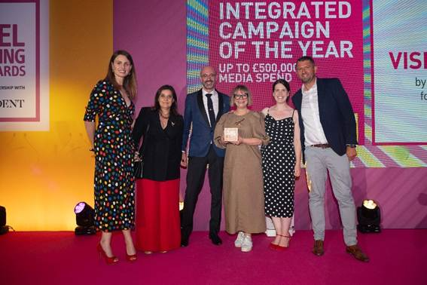
Comedian, television personality, actress, and writer Ellie Taylor presents the award for Integrated Campaign Of The Year (up to £500,000 media spend) to VisitNorwich & Fabbrica Media
Credit: AG Studios

On Wednesday 9th July VisitNorwich and Fabbrica Media attended The Travel Media Awards in collaboration with the Travel Marketing Professionals Network at the London Marriott Hotel Grosvenor Square. A prestigious annual event organised by the Chartered Institute of Marketing's Travel Group (CIM TG)- VisitNorwich and Fabbrica Media- walked off winning Integrated Campaign Of The Year (up to £500,000 media spend) with a GOLD standard.
Shortlisted in the category along with Brand USA, Travel Texas, Wild Frontiers and Nassau & Paradise Island working with renowned global marketing agencies MMGY Global, FINN Partners, and Designate and Accord Marketing, the VisitNorwich campaign with Fabbrica Media faced stiff competition.
Running in two phases the VisitNorwich campaign launched in autumn 2024 – an awareness campaign. The second phase ran January- February encouraging people to book a spring break. The objectives were to increase awareness of Norwich, spread the season and drive visitors to visitnorwich.co.uk.
With four content pillars- Old Meets Now; Take A Seat, Let’s Eat; Act Natural and Independent Spirit- the campaign was aimed at pre-nesters an audience as defined by VisitEngland. And an audience motivated by food and drink, arts and culture wanting to discover the undiscovered. Content included curated itineraries supporting each content pillar, new photography and four campaign short films.
Campaign results included reach on social channels organically increasing by 85.4% year on year; landing pages on visitnorwich.co.uk reaching 96.01% - 98.96% engagement rate against a benchmark of 61.55% (source:Databox) and page visits up 50%.
With 900 years of history, Norwich, once England’s second city; with its Norman Castle, two breathtaking Cathedrals, and one of the oldest and largest 6-day-a-week, open-air markets in the country, has huge appeal. Add its 365-day a year cultural offer, incredible local food, drink and talent, its strong independence and location as part of the Broads National Park as well as its closeness to the coast and you have a very desirable destination.
Mel March, PR & marketing manager, VisitNorwich said: “It sounds like a cliché, but we were thrilled just to be shortlisted. We had confidence our campaign was strong but to be up against global brands with big budgets we felt we had a mountain to climb. Our campaign budget wasn’t even 5% of the £500,000 media spend in this category!
“This year, VisitNorwich celebrates its 20th anniversary, and this huge award could not be more fitting. I am beyond delighted for the team here and Richard Rizzo Hills at Fabbrica Media- this is so well deserved. But a campaign whether big or small cannot happen without talented experts, so a huge thank you also goes to Joe Harrington at JH Film Production, Nick Warner (photography) and Sarah Herman (copywriting).
“We are a small but mighty team at VisitNorwich and winning this award on a very modest budget shows just what can be achieved with dedication, tenacity, and teamwork. I am so proud of everyone involved in making this happen.”
Richard Rizzo Hills, founder and media strategist, Fabbrica said: “We were delighted to have been shortlisted for the Best Integrated Campaign (below £500k spend) Award, but overwhelmed that, alongside the wonderful team at VisitNorwich, to have been selected as the winners for this prestigious award.
“It’s been a delight to have worked closely with the VisitNorwich team on this campaign and for all the hard work to have been recognised by the Travel Marketing Awards judges is certainly one of our career highs. It’s the teamwork that has created success, firstly with the campaign’s performance, but also the recognition of this win. Teamwork really does make the dream work!"
<ends>

Notes to Editors
For interviews contact Mel March, PR & marketing manager, VisitNorwich on mel.march@norwichbid.co.uk
Campaign images: https://show.pics.io/visitnorwich-campaign-images-2024-2025
visitnorwich.co.uk | Instagram | Facebook | #visitnorwich

About VisitNorwich
- VisitNorwich is the Destination Marketing Organisation (DMO) for the Norwich area and is the tourism destination marketing function of Norwich Business Improvement District (BID) - www.visitnorwich.co.uk.
- VisitNorwich is a membership organisation within Norwich BID and its activities are funded by members, public sector stakeholders including Norwich City Council and directly by Norwich BID.
- VisitNorwich’s sole focus is to promote and develop the destination and support its members through collaborative marketing & PR, research, information and business advice.
- Total value of tourism in Norwich is £769,350,590 including 12,938,800 trips (day and staying) - Destination Research: Economic Impact of Tourism report 2023.
- In 2025 VisitNorwich and Fabbrica Media won in the category: ‘Integrated Campaign Of The Year (up to £500,000 media spend)' at the Travel Marketing Awards (CIM TM).
- In 2020 Norwich, the City of Stories was shortlisted in the City Nation Place Awards 2020 for ‘Place Brand of the Year’.
- In 2012 Norwich became England’s first UNESCO City of Literature.
About Fabbrica
Fabbrica Media is a full service media agency, planning and buying media across all media channels, digital and traditional. They help travel brands increase awareness, attract customers, sell more tickets, and grow through audience research, media planning and buying, programmatic advertising, and thoughtful media strategy.

