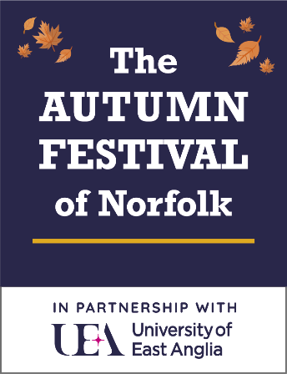**PRESS RELEASE –**

**ASSETS:** Brochure Cover, Festival Logos, Kieron Williamson, Dance into the Fall, Room with a View, Michael Morpurgo, Reeta Chakrabarti, Tony Robinson, Evan Davies, Rachel Osbourne, Paul Jackson, Jules Maxwell, African Choir, Braimah & Kadiatu Kanneh-Mason, WHAT’S ON QR Code, UEA LIVE Logo

**The AUTUMN FESTIVAL of Norfolk Announces 15th Anniversary Programme**

The AUTUMN FESTIVAL of Norfolk returns with an exciting programme for 2025, celebrating 15 years of original commissions, internationally renowned guest speakers and creative projects that involve people from all four corners of Norfolk.

Stash Kirkbride, Co-Founder and Artistic Director said:  
*"We are thrilled to present this year's Autumn Festival anniversary programme. As ever, we continue to champion creativity through our Signature Projects:* ***The Norfolk Arts Awards, The Norfolk Actors Company, Total Ensemble: Arts Initiative,*** *and* ***The African Choir of Norfolk****. We invite everyone to join us this autumn for our season of celebration."*

**Look out for the 2025 Festival Brochure**Gracing this year’s festival brochure cover is a painting by celebrated young Norfolk artist **Kieron Williamson** whose remarkable contribution to the arts locally will be recognised with the *Norfolk Icon Award* in this year’s Norfolk Arts Awards. Kieron’s creativity and deep connection to the region are central to the visual identity of the festival’s 15th anniversary season.

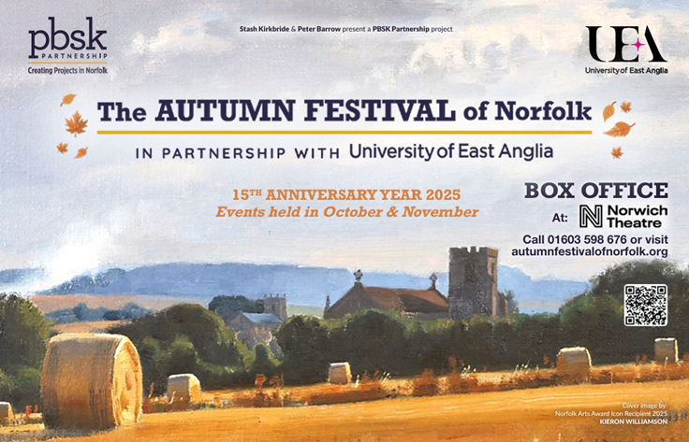

**Top of Form**

**Bottom of Form**

**Programme Highlights**

**Dance Into The Fall**  
The festival opens on **Saturday 18th October** with ***Dance Into The Fall 2025*** at **UEA Drama Studio.** This multi-generational, inclusive dance platform, produced by **Total Ensemble: Arts Initiative,** features both community groups and professional dancers. Tickets include a post-show social with complimentary refreshments, setting the tone for a festival that blends heart and celebration.

**Festival Central Production**  
The **Norfolk Actors Company** will present a unique staging of **E.M. Forster’s *A Room With A View*** in-the-round at the **Hostry, Norwich Cathedral**. This classic romantic comedy, with a cast of over 20 actors from across Norfolk, is set to delight audiences from **27th October to 1st November.**

**Headline Conversations**  
Beloved author ***Michael Morpurgo*** appears live in conversation with ***Dr Jasmin Kirkbride*** at UEA Lecture Theatre 1 on Saturday 1st November. In partnership with UEA Live and Bookbugs & Dragon Tales, this special afternoon celebrates Morpurgo’s extraordinary literary legacy, spanning over 100 books that have captured the hearts of readers young and old. Audiences will have the exclusive opportunity to purchase his two brand new titles. A rare chance to hear directly from one of the UK’s most treasured writers, this is an unmissable highlight for literature lovers.

On the same day, ***Reeta Chakrabarti***, one of the UK's most respected broadcasters, joins writer **Tahira Yaqoob** at **The Hostry** for an in-depth conversation exploring journalism, identity and public life.

**Sunday 2nd November** offers two further headline events at **The Hostry**: an in-depth conversation between beloved actor and presenter **Tony Robinson** and **Nicholas Witchell** at 1pm, followed by broadcaster and economist **Evan Davis** with festival ambassador **Chris Jacob** at 3:30pm. Early booking is recommended with just 120 seats at these festival exclusive events.

**November musical highlights**

**Friday 14th November**: Composer, songwriter and multi-instrumentalist ***Jules Maxwell*** performs *Ballads & Nocturnes* at the **Octagon Chapel**. Described as “sublime” and “music for the soul,” this atmospheric performance promises to transport audiences through evocative soundscapes and lyrical reflections.

**Saturday 15th November:** ***The African Choir of Norfolk*** presents its much-anticipated 5th Annual Gala at **Norwich Playhouse**, under the direction of ***Anna Mudeka***, this vibrant celebration promises a fresh repertoire, stunning costumes and an unforgettable finale that honours African heritage and community spirit.

**Sunday 16th November:** Festival Patron ***Braimah Kanneh-Mason*** and soprano ***Lisa Cassidy*** perform chamber works in both matinee and evening performances in the **Chapel, Norwich School** and at4pm, festival patrons ***Kadiatu Kanneh-Mason*** & ***Christine Webber*** are in conversation about Kadiatu’s fascinating newly published book profiling her musical family, *To Be Young Gifted and Black.*

**Theatre and New Writing**

**3rd–8th November**: ***Paul Jackson*** returns to **Anteros Arts** with a magical new *Realms of Elsewhere* exhibition and a launch of the latest edition of his fantasy novel series which he writes, illustrates and performs - *The Merchant of Storms.*

**Saturday 22nd November: *Agatha Christie – Murder in the Studio*** at **Maddermarket Theatre** features live foley and Norfolk actors in vintage mystery style. Acclaimed Norfolk jazz pianist **Simon Brown** will provide an elegant musical backdrop for the post-show gala, performing his distinctive style live at the piano in the bar as guests enjoy a celebratory glass of fizz. A fitting finale weekend to this year’s **AUTUMN FESTIVAL of Norfolk** season.

***Sunday 23rd November*: *Unlettered***, a new dark comedy by *Rachel Osborne*, Norfolk-born playwright and an alumna of the University of East Anglia, will receive its first rehearsed reading at **UEA Drama Studio**.

As the AUTUMN FESTIVAL of Norfolk celebrates 15 years of inspiring, connecting, and delighting audiences across the region, from first-time festivalgoers to loyal supporters, there has never been a better moment to get involved and be part of this local celebration.

