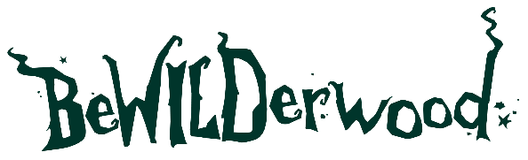

PRESS RELEASE
BeWILDerwood Celebrates Silver Award
for ‘Best Theme Park for Toddlers’

Sent by BeWILDerwood
19th September 2025

BeWILDerwood Celebrates Silver Award for ‘Best Theme Park for Toddlers’
BeWILDerwood is thrilled to announce it has been awarded Silver in the ‘Best Theme Park for Toddlers’ - Small Attraction Category at the 2025 UK Theme Park Awards. The award recognises the park’s ongoing commitment to creating magical, family-friendly adventures for even the youngest explorers.
This award follows an exciting few years for BeWILDerwood, with the introduction of the Toddlewood Ticket, the launch of the much-loved Minty character (who has been extremely popular with visitors), and the release of the new Minty and the Big Stink book - all specially designed to capture the imagination of younger children. These new additions have welcomed a whole new audience into the enchanting world of BeWILDerwood.
Head of Marketing and Media Lydia Downey commented,
“We’ve absolutely loved welcoming families with tots into the woods over the past 2 years. We’ve worked really hard to attract this new market and we have so much for toddlers to love at BeWILDerwood, including dedicated toddler play areas, a new sensory room in Cheshire, and even mini zip wires. The launch of our new short story is so exciting and marks a new era for BeWILDerwood. We have more short stories coming out very soon too! We’re very happy to be recognised as a standout attraction for toddlers and be amongst so many other amazing UK attractions! Congratulations to all the winners, very well deserved!”
Looking ahead to 2026, BeWILDerwood is delighted to confirm that the much-loved Twiggle Tot days and Toddlewood ticket will be back in the new year with extended dates, giving even more families the chance to enjoy the magic at a special toddler-friendly price.
BeWILDerwood would like to thank all the families, visitors, and Twiggles who voted for them.
ENDS

About BeWILDerwood:
BeWILDerwood opened its first park in May 2007, on the outskirts of the Broadland village of Hoveton, Norfolk. BeWILDerwood Norfolk is one of the most successful visitor attractions in the East of England.
April 2021 saw the grand opening of BeWILDerwood’s second park in Cheshire. Since opening BeWILDerwood Cheshire has seen huge demand and rave reviews. Both parks are beautifully designed to be in keeping with their natural surroundings, encouraging outdoor, nostalgic play and allowing families to play and create memories together.
Based on the book and curious characters from the book, 'A Boggle at BeWILDerwood' by Tom Blofeld, the two parks bring both adventure and imagination to life as visitors follow in the footsteps of the main characters from the book.
The woodland parks are filled with zip lines, slides, mazes, giant treehouses, and much, much more. There is also a whole range of free activities available, all included within your ticket price, including storytelling shows and crafts!

Opening Dates, Times and Pricing:
See website for seasonal opening dates and ticket prices:
www.bewilderwood.co.uk

BeWILDerwood Cheshire:
BeWILDerwood Cheshire
Bickley Moss
Cheshire
SY13 4JF
Email: Cheshire@bewilderwood.co.uk

BeWILDerwood Norfolk:
BeWILDerwood Norfolk
Horning Rd
Hoveton
Norwich
NR12 8JW
Email: norfolk@bewilderwood.co.uk

Twiggle Tots Press pack including an image gallery and logo.

For all press enquiries please contact:
Lydia Downey, Head of Marketing and Media BeWILDerwood
lydia@bewilderwood.co.uk
01829 830730

