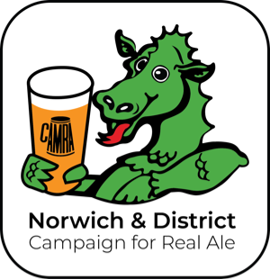**Norwich & District Campaign For Real Ale**

For Immediate Release

**46th NORWICH BEER FESTIVAL**

**Two Weeks, Two Main Venues, One Unique Celebration!**

In 2025, the **46th Norwich Beer Festival** will take place across **two weeks and two main** **venues**, giving thousands of visitors choice and flexibility and a unique experience in the festival’s history.

**Festival Schedule:**

* **Launch Event** – **Redwell Brewery Tap Room**, NR1  
  Dates: Fri 17th to Sun 19th October  
  Timings: Fri and Sat 12-9pm, Sun 12-5pm
* **Main Festival Part 1 – Waterfront**, NR1  
  Dates: Mon 27th, Tue 28th & Wed 29th October  
  Timings: Mon 27th CAMRA Members’ Preview 4-5pm, then open 5-10pm to the public.   
  Tue 28th and Wed 29th - 11.30-3.30pm and 5-10pm.
* **Main Festival Part 2 - Castle Social**, Level 3, Castle Quarter NR1 (next to food court)  
  Dates: Thu 30th, Fri 31st October & Sat 1st November  
  Timings: Thu to Sat 11.30-3.30pm and 5-11pm

There will be a **pubs and breweries Fringe Festival** taking place from **Friday 17th October to Sunday 2nd November**.

All events are **free to CAMRA members**. All members of the public can **prebook their entrance**, officialfestival glass and drink tokens. CAMRA membership can be purchased online or at any of the three main events.

All events will showcase a fantastic selection of real ales, ciders and foreign beers. The official **46th Norwich Beer Festival glass**, featuring the legendary dragon, will be available to prebook or purchase at the Redwell launch, Waterfront and Castle Social events, along with other festival merchandise. The Castle Social event will take place on the top floor, alongside food outlets and will offer live music.

‘With limited space, we urge people to pre-book to guarantee entry. We’re looking forward to what promises to be an exciting two-weeks and a truly unique experience’, comments **Craig Harmer, Norwich Beer Festival & Fringe Organiser.**

‘The 46th Norwich Beer Festival promises the very best of beers and ciders’enthuses **Ian Stamp, Chair** of Norwich & District CAMRA.

The festival charity is **Keeping Abreast**, offering support to local women undergoing breast treatment and reconstruction.

The festival is **NOT a ticket-only event**, but spaces for non-ticket holders are limited, so pre-booking is strongly advised. More information on music, food vendors, merchandise and CAMRA membership discounts will be released shortly.

For more updates, you can follow the Norwich & District CAMRA website, <https://norwich.camra.org.uk> or social media sites.

**Logo:**

The 46th Norwich Beer Festival logo can be found below:

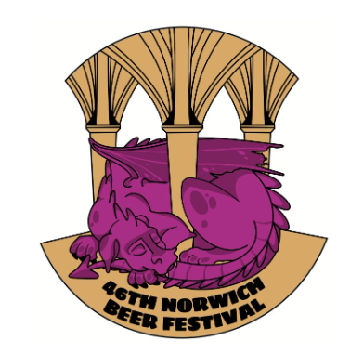

**Contacts:**

Craig Harmer, Norwich Beer Festival Organiser, Tel: 07733 335078

E-mail: [Organiser@norwich.CAMRA.org.](mailto:Organiser@norwich.CAMRA.org.)[uk](mailto:beerfestival@NorwichCAMRA.org.uk)

Ian Stamp, Pubs Officer & Chairman, Tel: 07770 978296

Email: [Chair@Norwich.CAMRA.org.uk](mailto:Chair@Norwich.CAMRA.org.uk)

Jenny Bach, N&D CAMRA Branch Press Officer, Tel: 07900 922915

E-mail: [PressOfficer@Norwich.CAMRA.org.uk](mailto:PressOfficer@Norwich.CAMRA.org.uk)

Norwich & District CAMRA: www.norwich.camra.org.uk

Please note that ‘Campaign for Real Ale’ should be referred to as CAMRA, in capitals.