Press Release
8 September 2025

Old City, New Attitude: Autumn 2025 in Norwich, the City of Stories
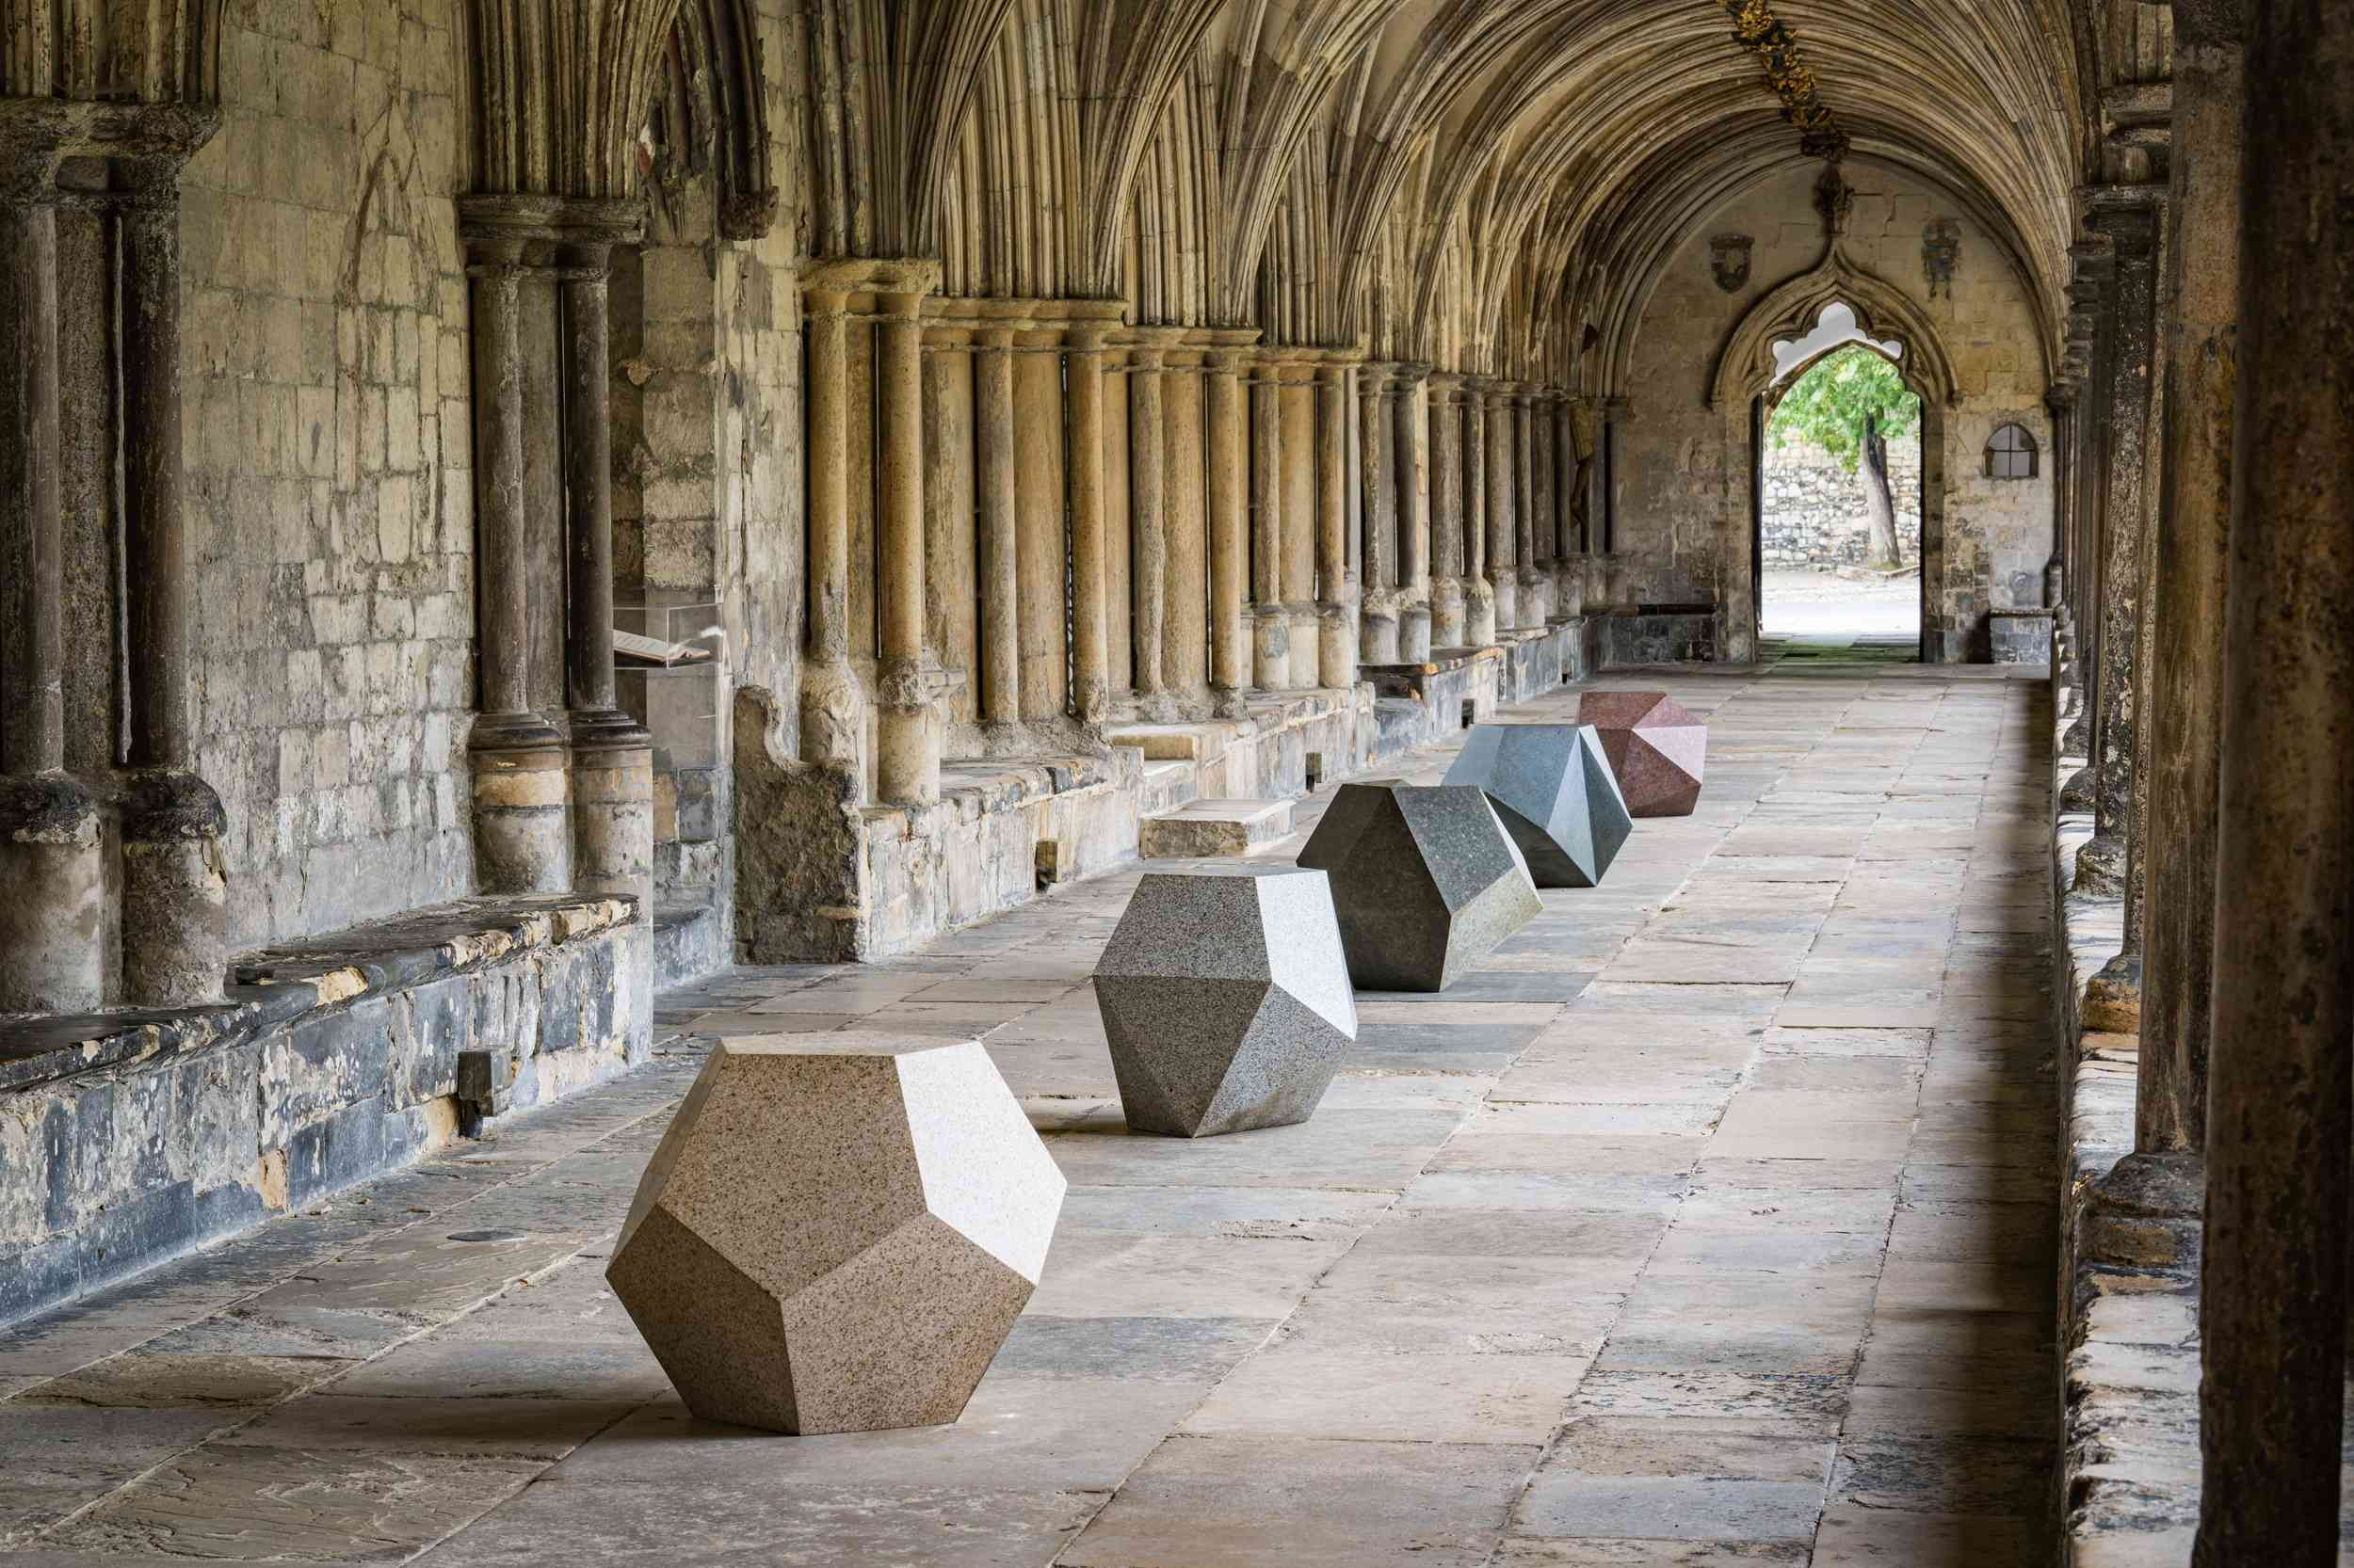
Art in the Close, Norwich Cathedral

Culture in Norwich this autumn continues to push the boundaries, hot on the heels of Norwich Castle Keep’s recent re-opening which is now attracting over 1500 visitors daily.
- NEW Art in the Close at Norwich Cathedral
- NEW Sainsbury Centre season of exhibitions exploring the fundamental question Can We Stop Killing Each Other?
- Wild Paths Festival an award-winning multi-venue music festival spread across Norwich
- Norwich Cocktail Week
- Norwich Book Festival
- NEW Cheryl Cade’s Sausage Roll Tour & Naughty Norwich Tour
Explore new contemporary artworks at Art in the Close with Lynn Chadwick and John Maine in England’s largest Close at our Romanesque Norwich Cathedral, and the latest season of exhibitions at Norman Foster designed Sainsbury Centre responding to Can We Stop Killing Each Other?
Then experience music of all genres in unique venues at Wild Paths- a multi-venue award-winning festival across Norwich with 150 live acts over five days, while The Autumn Festival of Norfolk gives us conversations, theatre and music to soak up. The second iteration of Norwich Book Festival returns bigger and better than ever between 24 – 31 October.
And if you love a good walking tour with an animated guide we have two new tours from Cheryl Cade. On possibly the country’s only Sausage Roll Tour taste five delicious local offerings in five different venues with a bit of Norwich’s history thrown in too. Then take a peek into the historic, seedier side of the city with a Naughty Norwich tour, which is not for the feint hearted or easily offended!
Art in The Close at Norwich Cathedral
Now until spring 2026, free
https://cathedral.org.uk/news/art-in-the-close/
This is where ancient architecture and contemporary sculpture combine in an exciting new exhibition of outdoor art at Norwich Cathedral. See the country’s largest Cathedral Close become the inspirational setting for a mix of works by artists Lynn Chadwick and John Maine.
Can We Stop Killing Each Other? Sainsbury Centre
20 September – 15 February 2026
https://sainsburycentre.ac.uk/whats-on/
The Sainsbury Centre’s radical exhibition programme seeks to answer the most important questions in our lives. The latest wrestles with one of the darkest and deadliest aspects of humanity: Can We Stop Killing Each Other? The question asks if creative thinkers, and the art they produce, can use human empathy to create change – asking humanity to choose hope over violence.
Featured exhibitions: ● Tiaki Ora - Protecting Life: Anton Forde, 2 August 2025 – 19 April 2026 ● Eyewitness, 20 September 2025 – 15 February 2026 ● Roots of Resilience: Tesfaye Urgessa, 20 September 2025 – 15 February 2026 ● The National Gallery Masterpiece Tour: Reflections on Peace, 20 September 2025 – 11 January 2026 ● Seeds of Hate and Hope, 28 November 2025 – 17 May 2026
Norwich Cocktail Week (re-launch)
26 September – 5 October
https://norwichcocktailweek.co.uk/
Norwich Cocktail Week re-launches in 2025 with a brand-new look, brand new app and five new trails to follow. This is a week of celebrations of Norwich’s vibrant cocktail culture. Discover over 30 (mostly) independent bars and stylish restaurants serving up discounted signature cocktails and mocktails for £7.50 and £6 respectively, as well as events such as drinks-making masterclasses and tasting sessions, themed nights and exclusive experiences.
Wild Paths Festival
14 – 18 October
Five days, 15 stages, 150 Live Acts across Norwich
https://wildpaths.co.uk/
A multi-venue music festival spread across Norwich showcasing the best emerging bands and artists in a variety of venues and pop-up stages, hosting discussions with key figures from the music industry and afterparty events featuring renowned DJs, live electronic acts and a late night jazz jam in a church!

The Festival of Norfolk
Various locations across Norwich
18 October – 23 November
https://www.autumnfestivalofnorfolk.org/
The AUTUMN FESTIVAL of Norfolk returns with an exciting programme for 2025, celebrating 15 years of original commissions, internationally renowned guest speakers and creative projects that involve people from all four corners of Norfolk.
Norwich Book Festival
24 - 31 October
Various venues across Norwich
https://norwichbookfestival.co.uk/
A citywide festival where readers will be treated to a bumper programme at a host of venues across Norwich including The Forum, local bookshops, theatres and churches. Big names include Paula Hawkins, David Goldblatt, Alison Weir, Larry Lamb and more. Plus there are plenty of family events as this takes place during half term.

The Sausage Roll Tour
Selected dates, 2 hours £30.74
https://cherylcade.com/
In a county rich with food producers, talented chefs and bakers- who makes the best Sausage Roll in Norwich? Join food and drink judge (and beer sommelier) Cheryl Cade on an animated stroll across Norwich visiting five venues and tasting five locally made sausage rolls in search of the answer. With a bit of local history thrown in for good measure!
Naughty Norwich (strictly over 16’s, explicit terminology)
Selected dates, 2 hours £10
Not for the feint hearted (or easily offended), Norwich newest walking tour lets you into the bawdier side of Norwich’s history, secrets and stories. Expect gossip, murder, sex, crime and punishment.
<ends>
Notes to Editors
For further information contact Mel March senior PR & marketing manager, VisitNorwich
mel.march@norwichbid.co.uk
Images: https://show.pics.io/autumn-in-norwich-2025
About VisitNorwich
- VisitNorwich is the Destination Marketing Organisation (DMO) for the Norwich area and is the tourism destination marketing function of Norwich Business Improvement District (BID) - www.visitnorwich.co.uk.
- VisitNorwich is a membership organisation within Norwich BID and its activities are funded by Investment Partners, public sector stakeholders including Norwich City Council and directly by Norwich BID.
- VisitNorwich’s sole focus is to promote and develop the destination and support its Investment Partners through collaborative marketing, research, information and business advice.
- In 2025 VisitNorwich won in the category: ‘Integrated Campaign Of The Year under £500,000’ at the Travel Marketing Awards.
- In 2020 Norwich, the City of Stories was shortlisted in the City Nation Place Awards 2020 for ‘Place Brand of the Year’.
- In 2012 Norwich became England’s first UNESCO City of Literature.
- Total value of tourism in Norwich is £769,350,590 including 12,938,800 trips (day and staying) - Destination Research: Economic Impact of Tourism report 2023.

