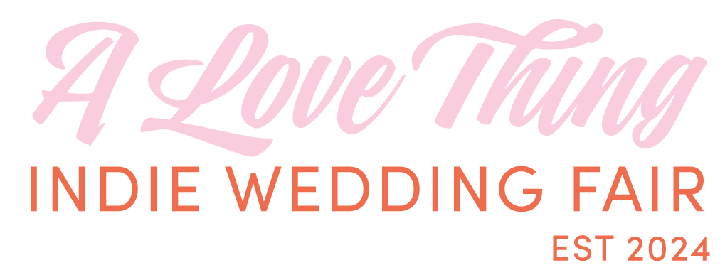

**A Love Thing Indie Wedding Fair is back!**

**​**Are you newly engaged and looking for some alternative wedding / party inspiration that’s just a little bit different? Then A Love Thing Indie Wedding Fair is for you, featuring over 20 wedding suppliers under one roof.   
  
A Love Thing celebrates love in all its shapes and sizes and champions independent brands and the makers and shakers who create outstanding work.  
Expect to find businesses that specialise in stationery, flowers, photography, cakes, accessories and more showcasing their unique talents to make your wedding one of a kind.

“*We want to break down barriers and remove stigmas within the wedding industry. Breaking traditions, we believe it’s your day, your way so pop down for a chance to meet suppliers face to face. It will be a great opportunity to talk through ideas and meet business owners in an informal setting”* Kate Seaward and Kelly Robb - A Love Thing Organisers.

​The fair will be held at [Norwich Arts Centre](https://norwichartscentre.co.uk/) on Sunday 2 November, an inclusive, independent music and performance venue in the city centre, housed within a Grade 1 listed beautiful church. Since 1980 NAC has played host to countless of music legends and performers and when it’s not hosting amazing bands and artists NAC is also the perfect wedding/party venue!

It’s free to drop in between on 11am-3pm on Sunday 2 November at Norwich Arts Centre, a fully accessible venue, with a quiet hour between 2pm-3pm. The cafe bar will open for teas, coffees and alcoholic / non alcoholic beverages.

Free tickets for this event can be purchased via the website [alovethingwedding.com](http://alovethingwedding.com). Free goody bags for the first 50 nearly-wed couples through the door.

ENDS

Contacts: Kate Seaward and Kelly Robb alovethingwedding@gmail.com

A Love Thing Wedding Fair Website <https://www.alovethingwedding.com/>

A Love Thing Instagram <https://www.instagram.com/alovethingwedding/>  
Norwich Arts Centre Website <https://norwichartscentre.co.uk/>