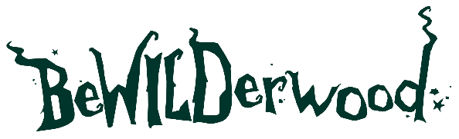

PRESS RELEASE
Join the Halloween Fancy Dress
Competition at BeWILDerwood

Sent by BeWILDerwood
22nd October 2025

Join the Halloween Fancy Dress Competition at BeWILDerwood
Get your best fancy dress ready! BeWILDerwood’s new Halloween event, Halloween at BeWILDerwood has opened to great success, and the woods have been filled with the most fantastic Halloween costumes imaginable. To celebrate all the spooktacular creativity, BeWILDerwood is launching a brand-new fancy dress competition: Best Dressed Boggle.
Running daily from 25th October – 2nd November, the competition will crown one lucky visitor each day as the Best Dressed Boggle. Whether you come as a witch, wizard, Crocklebog, or your own magical creation, the Boggles of BeWILDerwood will be keeping an eye out for the most imaginative, colourful, and creative fancy dress in the woods.
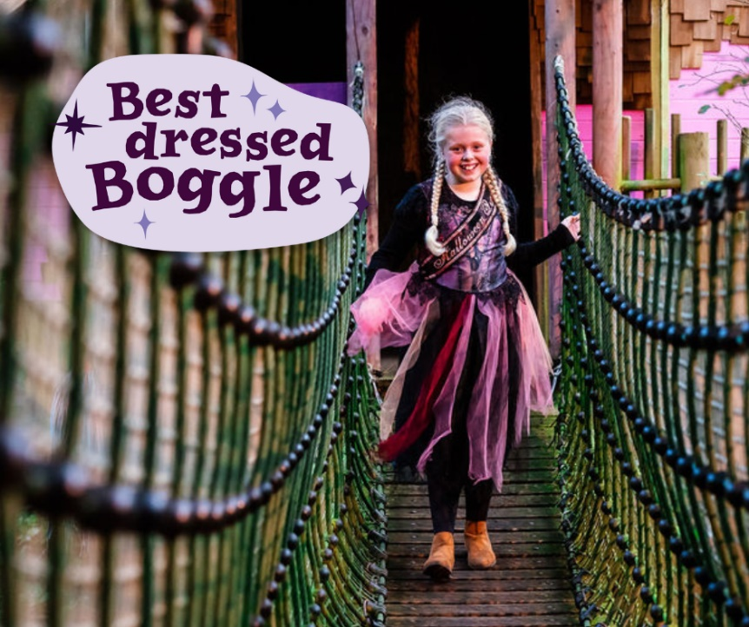

Each day’s winner will receive a copy of the brand-new BeWILDerwood short story, Minty and the Four Feathers - the next instalment in the Minty short stories’ series, launching October half term. Along with a sweet treat and a return ticket to come and play again next year*!
Head of Events and Park Production, Matt Dallen commented:
“It’s been such a fantastic launch to our new event, and we’ve been blown away by how many visitors have turned up in fancy dress - it’s exactly what we wanted! Everyone is getting into the Halloween spirt and enjoying ALL the best things about BeWILDerwood - playing in the day, going Twig or Treating and following the Glowing Light Trail - which will get better and better when the clocks go back.
This year we wanted to add as much value for families so combining everything into one ticket and tweaking our opening times to accommodate our families with younger children means that everyone can enjoy all the fun without a late bedtime. We can’t wait to welcome more visitors for October half term too!”
Set in the enchanting world of BeWILDerwood, Halloween at BeWILDerwood offers a full day of play, Halloween activities such as face stencils, crafts and even a Spooky Disco. As well as a Twig or Treat trail, which is BeWILDerwood’s twist on trick-or-treating, and even a small Glowing Light Trail too!
So, don’t forget your costume - it could earn you the title of Best Dressed Boggle 2025! Tickets for the new Halloween activities are selling fast, so the park recommends booking ahead to avoid missing out. Book here.
Event Details:
Name: Halloween at BeWILDerwood – Spooooky Fun For Everyone!
Dates: 25th October – 2nd November
Location: BeWILDerwood Norfolk & BeWILDerwood Cheshire
Tickets: Info and tickets

Competition Info:
Best Dressed Boggle competition - Visit BeWILDerwood during 25th October – 2nd November 2025 in your best fancy dressed for your chance to be crowned Best Dressed Boggle. 1 x winner will be crowned each day and will win 1 x Minty book, 1 x return ticket (with another paying ticket) valid until 31st October 2026, 1 x bag of sweets. Winner will be randomly selected throughout the day and be approached by a member of the BeWILDerwood Twiggle Team.

*T&Cs apply.

ENDS.
Editor Notes:
About BeWILDerwood
The award-winning attraction aims to encourage even more children and their families to enjoy traditional, imaginative, and healthy outdoor play.
The attraction is based on the book series by author and creator Tom Blofeld, with hints of his magical stories and curious characters throughout the forest.

BeWILDerwood opened its first park in May 2007, on the outskirts of the Broadland village of Hoveton, Norfolk. BeWILDerwood Norfolk is one of the most successful visitor attractions in the East of England.
Opening Dates and Times
See website for seasonal opening dates: https://bewilderwood.co.uk/plan-your-visit/opening-times-and-prices

Admission Prices:
Everything included in the ticket price for Halloween at BeWILDerwood (daytime play, Halloween activities, crafts, face stencils, shows, Twig or Treating and Glowing Light Trail)
Born to BeWILD (under 92cm) Free
Almost WILD (92-105cm) £20.95
BeWILD Now (over 105cm) £22.95
Still WILD (65 years+) £14.95
Carer (proof required) Free

BeWILDerwood Cheshire:
BeWILDerwood Cheshire
Bickley Moss
Cheshire
SY13 4JF
Email: cheshire@bewilderwood.co.uk

BeWILDerwood Norfolk:
BeWILDerwood Norfolk
Horning Rd
Hoveton
Norwich
NR12 8JW
Email: norfolk@bewilderwood.co.uk

Website: https://bewilderwood.co.uk/
Press pack including image gallery and logo.

For all press enquiries and exclusive interviews with Creator and Author Tom Blofeld:
Lydia Downey, Head of Marketing and Media BeWILDerwood
lydia@bewilderwood.co.uk
01829 830730

