

Press Release
For Immediate Release

Seeds of Hate and Hope

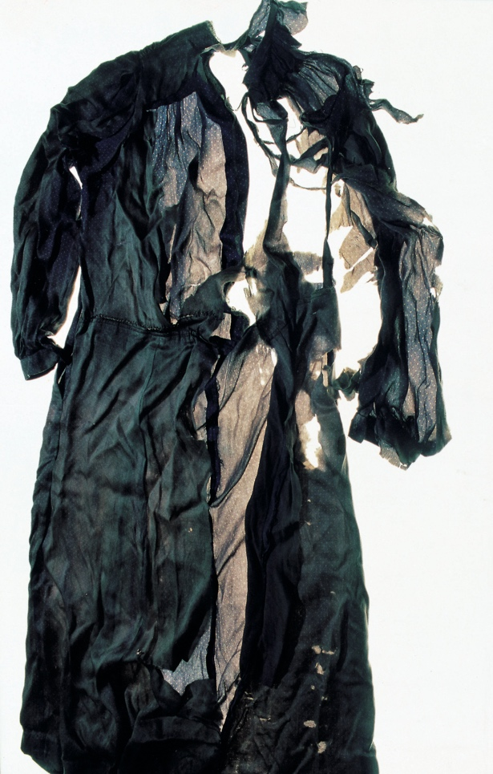

Ishiuchi Miyako, ひろしま/hiroshima#71 donor: Hatamura, T, 2007. Copyright: Ishiuchi Miyako.
Courtesy of Michael Hoppen Gallery

28 November 2025 – 17 May 2026
Sainsbury Centre, Norwich

Seeds of Hate and Hope presents personal artistic responses to global mass atrocities, such as genocides, ethnic cleansing, war crimes and crimes against humanity. Featuring work by artists including Mona Hatoum, William Kentridge, Hew Locke, Zoran Mušič, Peter Oloya, Kimberly Fulton Orozco and Indrė Šerpytytė, it explores how, throughout the 20th and 21st centuries, artists have witnessed, experienced and responded to atrocity crimes and conflicts with powerful and compelling artworks. Drawing courage and inspiration from personal experience as well as shared histories, they have reacted to these events for many reasons including but not limited to bearing witness, expressing grief and promoting healing.

With the aim of raising awareness about global conflicts and the role of art in confronting their legacy, this exhibition highlights artistic responses to such devastating events with creativity and courage. It features artworks which are reflections of, rather than images of, violence or victims; and which challenge the typical depictions of war and conflict often shown in the media.

Significant works on display include William Kentridge’s Ubu Tells the Truth (1997), which confronts the violence and injustice of apartheid in South Africa; Gideon Rubin’s Black Book (2017) which redacts every page of Adolf Hitler’s Mein Kampf, symbolically stripping the text and imagery of its intent; Ishiuchi Miyako’s photographs of everyday objects which belonged to victims of the atomic bombings of Hiroshima and Nagasaki; Mona Hatoum’s iconic Hot Spot (2006), a reference to a world which Hatoum describes as “continually caught up in conflict and unrest”; and a series of bronze sculptures by Peter Oloya, whose experiences of violence and displacement during conflict in northern Uganda informed his love of modelling shapes and figures first in clay, and later in bronze and wood.

Through its diverse body of work, Seeds of Hate and Hope explores how both individual and collective acts of resistance and resilience often take root in times of conflict. The exhibition emphasises the vital role that human empathy and respect play in safeguarding society against the destructive forces of prejudice, hate speech, discrimination and dehumanisation. Each artwork becomes a catalyst for healing – promoting tolerance and understanding across cultures, religions and identities.

Can We Stop Killing Each Other? is the latest in an innovative series of investigative exhibition seasons by the Sainsbury Centre following its radical relaunch in 2023 to formally recognise the lifeforce of art, enabling people to build relationships with living art across its dynamic museum landscape.

Seeds of Hate and Hope joins four other exhibitions which explore Can We Stop Killing Each Other?. These are Tiaki Ora ∞ Protecting Life: Anton Forde; Eyewitness; Roots of Resilience: Tesfaye Urgessa; and The National Gallery Masterpiece Tour: Reflections on Peace. It is curated by Tafadzwa Makwabarara, Curator of Cultural Empowerment at the Sainsbury Centre and Jelena Sofronijevic, an independent curator, writer, and the producer of the EMPIRE LINES podcast, which addresses the unexpected, and often two-way, flow of empires through art.

Exhibition research was supported by the Jonathan Ruffer grant from the Art Fund.

NOTES TO EDITORS

For more information, interviews and images:
Mary Doherty
mary@sam-talbot.com / 07716701499

Exhibition details
Seeds of Hate and Hope
28 November 2025 – 17 May 2026
Sainsbury Centre, University of East Anglia,
Norfolk Road,
Norwich NR4 7TJ

The Sainsbury Centre continues its innovative series of investigative exhibitions in 2025 with a new programme that examines the fundamental question of why humans are led to kill, and how art, film, TV and culture have grappled with, or even aggravated, our proximity to violence.

Five concurrent exhibitions ask Can We Stop Killing Each Other?: if creative thinkers, and the art they produce, can use empathy to create change, and if humanity can choose hope over violence.

Featured exhibitions:
• Tiaki Ora ∞ Protecting Life: Anton Forde, 2 August 2025 – 19 April 2026
• Eyewitness, 20 September 2025 – 15 February 2026
• Roots of Resilience: Tesfaye Urgessa, 20 September 2025 – 15 February 2026
• The National Gallery Masterpiece Tour: Reflections on Peace, 20 September
2025 – 11 January 2026
• Seeds of Hate and Hope, 28 November 2025 – 17 May 2026

Opening times
Tuesday – Friday 9am-6pm (exhibitions open 9.30am)
Saturday – Sunday 10am-5pm
Closed Mondays, including bank holidays

Entry
Tickets operate on a ‘Pay Only If and What You Want’ basis, so you can choose the price from free through to full membership. A Universal Ticket grants access to the permanent collection, Lower and Mezzanine Galleries, and Sculpture Park.

The Sainsbury Centre is a world-class art museum with a unique perspective on how art can foster cultural dialogue and exchange. Following a radical relaunch in 2023 the Sainsbury Centre formally recognises the living lifeforce of art, enabling people to build relationships across an arts landscape.

The art of the Sainsbury Centre can help reframe and answer the most important questions people have in their lives. It is not a museum to only learn more about artists, cultures or movements like Francis Bacon, the Tang Dynasty or Modernism, it is a place of experience, where collections are animate, and visitors are emotionally connected.

One of the first museums in the world to display art from all around the globe and from all time periods equally and collectively, Sir Robert and Lady Lisa Sainsbury created one of the most sought after yet non-conformist art collections. In 1973 they donated their collection, which transcended traditional barriers between art, architecture, archaeology and anthropology, to the University of East Anglia, and created an entirely new type of museum. Housed in Sir Norman Foster’s revolutionary first ever public building, the space aimed for an interactive relationship between people, object and landscape, where art was placed within an open yet intimate ‘living area’.

Visit www.sainsburycentre.ac.uk and follow @sainsburycentre on Facebook, X, Instagram, TikTok and LinkedIn, as well as @TheSainsburyCentre on YouTube.

Tafadzwa Makwabarara
Tafadzwa Makwabarara is the Curator of Cultural Empowerment at the Sainsbury Centre, and co-editor of the Can We Stop Killing Each Other? publication. Her role is focused on encouraging critical thinking, cooperation and collaboration on universal contemporary issues through the inclusion and re-engagement of minority and marginalised groups in society. At the Sainsbury Centre, Tafadzwa co-curated Seeds of Hate and Hope for the ‘Can We Stop Killing Each Other?’ season, and curated Heroin Falls as part of the ‘Why Do We Take Drugs?’ season. She was project curator on The Camera Never Lies: Challenging Images from The Incite Project for ‘What Is Truth?’ and contributed to the books What is Truth? And Why do We Take Drugs?, both published by the Sainsbury Centre in 2024.

Jelena Sofronijevic
Jelena Sofronijevic is a producer, curator, writer, and researcher, working at the intersections of cultural history, politics, and the arts. Their independent curatorial projects include Invasion Ecology (2024), SEEDLINGS: Diasporic Imaginaries (2025), and they produce EMPIRE LINES, a podcast which uncovers the unexpected flows of empires through art. They are also pursuing a practice-based PhD with Gray’s School of Art, curating exhibitions of Balkan and Yugoslavian/diasporic artists in British art collections.
Much of their research centres on pluralising representations of Central, Eastern and Southeastern Europe (CESEE)/diaspora communities and cultures, particularly from the Balkans and Yugoslavia, and more constructive, contemporary histories of non-alignment. More widely, they seek to platform lived experiences and perspectives often marginalised or excluded from representation, especially in anti-colonial and environmental activism. They work to make complex ideas accessible, not simple.


