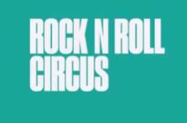
THURSDAY 4 OCTOBER 2026
THE STREETS ANNOUNCED AS FIRST HEADLINERS FOR ROCK N ROLL CIRCUS RETURN TO NORWICH

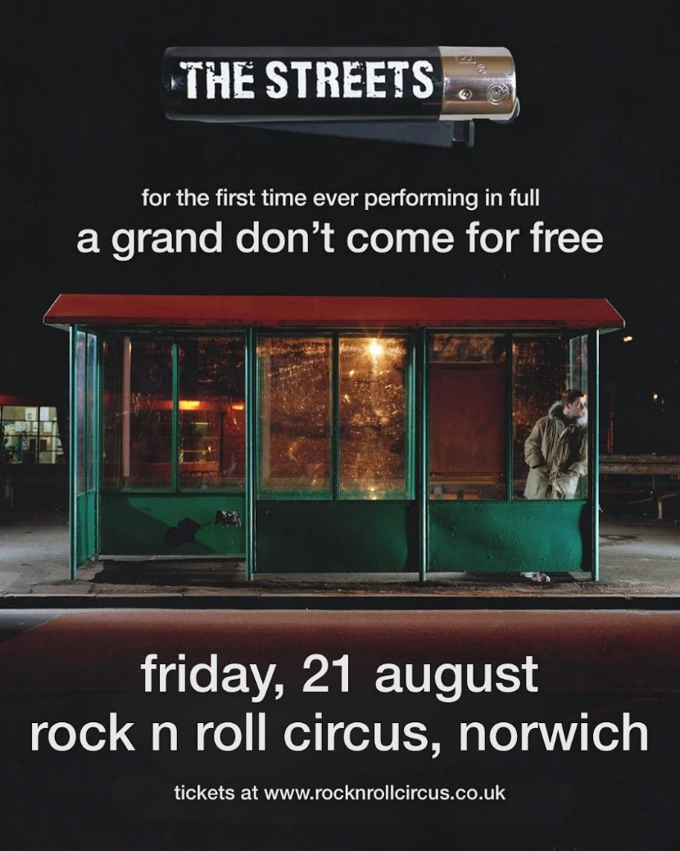

Rock N Roll Circus will return to Earlham Park, Norwich from Friday 21st – Sunday 23rd August 2026 - and organisers have confirmed that the first headliners will be The Streets, performing their landmark album A Grand Don’t Come For Free in full for the very first time.
The announcement comes as part of The Streets’ newly revealed 2026 UK tour, which will see Mike Skinner and his band take the record on the road in its entirety. The run includes major headline shows across Margate, Bristol, Manchester, London, Ludlow, Leeds and Essex – before arriving in Norwich to headline Rock N Roll Circus on Friday 21 August 2026.
The news marks a major coup for Norwich, following the huge success of Rock N Roll Circus’ debut edition in summer 2025. Across three days, thousands flocked to Earlham Park for headline sets by McFly, Courteeners and Olly Murs, alongside circus performances, workshops, street food and family entertainment.
Festival Director Ali O’Reilly said: “The atmosphere in Norwich last year was electric. The people made it absolutely clear they wanted the circus back, and we knew we had to deliver something special. Announcing The Streets as our first headliner for 2026 is really exciting. To see A Grand Don’t Come For Free performed in full under the big top will be very special.”
Released in 2004, A Grand Don’t Come For Free remains one of the most important British albums of the 21st century. Entering the UK charts at Number One and going multi-platinum, it produced era-defining singles Dry Your Eyes, Fit But You Know It and Blinded By The Lights. Revered for its concept-driven narrative, the album captured the humour, heartbreak and chaos of everyday life with rare poetic clarity, cementing Mike Skinner as one of the UK’s most vital voices.
Speaking about the upcoming live shows, Skinner said: “A Grand Don’t Come For Free was a moment in time - for me, and for everyone who grew up with it. I wrote it as a story from beginning to end, even studying screenwriting to shape it, without the faintest idea how people would react.
"Some tracks have never been played live, others haven’t surfaced in years. It’s a new challenge to bring the whole journey to life on stage, but with the band we have now, I’m certain we’ll find out what happened to that thousand quid a party every night.”
Rock N Roll Circus is far more than a standard festival. Alongside headline performances, fans can expect a packed programme of acrobatics, fire shows, aerialists, interactive workshops, and a curated food and drink village.
The Big Top set-up means shows are intimate and atmospheric – and always go ahead, whatever the weather.
With The Streets now confirmed for Friday 21 August 2026, organisers promise further headline and line-up announcements in the coming months.
Ticket Information
Artist presale opens Tuesday 14 October 2025 at 10am BST (sign-up required).
General sale begins Friday 17 October 2025 at 10am BST.
Tickets & info: www.rocknrollcircus.co.uk/norwich

NOTES TO EDITOR:
‘By the time Olly closed with Wrapped Up and a reprise of Dance With Me Tonight, confetti rained down on a crowd that didn’t want the night—or the festival—to end. It was a finale that balanced stadium-sized fun with a heartfelt tribute, sealing Rock N Roll Circus as one of Norwich’s unmissable summer moments.’ Popscoop
‘As the name suggests - it was far more theatrical than an average festival. instead of waiting through the usual lulls in between sets, crowds were treated to some phenomenal circus-style performances to rock music, which made the gaps between artists feel like an experience in its own right.’ Norwich Evening News

