Adventurer Aldo Kane and YouTube star Maddie Moate announced as headliners for Norwich Science Festival 2026
City-wide Festival returns with celebrity line-up and popular family events for the half-term
27.11.25
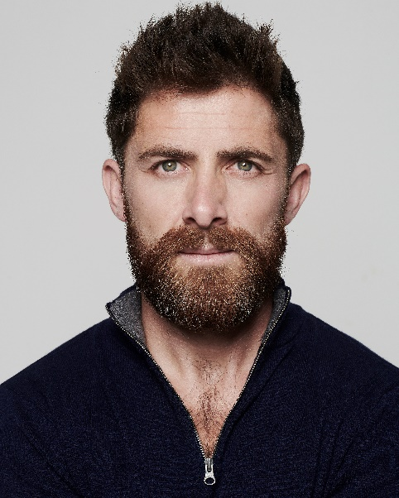
Image credit: Headliners at Norwich Science Festival 2026 include author and adventurer Aldo Kane, and CBeebies star Maddie Moate
NEWS: A popular city-wide Festival will return in February half-term next year, and tickets are going on sale today, Thursday 27 November.
Presented by The Forum, Norwich Science Festival has announced its headliners for 2026, with adventurer, TV presenter and best-selling author Aldo Kane, BAFTA-winning YouTuber Maddie Moate, Dr Jack Mosley, and a GBBO Finalist set to take to the stage in this yearly celebration of science.
The Festival returns to the city Saturday 14-Saturday 21 February 2026, with more than 200 events for all ages – including explosive family shows, insightful science talks, immersive experiences and workshops for kids.
Next year will be particularly special, as the Festival celebrates its 10th anniversary.
Norwich Science Festival will open on Valentine’s Day, with special events to mark the occasion - including a live dissection of animal hearts with Festival patron and biologist Prof Ben Garrod and cardiologist Dr Rohin Francis. In the evening, Dr Rohin Francis will deliver an evening of comedy exploring affairs of the heart at The Exchange restaurant in Jarrolds – a perfect blend of medical insight and heartfelt humour.
On the final day of the Festival, Saturday 21 February, Dr Jack Mosley will be in conversation about his new book, Food Noise. Having researched weight loss drugs with his father, the late Dr Michael Mosley, Jack will offer his insight into the importance of nutrition and the science behind GLP-1s.
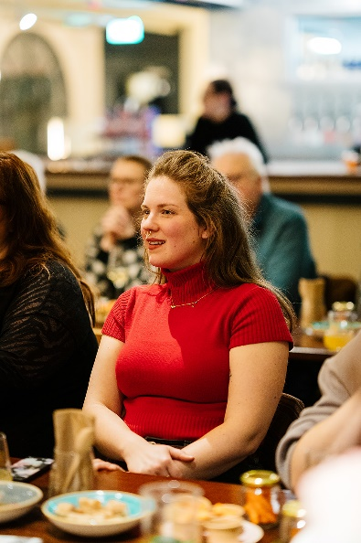
Image credit: Foodies can enjoy a unique evening of kombucha and cheese tasting with the team behind award-winning Oichi Kombucha at YALM Foodhall
Something for the grown-ups
The Festival may be in half-term, but there’s plenty for adults to enjoy throughout the week!
For the first time ever, The Explorium will be opened after hours for grown-ups only – to celebrate the Festival’s 10th anniversary. Visitors can get stuck into hands-on science fun, including an epic bubble show from Bubble Inc, and a trio of fantastic talks. There’ll be a DJ and a bar to enjoy too (Fri 13 Feb).
Foodies can enjoy a unique cheese and kombucha tasting experience with the team behind award-winning Norfolk brand, Oichi Kombucha at YALM Foodhall (Sun 15 Feb). The event will feature live demonstrations and the opportunity to discover the traditional craft techniques behind fermented tea.
Author, presenter and adventurer Aldo Kane shares stories from the world’s most hostile and awe-inspiring environments at a special event at Norwich Theatre Royal (Sun 15 Feb) – expect to be inspired as Aldo takes you to the edge of survival.
Singer-songwriter Hannah Rose Platt will shine a light on hidden histories and the fight for women’s bodily autonomy, with a mix of powerful original music and storytelling at Norwich Arts Centre (Tue 17 Feb).
Science, comedy and music come together in Nine Lessons for Norwich Science Festival – a unique variety mash event featuring comedian and writer Robin Ince, Dr Helen Czerski, Dr Anjana Khatwa, Dr Clara Nellist and Simon Watt (Fri 20 Feb).

Family favourites
Families can keep the kids entertained during the half-term with a fantastic line-up of events – from all the wonders of space to animatronic dinosaurs and pancake flipping!
Dr Nikhil Mistry will showcase amazing science demonstrations that you can do with regular household items in Do Try This at Home at Epic Studios (Sun 15 Feb) – from colour-changing potions to rocket launches.
Great British Bake-Off Finalist Dr Josh Smalley dives into the chemistry of pancakes for a special event on Pancake Day at The Blake Studio, featuring exciting experiments and even a liquid nitrogen ice cream finale (Tue 17 Feb)!
Fresh from Dragon’s Den, Dinomania Ranger Chris goes head-to-head with Prof Ben Garrod in an epic dinosaur showdown at Epic Studios. Audiences can expect amazing life-sized walking dinosaurs, state-of-the-art animatronics and jaw-dropping fossils (Thu 19 Feb).
CBeebies star and award-winner Maddie Moate returns to Norwich with an interactive family show exploring the inner workings of everyday machines at Norwich Theatre Playhouse (Fri 20 Feb).
The popular Explorer Dome will also return to the Festival (Sat 14-Wed 18 Feb). Visitors can step into new worlds in this immersive, inflatable planetarium.

Book early to avoid disappointment
With many sell-out shows in 2025, the Festival advises early booking. Almost all events, including free talks, must be pre-booked. The full line-up will be revealed today, Thursday 27 November, with tickets on-sale at norwichsciencefestival.co.uk.

**ENDS**

Notes for Editors
For more information about Norwich Science Festival 2026, please contact Marketing and Communications Manager, Danie Hadley at danie.hadley@theforumnorwich.co.uk or call 01603 727 962.
Link to download images:
https://drive.google.com/drive/folders/1gQqktnP-xdF4kFXaiyIHLE1riZ2_YpzM?usp=sharing

About Norwich Science Festival
Saturday 14-Saturday 21 February 2026
Norwich Science Festival is a celebration of science and technology, showcasing the ground-breaking research and innovation associated with the city. The Festival gives visitors of all ages the chance to explore the wonders of the universe and meet the scientists whose research is changing the world.
Norwich Science Festival is presented by The Forum, alongside Principal Partner the University of East Anglia.
The Festival’s patrons are Professor Ben Garrod, Maddie Moate, Dr Jess French, Jon Chase and Mark Thompson.
Sponsors for 2026 include Aviva, Chestnut Nursery, CIM Signs & Graphics, Connected Innovation, Howes Percival, KLM UK Engineering, Norwich High School for Girls, Norwich University of the Arts, RENEnergy, RWE and WestCoTec.
www.norwichsciencefestival.co.uk

About The Forum
- The Forum, a landmark building in the centre of Norwich, is one of the UK’s most successful Millennium projects.
- It’s a public building, open seven days a week, all year round (except Christmas Day and Boxing Day).
- Everyone is welcome. Most of the public events, exhibitions and activities which take place at The Forum are free.
- The Forum delivers Norwich Science Festival, Norwich Book Festival and coordinates Norfolk Heritage Open Days. It is a cultural hub for the city and county.
- The Forum Trust is the independent, self-financing, charitable organisation which manages The Forum building: our income helps us to maintain the building, and put on our free programme of year-round events.
- The Trust works with many partners to ensure The Forum plays a valuable role in the community.

Find out more about The Forum on theforumnorwich.co.uk

