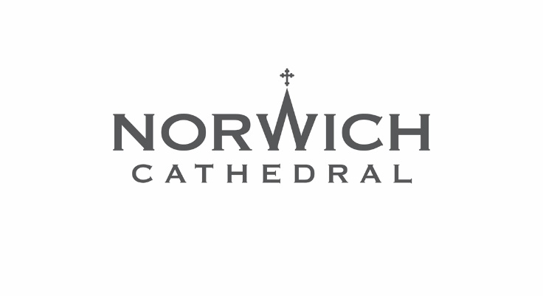
Press Release: Friday 7 November

Celebrate Christmas with new festive album
from Norwich Cathedral Choir

Enjoy carols sung by Norwich Cathedral Choir on a new album that has been recorded to celebrate the festive season.

Lord of the Dance: Christmas Carols from Norwich Cathedral has been released today (Friday 7 November) on all major streaming platforms and features the choir singing 20 carols ranging from Away in a Manger to The First Nowell and Sussex Carol.

The album is also available to buy in a CD format from Norwich Cathedral’s gift shop for an introductory price of £10.

The album was recorded in Norwich Cathedral’s Nave in June this year, with the choir joined by music ensemble Onyx Brass and David Dunnett who retired as the Cathedral organist this summer after an incredible musical tenure of 29 years.

Norwich Cathedral’s Master of Music Ashley Grote, who conducted the choir during the recording, said: “I'm really thrilled with our new Christmas album, Lord of the Dance, which is a collection of some of the best-loved carols, some in new arrangements.
“The combination of the Cathedral Choir, the newly rebuilt organ, along with award-winning ensemble Onyx Brass is a very special sound.
“It was wonderful to work on this project with Norwich-based independent record label Deux-Elles Classical Recordings; they have managed to capture a sense of what it is like to be in Norwich Cathedral at Christmas time.
“I hope that the album will bring a lot of joy to people this Christmas!”

The title track is a new arrangement of Lord of the Dance by Ashley who has also created new arrangements of O Come, Emmanuel, Away in a Manger and Silent Night. Also featured on the album are new arrangements by leading choral composer Bob Chilcott and popular arrangements by Sir David Willcocks and contemporary works by Sally Beamish and Will Todd.

The album was the first recording at the Cathedral since the Cathedral’s historic pipe organ underwent a major rebuild in 2023, and the cover artwork celebrates the organ by featuring the special star – known as a cymbelstern – that decorates the top of organ.

About 50 singers from Norwich Cathedral Choir perform on the album, including choristers, lay clerks and choral scholars.

Senior Girl Chorister Hannah Kelleway, 17, said: “Everyone really enjoyed recording the Christmas album. It was a unique and wonderful opportunity and it was very interesting to see the work that goes into creating a professional recording.”

Chorister Max Kotzee, 12, said: “I most enjoyed listening to and working with Onyx Brass, who were amazing. It was interesting seeing the recording technicians in action and learning about sound recording.”

The album has been recorded and produced by Norwich-based independent record label Deux-Elles Classical Recordings. It was made possible due to funding from The Statham Society, Norwich Cathedral’s group of dedicated music supporters, and a generous legacy.

The CD album of Lord of the Dance: Christmas Carols from Norwich Cathedral is available to buy now for an introductory price of £10 from Norwich Cathedral Shop and online at https://cathedral.org.uk/gift-shop/

The album is available on all major streaming platforms including Spotify, Apple Music, Apple Music Classical, Amazon Music and Presto Classical.

For all the latest information about festive services and events at Norwich Cathedral, visit cathedral.org.uk/Christmas

Notes to editors
For more information, including to arrange interviews, please contact Norwich Cathedral’s marketing and communications manager Emma Knights via eknights@cathedral.org.uk or 07968 460963.

The full list of tracks on Lord of the Dance: Christmas Carols from Norwich Cathedral

1. O come, Emmanuel, arr. Ashley Grote 4:02
2. Away in a manger, arr. Ashley Grote 3:02
3. Once in Royal David’s City, Descant Stephen Cleobury 4:32
4. Lord of the Dance, arr. Ashley Grote 4:04
5. The First Nowell, arr. David Willcocks 5:23
6. Alleluia! A new work is come on hand, Bob Chilcott 3:11
7. In the stillness, Sally Beamish 2:21
8. O Little Town of Bethlehem, Vaughan Williams 3:26
9. In dulci jubilo, arr. Robert Pearsall 3:23
10. I saw three ships, arr. Stuart Nicholson 2:23
11. It came upon a midnight clear, arr. David Willcocks 3:21
12. Silent night, arr. Ashley Grote 3:47
13. Midwinter, Bob Chilcott 4:07
14. While shepherds watched their flocks, arr. Ashley Grote 2:42
15. My Lord has come, Will Todd 3:41
16. O come, all ye faithful, arr. David Willcocks 4:43
17. Sussex Carol, arr. Bob Chilcott 2:16
18. Hark! The herald angels sing, arr. David Willcocks 4:03
19. Jingle Bells, arr. David Willcocks 2:15
20. We wish you a Merry Christmas, arr. Arthur Warrell 1:49

Norwich Cathedral Choir’s Festive Concerts

Christmas with Norwich Cathedral Choir
Friday 12 December, 7.30pm
Norwich Cathedral Choir
Onyx Brass
Graham Thorpe and Christopher Too Organ
Ashley Grote Conductor
Join Norwich Cathedral Choir for a feast of festive music, both sacred and secular, with carols for choir and audience, not forgetting the great 12 Days of Christmas sing-along!
Tickets £15/£20/£25 (£5 Under 18s in the side aisles).
To book, visit cathedral.org.uk or call 0333 666 3366.

Handel’s Messiah by Candlelight
Saturday 20 December, 7pm
Norwich Cathedral Choir
Norwich Baroque
Zoë Brookshaw Soprano
Hugh Cutting Counter tenor
David de Winter Tenor
Edward Grint Bass
Ashley Grote Conductor
Norwich Cathedral Choir are joined by Norwich Baroque and a cast of internationally-acclaimed soloists for their annual performance of Handel's Messiah by candlelight in the stunning surrounds of the Cathedral's Nave.
Tickets £15/£25/£35/£40 (£5 Under 18s in side aisles).
To book, visit cathedral.org.uk or call 0333 666 3366.

