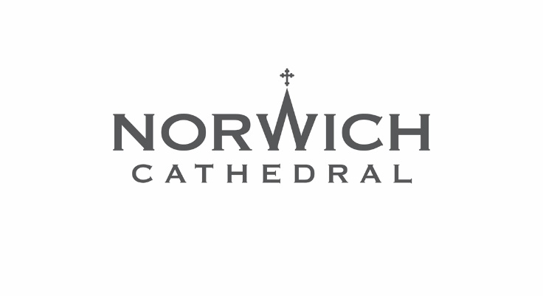
Press Release: For immediate release

Advent and Christmas 2025 at Norwich Cathedral

From festive concerts to special services and carols in the cloister, there is lots to look forward to at Norwich Cathedral throughout Advent and Christmas.

One of the first dates for festive diaries is the stunning Advent Procession on Sunday 30 November which will see the Cathedral filled with candlelight as we begin our preparations for Christmas.

There will be lots more to enjoy as the countdown to Christmas continues, and tickets are now on sale for the Cathedral Choir’s seasonal concerts.

Our traditional Christmas with Norwich Cathedral Choir concert will take place on Friday 12 December and the choir will also perform Handel’s Messiah by Candlelight on Saturday 20 December.

This year our Cathedral Shop also has the perfect present for those wanting to give the gift of music – Norwich Cathedral Choir’s brand new 2025 Christmas album Lord of the Dance: Christmas Carols from Norwich Cathedral has just been released and is available to buy for an introductory price of just £10.

Below are the key highlights of Norwich Cathedral’s festive services and events.
For the full details, visit cathedral.org.uk

Candlelit Advent Procession
Sunday 30 November, 6pm
Join us for carols and readings in a candlelit procession as we begin our preparations for Christmas.

Evensong with the making of a Child Bishop
Friday 5 December, 5.30pm
Reviving a custom from the Middle Ages, one of the Cathedral’s choristers will be made the ‘Child Bishop’ for this special Evensong celebrating St Nicholas, the patron saint of children, and concluding with the blessing of the outdoor crib outside the Hostry.
We will be joined by the Bishop of Thetford for this special service.

Tree of Remembrance
Friday 5 December until Sunday 4 January
Remember a loved one by placing a decoration on the Tree of Remembrance beside the Cathedral’s outdoor crib outside the Hostry.

Christmas with Norwich Cathedral Choir
Friday 12 December, 7.30pm
Norwich Cathedral Choir
Onyx Brass
Graham Thorpe and Christopher Too Organ
Ashley Grote Conductor
Join Norwich Cathedral Choir for a feast of festive music, both sacred and secular, with carols for choir and audience, not forgetting the great 12 Days of Christmas sing-along!
Tickets £15/£20/£25 (£5 Under 18s in the side aisles).
To book, visit cathedral.org.uk or call 0333 666 3366

Carols in the Cloister
Saturday 13 December, 4pm
Enjoy a carol singalong with members of Norwich Cathedral Choir in the stunning surrounds of the Cloister. We will be joined by the Norwich Citadel Band of the Salvation Army for this wonderful festive occasion. Warm, colourful and festive attire is encouraged!
Free admission, with a retiring collection in aid of The Children’s Society.

Handel’s Messiah by Candlelight
Saturday 20 December, 7pm
Norwich Cathedral Choir
Norwich Baroque
Zoë Brookshaw Soprano
Hugh Cutting Counter tenor
David de Winter Tenor
Edward Grint Bass
Ashley Grote Conductor
Norwich Cathedral Choir are joined by Norwich Baroque and a cast of internationally-acclaimed soloists for their annual performance of Handel's Messiah by candlelight in the stunning surrounds of the Cathedral's Nave.
Tickets £15/£25/£35/£40 (£5 Under 18s in side aisles).
To book, visit cathedral.org.uk or call 0333 666 3366.

Christmas Procession with Carols
Sunday 21 December, 3.30pm
Tuesday 23 December, 7pm
Wednesday 24 December, 3.30pm
Hear the story of Christmas told with carols and readings as the Cathedral Choir moves in procession through the whole Cathedral.

Crib Service
Wednesday 24 December, 12 noon
Fun for all the family as the Christmas Story is brought to life in this informal service where children are invited to dress as characters from the Nativity and the Cathedral Children’s Choir will sing.
Midnight Mass
Wednesday 24 December, 11.15pm
The traditional service sung by the Cathedral Choir to welcome in Christmas Day and celebrate the birth of Jesus. The Dean of Norwich, the Very Revd Dr Andrew Braddock, will preach. Please arrive early.

Family Eucharist of Christmas Day
Thursday 25 December, 10.30am
Celebrate Christmas Day at this special service sung by Norwich Cathedral Choir. The Bishop of Norwich, the Rt Revd Graham Usher, will preach.

Festal Evensong on Christmas Day
Thursday 25 December, 3.30pm
A special Evensong for Christmas Day with carols sung by Norwich Cathedral Choir.

New Year’s Day Organ Recital
Thursday 1 January, 11am
Norwich Cathedral’s Master of Music Ashley Grote presents a programme of seasonal organ music to kick off the New Year, including Tchaikovsky’s much-loved Nutcracker Suite.
Free admission, with a retiring collection.

New Year’s Day Eucharist
Thursday 1 January, 12 noon
Join us for the New Year’s Day Eucharist at the High Altar.

Epiphany Eucharist
Sunday 4 January, 10.30am
Join us for this service of Holy Communion as we celebrate The Epiphany.

Plough Sunday Evensong
Sunday 11 January, 3.30pm
A celebration of the beginning of the agricultural year and all who work in farming.

Messiaen’s La Nativité du Seigneur
Sunday 11 January, 6pm
Norwich Cathedral’s Master of Music Ashley Grote will play Messiaen's organ meditation on the nativity, La Nativité du Seigneur.
Free admission, with a retiring collection.

The Epiphany Procession
Sunday 18 January, 3.30pm
Norwich Cathedral Choir leads this processional service with readings, choral music and carols celebrating the season of The Epiphany.

Britten’s A Ceremony of Carols
Sunday 25 January, 6.30pm
The Choristers of Norwich Cathedral Choir
Elizabeth Green Harp
Ashley Grote Conductor
The Choristers of Norwich Cathedral Choir are joined by harpist Elizabeth Green for this candlelit performance of Britten’s ‘A Ceremony of Carols’, first performed here in Norwich at the Castle in December 1942.
Admission is free and no tickets are required. A retiring collection will be taken.
As featured on Norwich Cathedral Choir’s CD, Benjamin Britten Sacred Choral Works, which is available in the Cathedral Gift Shop.

Candlemas Eucharist
Monday 2 February, 6pm
Join us for this Festal Eucharist with candlelit procession, celebrating the end of the Christmas season.

Christmas shopping in the Cathedral Gift Shop
The Cathedral’s Gift Shop is open daily, offering lots of inspiration for the perfect presents.
Give the gift of the music with Norwich Cathedral Choir’s brand new 2025 Christmas album Lord of the Dance: Christmas Carols from Norwich Cathedral which is available to buy for an introductory price of just £10.
There is also a great selection of Christmas cards, Advent calendars, candles and nativities. Festive offers include four packs of selected Cathedral Christmas cards for £20 and two Cathedral ceramic decorations for £12.

For all the latest information about festive services and events at Norwich Cathedral, visit cathedral.org.uk/christmas

Notes to editors
For more information, including to arrange interviews, please contact Norwich Cathedral’s marketing and communications manager Emma Knights via eknights@cathedral.org.uk or 07968 460963.

