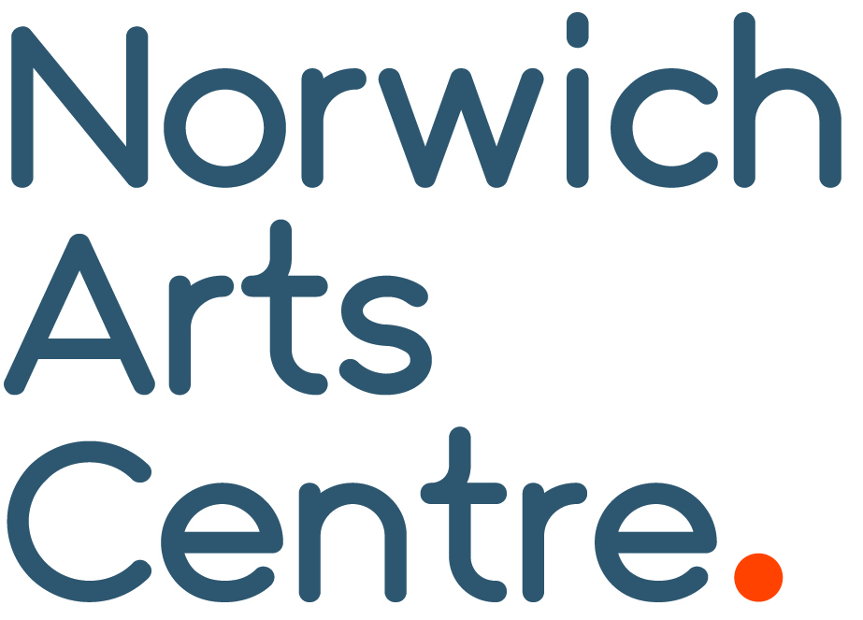
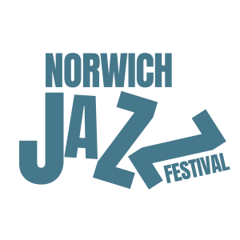
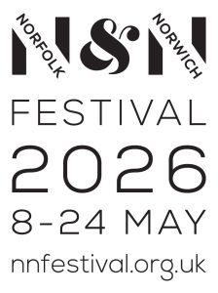

Norwich Jazz Festival Returns

*Embargoed until Thursday 13 November 10am*
The Norwich Jazz Festival returns in May 2026, and we’re thrilled to announce our headline act GoGo Penguin, performing at EPIC Studios on Saturday 23 May. The Manchester trio inspirationally blend jazz, classical and electronic influences and will be performing their powerful new album, Necessary Fictions.
Following a hugely successful relaunch in 2025, the festival is back and proud to be part of the Norfolk & Norwich Festival. Early highlights include GoGo Penguin and the Balimaya Project, who will perform at The Spiegeltent on Friday 15 May. The full Norwich Jazz Festival programme will be revealed in February 2026, alongside the Norfolk & Norwich Festival.
“We're excited to bring the Jazz Festival back with GoGo Penguin as our big headliner. Keep your eyes open for what we hope will be an incredible series of events!” Bradley Glasspoole, Artistic Director, Norwich Jazz Festival.
From 15–24 May, Norwich Arts Centre will present a series of performances, talks and film celebrating the best UK jazz talent across the city.
Tickets go on general sale for GoGo Penguin and and Balimaya Project on Tuesday 18 November 10am.

Visit norwichartscentre.co.uk for details.

END
NAC Contacts:
Kelly Robb and Grace Jackson Marketing & Communication Managers
E-mail: kelly@norwichartscentre.co.uk | grace@norwichartscentre.co.uk

