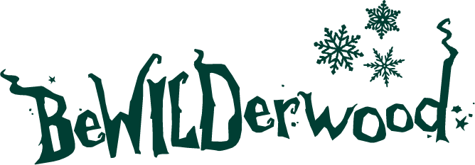

NEWS RELEASE
Step Into a Storybook Christmas at BeWILDerwood

Sent by BeWILDerwood Cheshire
27th November 2025

Step Into a Storybook Christmas at BeWILDerwood
Returning for another year of festive fun, BeWILDerwood Presents Christmas is back and invites families to experience the much-loved combination of storytelling, sparkly lights, and family fun in the woods for just £17.50.
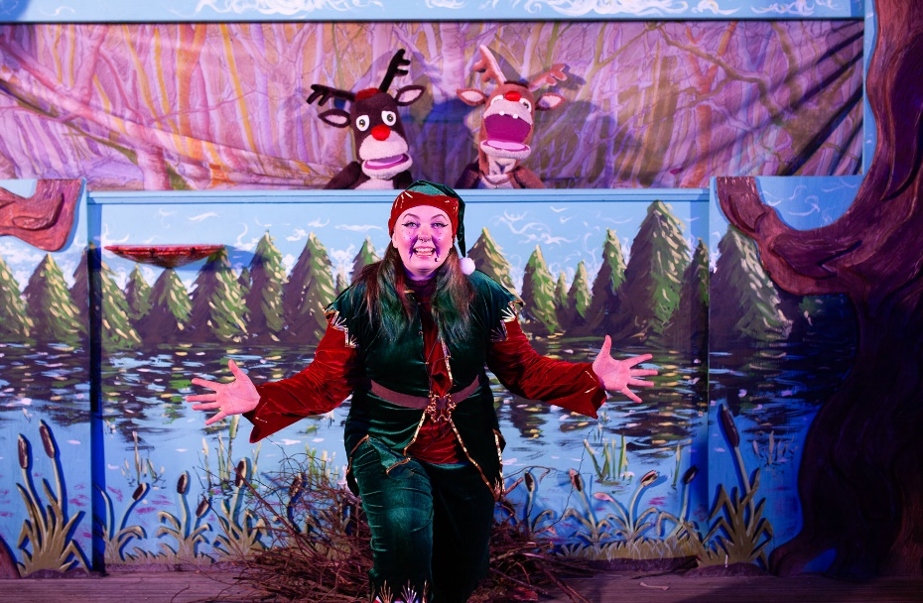

A wholesome Christmas event
Rather than relying on commercial add-ons, BeWILDerwood Presents Christmas focuses on what families say they value most at this time of year:
- Making memories together – creating new traditions and enjoying screen-free moments together
- A beautifully lit woodland walk to get you in the Christmas spirit – the woods are filled with twinkling lights and handmade decorations (all made in-house)
- A festive-filled pantomime - performed by BeWILDerwood’s beloved characters
- A good-value Christmas activity – at just £17.50 and everything included it really is one of the most reasonable events around this season
- The event is filled with imagination and wholesome fun - a refreshing alternative for families wanting something special without the pressure that often comes with the festive period.

Perfect for all the family
Designed with the whole family in mind, the storytelling, characters, and festive decorations create a magical experience for toddlers to grandparents - with a few jokes thrown in for the grown-ups too!

Everything included – no hidden extras
Staying true to BeWILDerwood’s ethos, everything needed for a full and festive visit is included in the ticket price:
- Parking
- Sparkly Light Trail
- Mini pantomime
- A copy of the BeWILDerwood Christmas book for every child
No upselling, no add-ons just a magical Christmas experience from beginning to end.

Tickets already selling out!
Tickets for BeWILDerwood Presents Christmas are already selling fast, with some timeslots already selling out. So, we recommend booking tickets early to avoid disappointment. At just £17.50 per person, it really is one of the most reasonable Christmas events around.

Key info
Dates: 29th-30th Nov, 6th-7th, 13th-14th, 19th-23rd Dec. Arrival timeslots 3pm, 4pm, 5pm, 6pm.
Duration: 1 hour 30 mins
Price: £17.50 per person
Book tickets: https://shorturl.at/6ESRn

ENDS.

Editor Notes:

About BeWILDerwood:

BeWILDerwood opened its first park in May 2007, on the outskirts of the Broadland village of Hoveton, Norfolk. BeWILDerwood Norfolk is one of the most successful visitor attractions in the East of England.

April 2021 saw the grand opening of BeWILDerwood’s second park in Cheshire. Since opening BeWILDerwood Cheshire has seen huge demand and rave reviews. Both parks are beautifully designed to be in keeping with their natural surroundings, encouraging outdoor, nostalgic play and allowing families to play and create memories together.
Based on the book and curious characters from the book, 'A Boggle at BeWILDerwood' by Tom Blofeld, the two parks bring both adventure and imagination to life as visitors follow in the footsteps of the main characters from the book.

The woodland parks are filled with zip lines, slides, mazes, giant treehouses, and much, much more. There is also a whole range of free activities available, all included within your ticket price, including storytelling shows and crafts!

Opening Date and Times:
BeWILDerwood Presents Christmas will run on selected dates from 29th November - 23rd December.

Prices:
£17.50 per person

Website: www.BeWILDerwood.co.uk
Press pack including an image gallery and logo can be found here: BeWILDerwood Presents Christmas – Press Pack

For all press enquiries and exclusive interviews with the BeWILDerwood team please contact:

Lydia Downey, Head of Marketing and Media BeWILDerwood:

lydia@bewilderwood.co.uk
01829 830730

