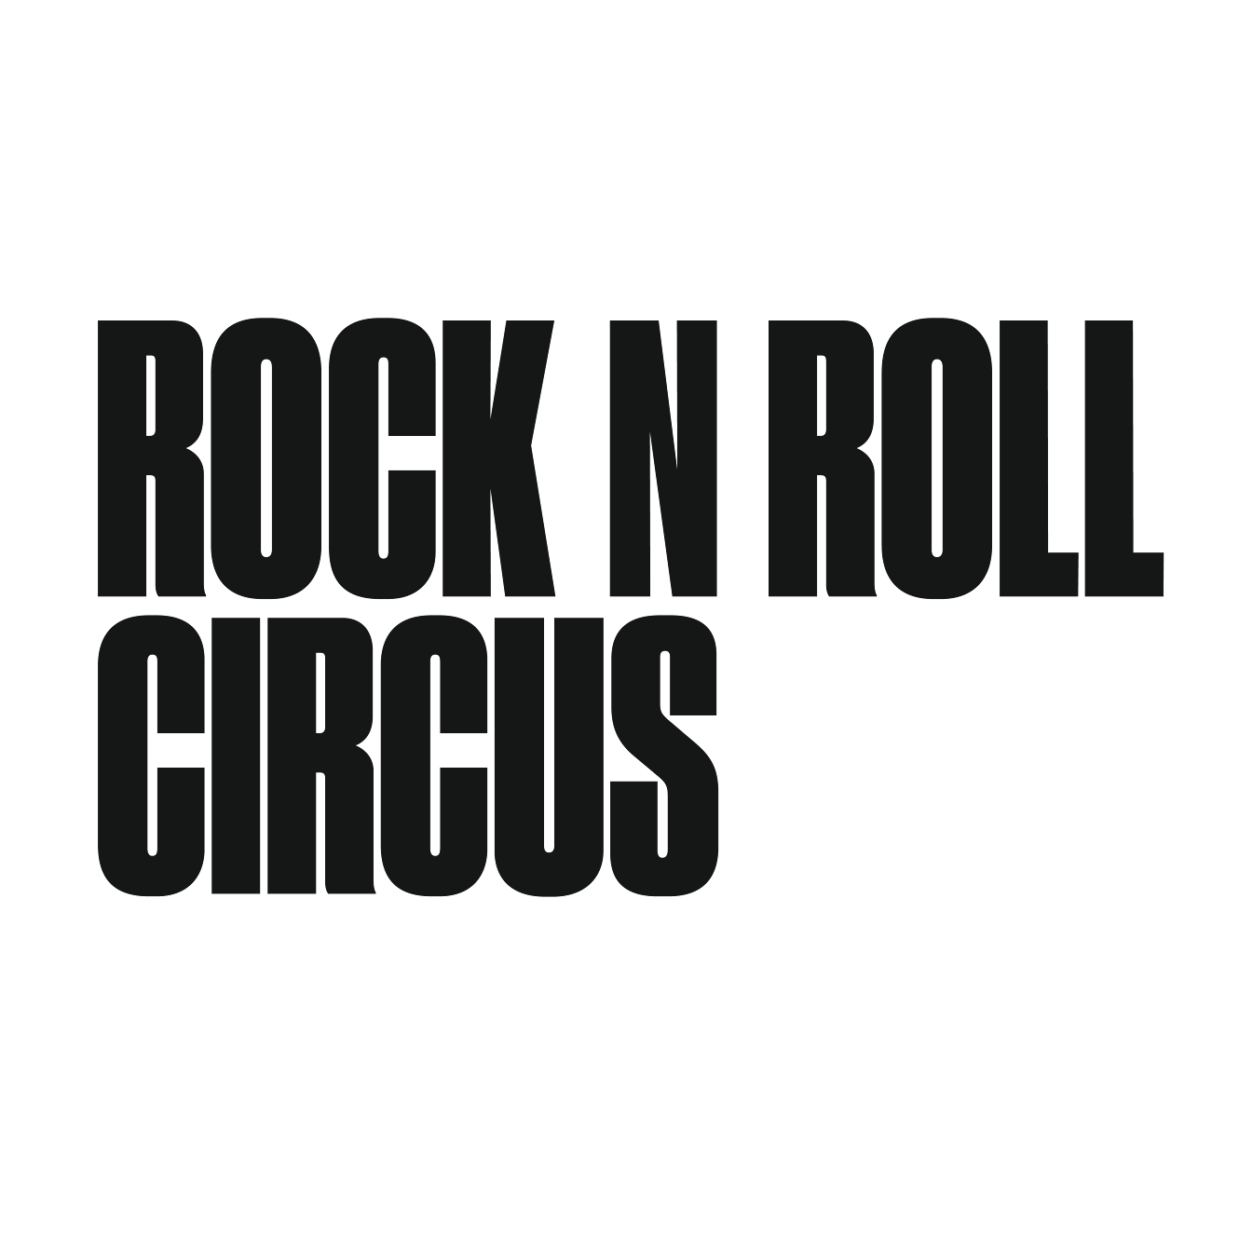

Friday 21st - Sunday 23rd August 2026
Earlham Park, Norwich

UNDER EMBARGO UNTIL 4PM MONDAY 17TH NOVEMBER

THE KOOKS WITH THE VACCINES & THE FRATELLIS ANNOUNCED FOR ROCK N ROLL CIRCUS NORWICH 2026

THREE ICONIC ALBUMS

SATURDAY 22ND AUGUST

Rock N Roll Circus has revealed the next major announcement for its return to Earlham Park, Norwich from Friday 21 - Sunday 23 August 2026, confirming a huge bill for Saturday 22nd August.
In a one-off celebration of three generation-defining records, The Kooks, The Vaccines and The Fratellis will each perform one of their seminal albums under the Big Top.

Brighton favourites The Kooks will headline the Saturday night, performing their platinum-selling debut album Inside In / Inside Out. The album catapulted the band into fame, selling more than 2 million copies and helping define an era of music. Two decades since their debut, The Kooks are resonating with a whole new generation. With sold-out tours and epic returns to festival main stages, the band has firmly cemented their place in the hearts of Gen Z fans. The album includes enduring anthems She Moves in Her Own Way, Ooh La and Naïve, and remains a staple part of indie culture more than 15 years after its release.

Joining them are London heroes The Vaccines, who will perform their explosive debut What Did You Expect From The Vaccines? in its entirety. Released in 2011 and containing breakout hits If You Wanna, Post Break-Up Sex and Nørgaard, the album became one of the fastest-selling debuts of the decade and helped define a new wave of British indie energy.

Completing the trio are Scottish icons The Fratellis, performing their beloved debut Costello Music from start to finish. The album launched the band onto the global stage with hits including Chelsea Dagger, Henrietta and Whistle For The Choir, earning the group a BRIT Award and setting the tone for one of the most recognisable sounds of the era.

The Saturday line-up marks another major moment for Rock N Roll Circus’ return to Norwich in 2026, following last year’s hugely successful debut which saw thousands head to Earlham Park for headline performances from McFly, Courteeners and Olly Murs, alongside acrobats, fire shows, circus performers and an immersive festival atmosphere that captivated the city.

Festival Director Ali O’Reilly said: “Norwich wanted the circus back - and we’ve listened. After the incredible response to last year’s debut, we wanted to create something truly special for the 2026 edition. A full day of iconic albums performed by three huge British bands is exactly that with lots more artists still to be announced. These are records that defined entire eras for so many people, it is set to be a special Saturday!

Rock N Roll Circus offers far more than a standard festival experience. Alongside its headline artists, the weekend will once again feature a full programme of circus performers, aerialists, fire shows, workshops and a dedicated food and drink village. With the entire main stage housed inside the Big Top, performances are intimate, atmospheric and weather-proof.

With The Streets already announced as Friday’s headliners, and Madness on Sunday, Saturday’s Kooks announcement will be a must see for indie fans. Yet more amazing acts and stage announcements will be confirmed soon.

Ticket Information
Presale opens Wednesday 19th November 2025 at 10am BST
General sale from Friday 21st November 2025 at 10am BST
Venue: Earlham Park, Norwich
Tickets & info: www.rocknrollcircus.co.uk/norwich


-Ends-

