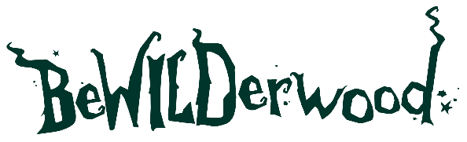

PRESS RELEASE
BeWILDerwood Reopens with
Buy One Get One Free tickets!

Sent by BeWILDerwood
8th January 2026

BeWILDerwood Reopens with Buy One Get One Free tickets!

BeWILDerwood reopens this February and is inviting families to shake off the winter blues, get outdoors and enjoy some screen-free imaginative play and storytelling - with its popular Buy One Get One Free offer returning for a limited time.
From the 14th to 22nd February 2026, visitors to both BeWILDerwood Cheshire and BeWILDerwood Norfolk can enjoy a full day of adventure for less, with one free ticket when purchasing another paid ticket*.
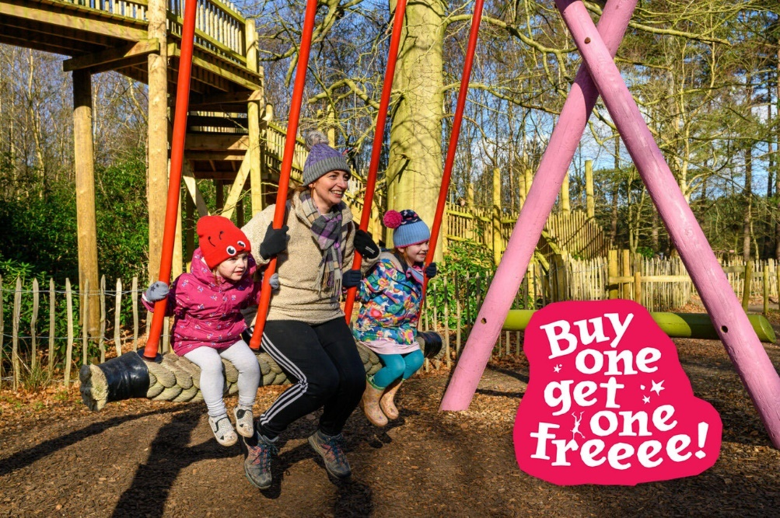

Perfect for families looking for something different to do to entertain all ages, whilst saving a few pennies! BeWILDerwood is based on children’s books and offers a unique outdoor experience where children and grownups are encouraged to immerse themselves in the story and world of BeWILDerwood. Meet the characters, climb, explore and get lost in the enchanted woods.
The Buy One Get One Free offer is available for visits between 14th - 22nd February 2026 and applies to Almost WILD tickets (92–102cm), BeWILD Now tickets (105cm and over) and Still WILD tickets (65 years and over). Tickets can be booked online in advance, where the offer is automatically applied at checkout, or purchased on arrival, subject to availability.
BeWILDerwood members can also take advantage of the offer, with one free ticket per membership, by bringing their membership card along on the day of their visit.
With both parks reopening especially for February half term, BeWILDerwood offers a refreshing alternative to indoor attractions, encouraging families to wrap up warm, get outdoors and enjoy time together in the woods away from their digital devices because let’s face it we all feel better after some fresh air!
Last year BeWILDerwood saw a sellout February, so they encourage visitors to book early if you want to make the most of this fantastic offer. Get your tickets today: https://shorturl.at/amhLw

*T&Cs apply:
February Half Term 2026 – Buy One Get One Free
1 free ticket when purchasing another paid ticket, cheapest ticket free. Valid when visiting BeWILDerwood Cheshire or BeWILDerwood Norfolk between 14th-22nd February 2026 only.
Tickets can be booked online in advance (offer automatically applied at checkout) or purchased on arrival (subject to availability).
The paying ticket can be an Almost WILD ticket (92-102cm), BeWILD Now ticket (105cm and over) or a Still WILD ticket (65 years and over).
Members can also claim this offer. Be sure to bring your Membership with you on the day you wish to visit. Please note, 1 free ticket per membership only.
Tickets are not transferable to another date and paid tickets are non-refundable. Cannot be used with any other offer or discounted ticket.
Valid for BeWILDerwood Cheshire and BeWILDerwood Norfolk.

ENDS.

Editor Notes:

About BeWILDerwood:
The award-winning attraction aims to encourage even more children and their families to enjoy traditional, imaginative, and healthy outdoor play.
The attraction is based on the book series by author and creator Tom Blofeld, with hints of his magical stories and curious characters throughout the forest.

BeWILDerwood opened its first park in May 2007, on the outskirts of the Broadland village of Hoveton, Norfolk. BeWILDerwood Norfolk is one of the most successful visitor attractions in the East of England.

April 2021 saw the grand opening of BeWILDerwood’s second park in Cheshire. Since opening BeWILDerwood Cheshire has seen huge demand and rave reviews. Both parks are beautifully designed to be in keeping with their natural surroundings, encouraging outdoor, nostalgic play and allowing families to play and create memories together.

Opening Date and Times:
BeWILDerwood reopens on 14th February. See website for seasonal opening dates: https://bewilderwood.co.uk/plan-your-visit/opening-times-and-prices

BeWILDerwood Cheshire:
BeWILDerwood Cheshire
Bickley Moss
Cheshire
SY13 4JF
Email: cheshire@bewilderwood.co.uk
BeWILDerwood Norfolk:
BeWILDerwood Norfolk
Horning Rd
Hoveton
Norwich
NR12 8JW
Email: norfolk@bewilderwood.co.uk

Website: https://bewilderwood.co.uk/

Press pack including an image gallery and logo.

For all press enquiries and exclusive interviews with Creator and Author Tom Blofeld please contact:

Lydia Downey, Head of Marketing and Media BeWILDerwood
lydia@bewilderwood.co.uk
01829 830730

