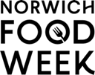

Press Release
22 January 2026

Join the Inaugural Norwich Food Week
Ten Days of Flavour, Creativity and Discovery
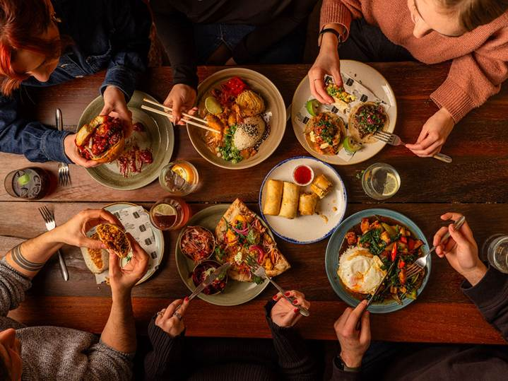
Norwich’s vibrant food scene takes centre stage next month with the launch of Norwich Food Week; a brand-new, city-wide celebration of the talent, ambition and diversity that defines local hospitality.
In 2026, luxury isn’t about white tablecloths or price tags - it’s about time together, discovering somewhere new, and enjoying great food without guilt. Norwich Food Week taps directly into this cultural shift, positioning the city as a place where everyday indulgence is accessible, social, and rooted in local creativity.
Organised by Norwich Business Improvement District (BID), the 10-day event will run from 27 February to 8 March, bringing together more than 40 restaurants, cafés, bars and venues to showcase some of the best food Norwich has to offer.
With specially created menus and offers priced between £5 and £35, Norwich Food Week invites residents and visitors alike to explore the city’s culinary landscape, try somewhere new, and enjoy high-quality food without needing a special occasion to celebrate - from authentic Italian pizza and relaxed neighbourhood favourites to refined plates from award-winning kitchens.

A City that Knows How to Eat Well
Norwich Food Week becomes the third food-and-drink-focused event delivered by Norwich BID, joining the hugely popular Norwich Wine Week (June) and Norwich Cocktail Week (September/October). Together, the trio reflects a city confidently celebrating its food culture and inviting people to discover it in new ways.
Designed to encourage exploration and support local hospitality, Norwich Food Week will feature exclusive menus, discounts and one-off experiences at venues including Benedicts, Grosvenor Fish Bar, Saporita, The Last Wine Bar & Restaurant, The Maids Head Hotel, The Bodega, Tallow, and Slice + Dice, among many others.
Whether it’s a midweek treat, a family meal or a long-overdue night out with friends, Norwich Food Week offers plenty of reasons to try somewhere new - or fall back in love with a favourite.
Richard Bainbridge, Owner and Chef Patron, Benedicts, said: "Norwich really is a foodie city, with an exceptional depth and diversity of culinary talent here. Norwich Food Week gives us the chance to come together and celebrate that, and for diners to explore new flavours and experiences at a range of different venues."
Stefan Gurney, Executive Director, Norwich Business Improvement District (BID), said: “Norwich Food Week is about celebrating what makes our city special. By bringing food venues together in a shared moment, we’re supporting creativity, driving footfall and reinforcing Norwich’s reputation as a destination for eating very well.”

One App. Three Food and Drink Weeks
Norwich Food Week is supported by the free Norwich Food & Drink Weeks app, which brings Food Week, Wine Week and Cocktail Week together in one place.
Through the app, users can:
- Browse participating venues and offers
- Discover new places to eat and drink
- Unlock exclusive discounts
- Collect digital stamps and enter prize draws
During Norwich Food Week, diners who collect three digital stamps by visiting participating venues can enter a prize draw to win a range of Food Week rewards.
How It Works
- Download the Norwich Food & Drink Weeks app via the Apple App Store or Google Play
- Browse Food Week offers and book ahead where required
- Check in at participating venues to redeem offers
- Collect three stamps between 27 February and 8 March to enter the prize draw

Find out more:
Website: https://norwichfoodweek.co.uk/
Instagram: https://www.instagram.com/norwichfoodweek/

<ends>
Notes to Editors:

For interviews please contact:
Mel March, senior PR & marketing manager, Norwich BID mel.march@norwichbid.co.uk
High resolution images: https://show.pics.io/food-week-2026-pr-selection
Website / Social Links:
https://norwichfoodweek.co.uk/ | https://www.instagram.com/norwichfoodweek/
About Norwich BID
Established in November 2012, Norwich BID is run for local businesses by local businesses. The BID covers a defined area of Norwich where businesses plan how to improve their trading environment, identifying additional projects and services that develop the city centre and trade. Investment in the BID area aims to enhance and promote the local environment for businesses, employees, customers and tourists. The overarching vision is to make a clear positive impact on the vitality of our city centre and the success of the businesses within it.

