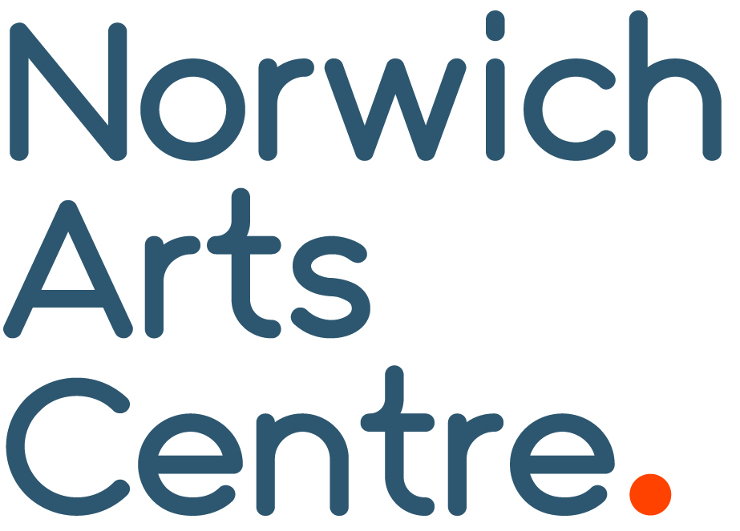

Norwich venue celebrates Independent Venue Week
Contemporary award-winning venue Norwich Arts Centre is gearing up to celebrate Independent Venue Week (IVW), the UK’s annual 7-day celebration of independent music & arts venues and the people that own, run and work in them.
From 26 January-1 February hundreds of venues across the UK celebrate live music with a series of independent music events.
“These venues, all local businesses, are the backbone of the live music scene and Independent Venue Week recognises all that they have done to create some of the most memorable nights of the past so they can continue to do the same in the future.”
Sybil Bell CEO and Founder of IVW
Internationally recognised and nestled in Norwich’s cultural and independent community, award-winning Norwich Arts Centre is a contemporary multi-arts venue. Since 1980, NAC has delivered an alternative programme of new music, theatre, comedy, live art and dance.
“We love being a part of this national event with hundreds of other independent venues that share our passion for championing new music and performers. It’s so important right now to keep local venues thriving! We’re here to take risks, to support new artists and musicians, provide you with new, exciting experiences and give a home to scenes outside of the mainstream. So go and take a punt at something. You’re unlikely to be disappointed. Tell your friends how amazing your local venue is and encourage them to go because independent venues are for everyone!” Norwich Arts Centre

Norwich Arts Centre kick start IVW 2026 on Tuesday 27 January with British singer, songwriter and composer A.A.Williams known for dark, atmospheric music that blends post-rock, gothic, and alternative influences. On Wednesday 28 January they present a double headline show, a night of alt-jazz infused rhythms with drummer 6161 and percussionist Jesse Barrett (ex-Mammal Hands) and multi-instrumentalist Pete Beardsworth join forces to create multi layered ambient music that blur the lines between ancient and modern.
On Thursday 29 January Halifax band The Orielles take to the stage, blending bold dreamy soundscapes with jangly guitar pop and danceable rhythms. They finish with Isle of White duo The Pill on Friday 30 January who turn chaos, satire and raw energy into riotous anthems.

Visit the Norwich Arts Centre website for full details and tickets norwichartscentre.co.uk

END

NAC Contacts:
Kelly Robb and Grace Jackson Marketing & Communication Managers
E-mail: kelly@norwichartscentre.co.uk | grace@norwichartscentre.co.uk

St. Benedict’s Street  Norwich NR2 4PG  www.norwichartscentre.co.uk | Box Office + 44 (0)1603 660352  Admin. + 44 (0)1603 660387  Fax. + 44 (0)1603 664806 | Norwich Arts Centre is a company limited by guarantee with charitable status  Reg. No. 1329092 VAT Reg. No. 720 3835 58 Charity No. 274803

