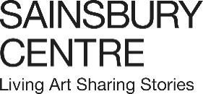

Press release
24 October 2025

Sainsbury Centre announces its 2026 programme, including two new seasons of exhibitions: What is the Meaning of Life? and How Do We Find Love?

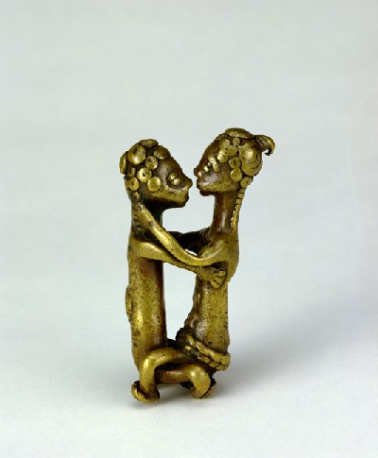
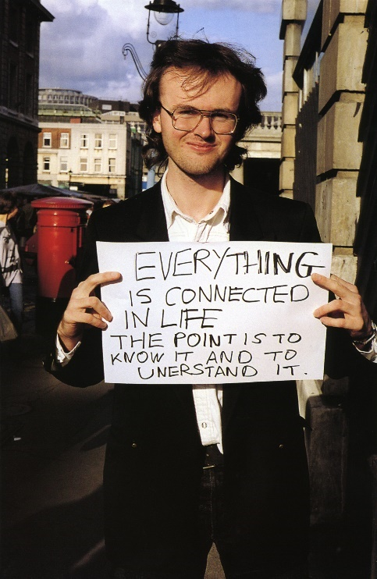

In 2026, the Sainsbury Centre continues its innovative series of investigative exhibitions engaging with fundamental questions of life with two new seasons. What is the Meaning of Life?, launching in May, delves into the fundamental questions of human existence, from rule-making, to time and play; and How Do We Find Love?, opening in November, explores the profound complexities of human relationships, desire, and intimacy.

What is the Meaning of Life?
16 May 2026

Featured exhibitions:
- Living by the Rule: Contemporary meets Medieval, an exhibition which compares contemporary artworks with historical artefacts such as the Hatton Codex and the Eadwine Psalter, one of the earliest architectural plans in Europe.
- An exhibition exploring the concept of play in human cultures, featuring works by artists including André Breton, Eileen Agar, John Armstrong, Leo Robinson, Sir John Lavery and Lygia Clark.
Living by the Rule: Contemporary meets Medieval
16 May – 4 October 2026

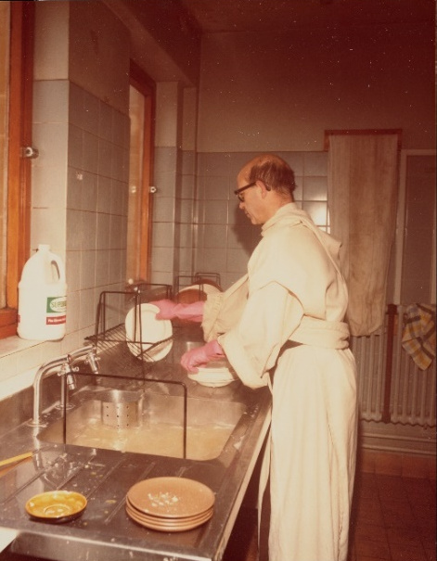
Exploring the idea of routine and regulation, this exhibition reflects on the ‘rules’ that we live by today. Taking as its starting point the Rule of St Benedict, written in the 6th century, as a paradigmatic example of a guide for communal living, it brings together extraordinary objects from medieval monastic contexts – the Hatton Codex, the earliest copy of the Rule of St Benedict in the world, made in c. 700 AD; the Etheldreda Panels – one of only a handful of English medieval paintings to have survived the Reformation; and the Ormesby and Macclesfield psalters, the most important illuminated manuscripts of the 14th century – with contemporary works by artists including Andrea Büttner, Tacita Dean, Ingrid Pollard, Elizabeth Price and Lucy Skaer.

The exhibition vividly presents the richness and complexity of the dialogue between medieval experiments in a different way to live, and modern reflections upon how life is (and might yet be) organised.

Living by the Rule: Contemporary meets Medieval is curated by Dr Jessica Barker FSA, Senior Lecturer in Medieval Art History at The Courtauld and Dr Ed Krčma, Associate Professor of Art History at the University of East Anglia.

Play Power
16 May – 4 October 2026

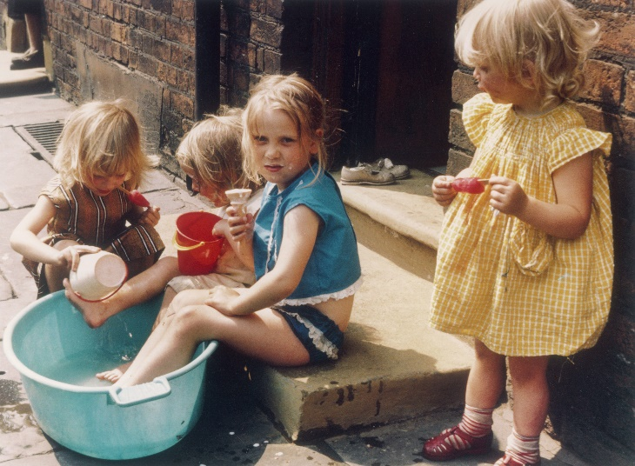
Exploring the concept of play in human cultures, this exhibition reflects on the broader significance of play and how play is integrated into our daily lives and asks whether we would live a more meaningful life if play were a central focus of day-to-day living.

Showcasing a variety of manifestations of play, both past and present, ranging from board games, games of chance, physical activity, creativity, video games and make believe, as well as ritual gambling and divination, the exhibition highlights the enduring role of play in shaping human societies.

It includes historical objects and artworks such as an ancient Egyptian senet board and game pieces, William Hogarth’s paintings A House of Cards (c.1730) and A Children’s Tea Party (1730), Germaine Richier’s Chessboard, Large Version (1959) and iconic toys, such as Bird and Fish, designed by Patrick Rylands. Work by artists including André Breton, Eileen Agar, John Armstrong, Leo Robinson, Sir John Lavery and Lygia Clark is also on display.

Play Power is curated by Tania Moore, Head of Exhibitions at the Sainsbury Centre.

Joy Like Time
20 June – 15 November 2026

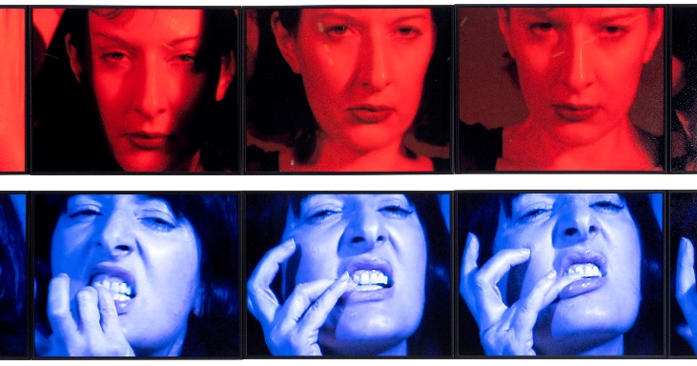
This exhibition explores how memory, ritual and renewal intersect through the work of internationally renowned artists. Featuring works by Marina Abramović, Kalliopi Lemos and Gillian Wearing.

Tracking the careers of a select group of artists in depth, this exhibition looks at how they have found life’s meaning through their practice via craft and repetition and asks, if duration marks everything from commutes to lifespans, from harvests to histories, might it also help us confront one of humanity’s most enduring questions: what is the meaning of life?

Joy Like Time is curated by John Kenneth Paranada, Curator of Art and Climate Change at the Sainsbury Centre.

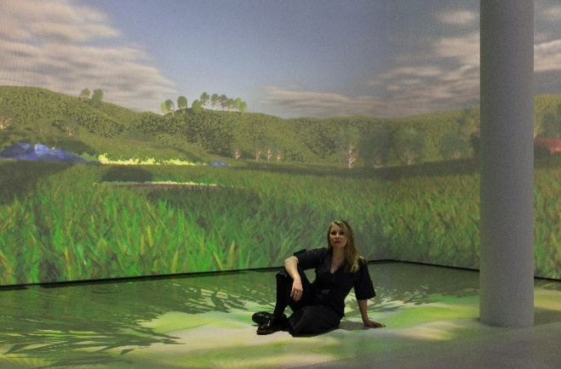
The What is the Meaning of Life? season also includes two newly commissioned artworks presented in the museum: Life in the Multiverse: Libby Heaney, a participatory digital installation using quantum computing; and CATKINS FOREVER: Ruth Ewan, which sees the artist working with people across Norfolk to unearth their personal stories relating to plants and trees. For more information on all projects in What is the Meaning of Life?, visit the Sainsbury Centre website.

How Do We Find Love?
14 November 2026

Featured exhibitions:
- Love Stories, a photography exhibition capturing the raw reality of everyday intimacy and relational dynamics.
- The Last Human Kiss, an exhibition which traces visual depictions of kissing from pre-history to its mediated, digital and post-human forms in the 21st century.
- An exhibition about how love is formed, broken and remembered through concepts of myth and ritual. Bringing together contemporary artworks with objects from the Sainsbury Centre’s collection, exploring desire, ecstasy, memory, and the traces that remain in love’s aftermath. Featuring works by Francis Bacon, Penny Goring, Jonathan Baldock, Penny Slinger, Maya Weishof, and Holly Stevenson's Love Bomb installation.

The Last Human Kiss
14 November 2026 – 11 April 2027

Tracing the visual history of kissing across 10,000 years, from prehistory to its digital expressions in the 21st century, this exhibition explores the kiss as a universal language through which desire, power, vulnerability and transcendence have been expressed and contested for millennia. At once scholarly and sensorial, The Last Human Kiss reimagines the kiss as one of humanity’s most enduring gestures: intimate and unruly, sacred and subversive.

The exhibition unfolds across five chapters: ‘The First Kiss’ contains some of the earliest known depictions of the kiss; ‘The Divine Kiss’ explores the Renaissance fascination with love’s power to disrupt; in ‘The Social Kiss’ intimacy takes the form of kinship; ‘The Romantic Kiss’ explores desire’s euphoric charge, while ‘The Trickster Kiss’ brings us to the present, where kissing takes on mediated, digital, and post-human forms, at once everywhere and strangely absent.

The Last Human Kiss is curated John Kenneth Paranada, Curator of Art and Climate Change at the Sainsbury Centre.

Ecstasy and the Aftermath
14 November 2026 – 11 April 2027

Love has long been imagined in terms of union and rupture, or transformation and longing – reflected in mythology, alchemy and contemporary rituals. Ecstasy and the Aftermath reconsiders love beyond romantic clichés, exploring it through the lens of kinship and mourning, and as a strategy of survival and act of resistance.

The exhibition brings together artists who engage with global histories, queer ecologies, and feminist politics. Structured as a series of ‘ritual chambers,’ the exhibition explores desire, ecstasy and the traces that remain in love’s aftermath. Timed for the winter season, where natural cycles of loss, fertility and renewal echo love’s own, this exhibition explores love as both a wounding and a world-building force.

Ecstasy and the Aftermath is curated by guest curator Huma Kabakci, in collaboration with Vanessa Tothill, Curator of Transhistorical Narratives at the Sainsbury Centre.

Love Stories
19 December 2026 – 30 May 2027

Love Stories will present series of photographs by a select group of photographers who use duration to capture the raw reality of everyday intimacy – exploding the idealised notions of love prevalent in popular culture and revealing instead the complex mix of mundane, humorous, painful and joyful emotions at the heart of human relationships. Playful, honest, poetic or sardonic, these photographic works draw attention to the subtly shifting dynamics involved in loving and being loved, whether romantic, familial or platonic.

Love Stories is curated by Tafadzwa Makwabarara, Curator of Cultural Empowerment at the Sainsbury Centre.

-END-

NOTES TO EDITORS

For more information, interviews and images:

DOWNLOAD HIGH RESOLUTION IMAGES HERE

Kate Wolstenholme
PR and Media Officer at the Sainsbury Centre
k.wolstenholme@uea.ac.uk
01603 592470

Image captions:
- Gillian Wearing, Signs that say what you want them to say and not Signs that say what someone else wants you to say EVERYTHING IS CONNECTED IN LIFE THE POINT IS TO KNOW IT AND TO UNDERSTAND IT, 1992 – 3, c-type print on aluminium © Gillian Wearing, courtesy Maureen Paley, London
- Goldweight representing human couple, c.1700 – 1899, brass, Africa, Ghana. Donated by Robert and Lisa Sainsbury, 1973 © Sainsbury Centre
- Anonymous, Photograph of Dom Sylvester Houédard standing in his cream robes washing up at a sink, undated. 16.2 x 12.6 cm. Image courtesy of Dom Sylvester Houédard Archive, John Rylands Research Institute and Library, University of Manchester. © Prinknash Abbey Trustees
- Shirley Baker, Four girls playing on pavement in Hulme, Manchester, 1965. Estate of Shirley Baker/Mary Evans Picture Library
- Marina Abramović, Red Period, Blue Period, 1998, single channel video
- 1998. © Marina Abramović. Courtesy of the Marina Abramović Archives
- Libby Heaney with work Ent-, 2022. Photo: Andrea Rossetti

Opening times
Tuesday – Friday 9am-6pm (exhibitions open 9.30am)
Saturday – Sunday 10am-5pm
Closed Mondays, including bank holidays

Entry
Tickets operate on a ‘Pay Only If and What You Want’ basis, so you can choose the price from free through to full membership. A Universal Ticket grants access to the permanent collection, Lower and Mezzanine Galleries, and Sculpture Park.

The Sainsbury Centre is a world-class art museum with a unique perspective on how art can foster cultural dialogue and exchange. Following a radical relaunch in 2023 the Sainsbury Centre formally recognises the living lifeforce of art, enabling people to build relationships across an arts landscape.

The art of the Sainsbury Centre can help reframe and answer the most important questions people have in their lives. It is not a museum to only learn more about artists, cultures or movements like Francis Bacon, the Tang Dynasty or Modernism, it is a place of experience, where collections are animate, and visitors are emotionally connected.

One of the first museums in the world to display art from all around the globe and from all time periods equally and collectively, Sir Robert and Lady Lisa Sainsbury created one of the most sought after yet non-conformist art collections. In 1973 they donated their collection, which transcended traditional barriers between art, architecture, archaeology and anthropology, to the University of East Anglia, and created an entirely new type of museum. Housed in Sir Norman Foster’s revolutionary first ever public building, the space aimed for an interactive relationship between people, object and landscape, where art was placed within an open yet intimate ‘living area’.

Visit sainsburycentre.ac.uk and follow @sainsburycentre on Facebook, X, Instagram, TikTok and LinkedIn, as well as @TheSainsburyCentre on YouTube.

