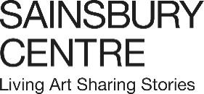

Press release

Living by the Rule: Contemporary meets Medieval

A bold transhistorical exhibition exploring the rules that structure our everyday lives, launching as part of the Sainsbury Centre’s new season, which delves into the fundamental question, What is the Meaning of Life?

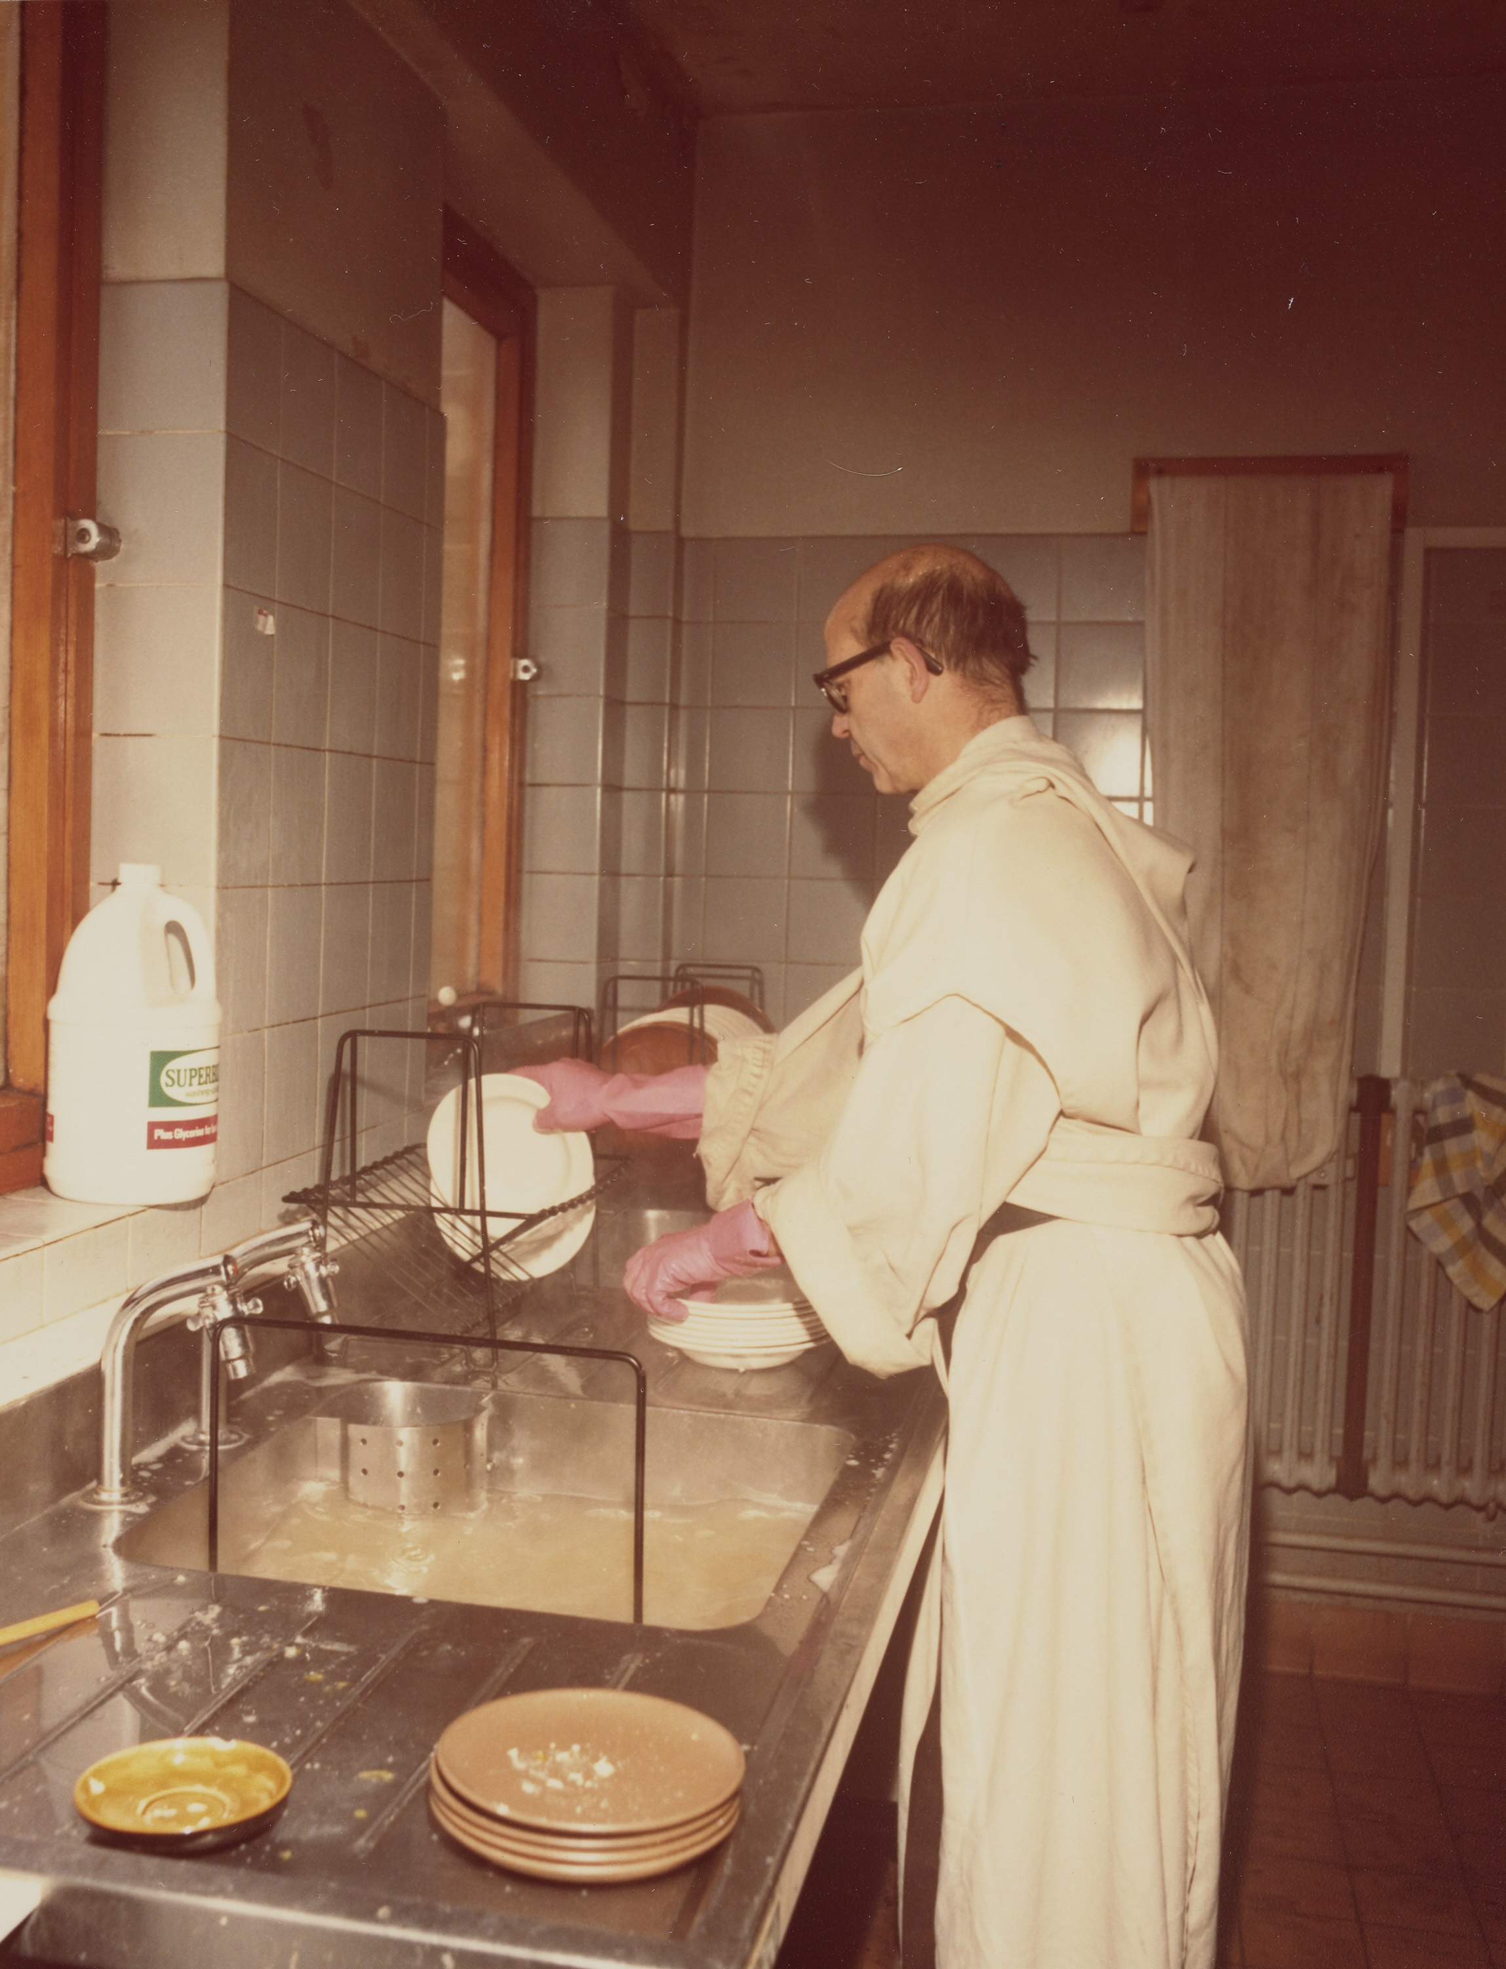

Anonymous, Photograph of Dom Sylvester Houédard standing in his cream robes washing up at a sink, circa early 1970s. 16.2 x 12.6 cm. Image courtesy of Dom Sylvester Houédard Archive, John Rylands Research Institute and Library, University of Manchester. © Prinknash Abbey Trustees

16 May – 4 October 2026
Sainsbury Centre, Norwich

Living by the Rule: Contemporary meets Medieval brings together contemporary artworks by artists including Ingrid Pollard, Tacita Dean, Andrea Büttner and Danh Vo, as well as new works on display for the first time by artists Elizabeth Price, Susan Morris, and Alison Turnbull, with extraordinary objects from medieval monastic contexts, presenting a rich dialogue between medieval rules for living, and modern reflections on how life is, and might yet be, organised.

The exhibition places contemporary conditions in dialogue with the Rule of St Benedict, written in 6th century Italy. Benedict’s Rule offered a framework for a radically different kind of life, explicitly set apart from the social hierarchies and economic imperatives of the wider world. Benedict’s rules were pragmatic rather than ideological: who should be served their dinner first, how to make sure everyone wakes up on time for night prayers, when to schedule toilet breaks. The Rule is preoccupied with all the gritty detail of everyday routines because these habitual and creaturely concerns were fundamental to the smooth running of a community – and Benedict believed that, if a community functioned well, it made space for its members to engage with the meaning of life beyond the everyday; or in his words, they could now “set out for loftier summits”.

Historical objects on display include some of the most important Benedictine objects in the world, such as the Hatton Codex, the oldest surviving copy of the Rule of St. Benedict, made in c. 700 AD, and the Eadwine Psalter, one of the earliest architectural plans in Europe. There are also artworks that depict female monastic leaders in the Middle Ages, such the extraordinary Etheldreda Panels – one of only a handful of English medieval paintings to have survived the Reformation. These will be shown alongside works that speak to the unruliness of medieval monasteries, such the Ormesby and Macclesfield Psalters, some of the most important illuminated manuscripts of 14th century England, which surround prayer-texts with ‘marginalia’ of wrestling, defecating, monstrous figures. Other objects associated with rule-breaking include the Godstow ring, which may have been given to a nun by her illicit lover.

Living by the Rule: Contemporary meets Medieval brings these extraordinary objects together with major works by lauded contemporary artists who, in their different ways, vividly explore the role of rules, and cultural and religious attitudes towards rules, in contemporary life and art.

Contemporary works on display for the first time include Disco Vestments, a new series of hand-tinted pinhole photographs recalling nun’s habits, by Elizabeth Price; the full series of Concordances by Susan Morris, finally completed after 20 years of work; and exquisite new Exercises drawings by Alison Turnbull, made to be in dialogue with the Eadwine Psalter, with which they will be displayed. There will also be a new one-off performance by Kate Pickering relating to St Julian of Norwich and commissioned especially for the show.

Alongside these new works are existing pieces such as four large-scale woodcuts by Andrea Büttner; Elizabeth Price’s groundbreaking digital video and sound installation, THE WOOLWORTHS CHOIR OF 1979, for which she won the Turner Prize in 2012; an early Cell drawing by Lucy Skaer; visions of heaven by Tacita Dean; and a potent series of lenticular photographs by Ingrid Pollard. These works will be joined by important contributions from international artists such as Danh Vo and Samuel Levi Jones.

The exhibition also presents a range of cathedral treasures which have rarely, and in some cases never, been on public display, including beautifully-sculpted fragments from the monastic plumbing system in Canterbury (the most sophisticated since the Roman Empire), and canopies from the wooden seats for the monks at Ely, made by the royal carpenter William Hurley.

The Etheldreda Panels – which survived the Reformation only because they were re-used as cupboard doors in a cottage in Ely – have been newly conserved for the exhibition and will be on display for the first time outside of London. The Ormesby Psalter, Macclesfield Psalter and Stowe Breviary – all made in Norwich – will be exhibited for the first time as a group, in what marks their first return to the city since the Reformation. On public display for the first time in the UK is the San Zeno Wheel – a unique fifteenth-century timekeeping device from a monastery in Italy.

In line with the Sainsbury Centre’s Living Art approach and as one the first museums in the world to display art from all time periods equally and collectively, the exhibition looks beyond a chronological model of art history, finding unexpected resonances between recent works and much earlier objects and texts. Although the medieval monastery is far removed from our contemporary situation, there remains something wild and even scandalous about the attempt to imagine and live out a different form of life, one that flies in the face of shared habits, assumptions, and priorities. This unique exhibition vividly stages an encounter between medieval and contemporary art to pose the questions: what rules do we live by today, and how might we imagine a different way of life?

Curators of the show, Dr Jessica Barker FSA and Dr Ed Krčma, said: "We are excited to bring together such extraordinary objects from the Middle Ages and works from some of the most important artists working today. We hope that this strange collision between two very different worlds will open up new perspectives on how we live now, and fresh ideas about how we might craft more balanced and meaningful lives in the future."

Director of the Sainsbury Centre, Jago Cooper, said: “The artworks brought together in this wonderful exhibition make us question the rules by which we often live so blindly. If we challenge the rules, can we find new meaning in our lives?”

Living by the Rule: Contemporary meets Medieval is curated by Dr Jessica Barker FSA, Senior Lecturer in Medieval Art History at The Courtauld and Dr Ed Krčma, Associate Professor of Art History at the University of East Anglia.

Exploring the routines by which we live our lives, and whether that offers meaning, the exhibition is part of the Sainsbury Centre’s latest series of innovative exhibitions exploring the fundamental question, What is the Meaning of Life?. The season also includes the exhibitions Play Power, launching 16 May, and Joy Like Time, opening 20 June and two new commissions: Life in the Multiverse: Libby Heaney, a participatory digital installation using quantum computing; and CATKINS FOREVER: Ruth Ewan, which sees the artist working with people across Norfolk to unearth their personal stories relating to plants and trees.

The season explores how art can help us uncover what it means to be human, from how we structure our lives to how play and games can reinforce or subvert our societal expectations, to finding meaning through creativity or after loss. Art encompasses the universality of human experience allowing us to explore meaning from across time and space.
The exhibition is supported by The Ruddock Foundation for the Arts, Pilgrim Trust, Sam Fogg, Paul Mellon Centre, Idlewild Trust, The Leche Trust, Barbara Whatmore Charitable Trust, Kress Foundation, International Centre for Medieval Art, The Worshipful Company of Clockmakers, and those who wish to remain anonymous.

NOTES TO EDITORS
HIGH RESOLUTION IMAGES FOR MEDIA USE CAN BE DOWNLOADED HERE
For more information, interviews and images:
Kate Wolstenholme
PR and Media Officer at the Sainsbury Centre
k.wolstenholme@uea.ac.uk
01603 592470

Exhibition details
Living by the Rule: Contemporary meets Medieval
16 May – 4 October 2026
Sainsbury Centre, University of East Anglia,
Norfolk Road,
Norwich NR4 7TJ

The Sainsbury Centre continues its innovative series of investigative exhibitions in 2026 with a new programme that examines the fundamental questions of human existence, from rule-making, to time and play.

Five concurrent exhibitions and interventions ask What is the Meaning of Life?, featuring:

- Living by the Rule: Contemporary meets Medieval, 16 May – 4 October 2026
- Play Power, 16 May – 4 October 2026
- Joy Like Time, 20 June – 15 November 2026
- Life in the Multiverse: Libby Heaney, 16 May – 4 October 2026
- CATKINS FOREVER: Ruth Ewan, 20 June – 15 November 2026

Opening times
Tuesday – Friday 9am–6pm (exhibitions open 9.30am)
Saturday – Sunday 10am–5pm
Closed Mondays, including bank holidays

Entry
Tickets operate on a Pay Only If and What You Can basis, so you can choose the price from free through to full membership. A Universal Ticket grants access to the permanent collection, Lower and Mezzanine Galleries, and Sculpture Park.

The Sainsbury Centre is a world-class art museum with a unique perspective on how art can foster cultural dialogue and exchange. Following a radical relaunch in 2023 the Sainsbury Centre formally recognises the living lifeforce of art, enabling people to build relationships across an arts landscape.

The art of the Sainsbury Centre can help reframe and answer the most important questions people have in their lives. It is not a museum to only learn more about artists, cultures or movements like Francis Bacon, the Tang Dynasty or Modernism, it is a place of experience, where collections are animate, and visitors are emotionally connected.

One of the first museums in the world to display art from all around the globe and from all time periods equally and collectively, Sir Robert and Lady Lisa Sainsbury created one of the most sought after yet non-conformist art collections. In 1973 they donated their collection, which transcended traditional barriers between art, architecture, archaeology and anthropology, to the University of East Anglia, and created an entirely new type of museum. Housed in Sir Norman Foster’s revolutionary first ever public building, the space aimed for an interactive relationship between people, object and landscape, where art was placed within an open yet intimate ‘living area’.

Visit sainsburycentre.ac.uk and follow @sainsburycentre on Facebook, X, Instagram, TikTok and LinkedIn, as well as @TheSainsburyCentre on YouTube.

