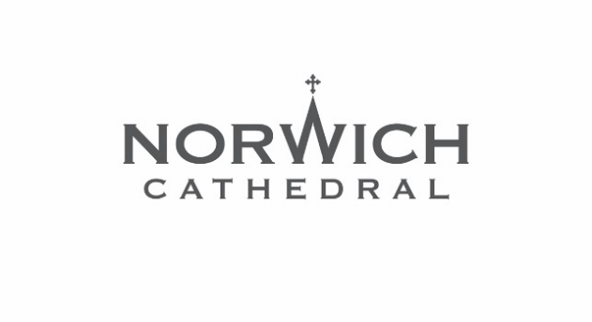
Press Release: For immediate release

Othello to take centre stage at
Norwich Cathedral’s summer Shakespeare Festival

One of Shakespeare’s most powerful and poignant plays will be performed in Norwich Cathedral’s Cloister this summer as Othello takes to the stage for this year’s Shakespeare Festival.

The Lord Chamberlain’s Men (TLCM) will perform the show on Friday 3 and Saturday 4 July 2026 at the annual open-air theatre event which is always a summer highlight at the Cathedral.

A story of deception, jealousy and a man that loved not wisely but too well, the tale of Othello is among the most captivating yet heartbreaking plays ever written.

See it performed how William Shakespeare first saw it, as The Lord Chamberlain’s Men – with a history stretching back to Shakespeare’s original company – present this play in the open air, with an all-male cast and Elizabethan costumes, music and dance.

Tickets cost £24 plus booking fee and are on sale now via the Norwich Cathedral website www.cathedral.org.uk/shakespeare

It is a welcome return for TLCM who last year wowed audiences at Norwich Cathedral with sold-out performances of Twelfth Night.

The Dean of Norwich, the Very Revd Dr Andrew Braddock, said: “We look forward to welcoming The Lord Chamberlain’s Men back to Norwich Cathedral’s Cloister for this year’s Shakespeare Festival.
“The Lord Chamberlain’s Men always put on an incredible show, and we cannot wait to see what is in store with this summer’s production of Othello.”

TLCM – this year in their 22nd year – have entertained audiences across the country and beyond, and at Norwich Cathedral they have previously performed Hamlet, Romeo and Juliet, As You Like It, The Comedy of Errors, Much Ado About Nothing, Twelfth Night, The Tempest, A Midsummer Night’s Dream and Macbeth.

For TLCM’s artistic director Peter Stickney, the Norwich Cathedral shows are a return to his roots as he grew up nearby in Saxlingham Nethergate, went to Long Stratton High and Hewett School, and first developed his love of theatre while acting in high school shows.

He said: “Bringing our performances to the glorious surroundings of Norwich Cathedral is always one of the highlights of the tour for me. Not only is the Cloister a fantastic place to enjoy our performances in, it is always special personally having grown up nearby.
“This year’s show is a real rollercoaster - the play is full of twists and turns and is compelling, horrifying and utterly electric. It is a sensational story and one you won’t want to miss.
“This is the first time that the company has presented Othello and, in my tenth year running the company, it is a fitting first and I am very excited to be tackling it.
“Our shows in Norwich always sell out and sell out quickly so, if you’re thinking about joining us, please don’t leave it to the last minute!”

The Lord Chamberlain’s Men will perform Othello in Norwich Cathedral’s Cloister on Friday 3 and Saturday 4 July 2026 at 7pm.

Tickets cost £24 plus booking fee. To book, visit www.cathedral.org.uk/shakespeare

Seating is provided but unreserved. On both nights, doors will open at 6pm for people to enjoy the beautiful surrounds of the Cloister before the show and Bread Source will be selling refreshments.
Notes to editors
For more information and to arrange interviews, please contact Norwich Cathedral’s marketing and communications manager Emma Knights via eknights@cathedral.org.uk or 07968 460963.

More details about the plot of Othello
Othello, the Moor of Venice, a respected General in the Venetian army, promotes the young Cassio to be his Lieutenant over Iago, a soldier in his service.

In doing so he unwittingly sparks Iago’s deep-seated hatred into terrifying life and sets in motion a horrendous spiral of vengeance and destruction that sweeps away everyone before it.

As Iago weaves his web and seeks his revenge he poisons Othello against Desdemona, who he has recently and secretly married, and turns the world upside down until Othello becomes unmoored from reality with devastating consequences.

