Thursday 19 March 2026
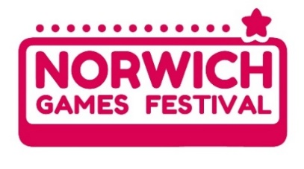
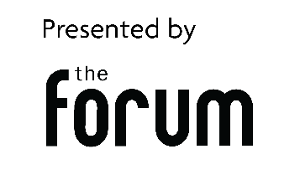
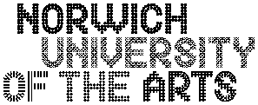

Norwich Games Festival Returns 23–30 May 2026 with Expanded Programme and New Interactive Experiences
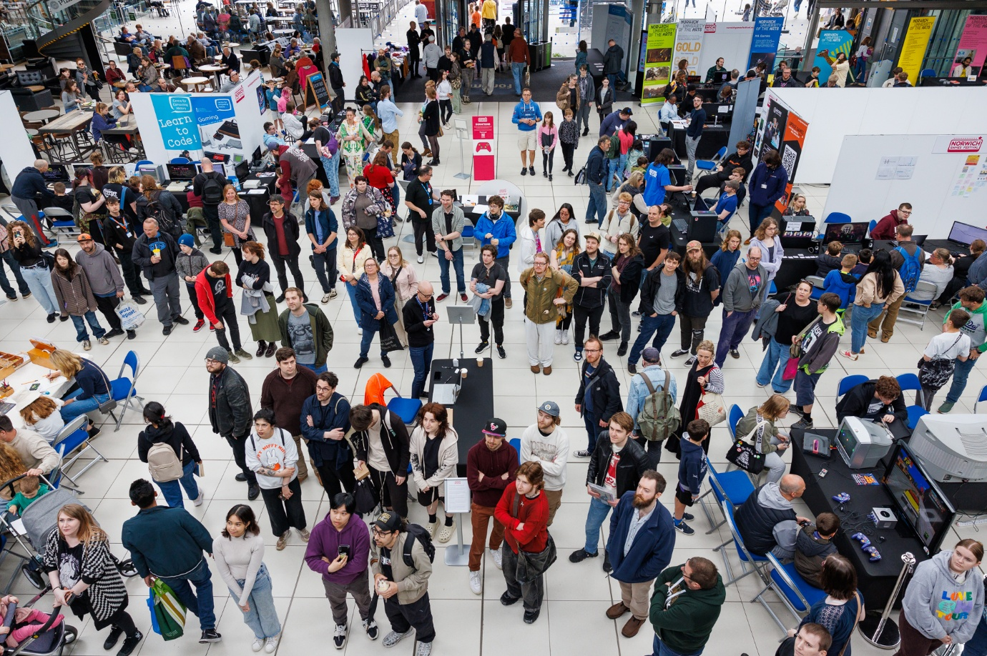
Photo: Norwich Games Festival at The Forum by Luke Witcomb
Norwich’s vibrant celebration of all things gaming is back from 23–30 May 2026, bringing a full week of interactive entertainment, industry insight, and hands-on creativity to the city. Presented by The Forum in partnership with Norwich University of the Arts, this year’s Norwich Games Festival (NGF26) showcases the very best of video games, computer games, tabletop and board games, as well as physical and retro gaming experiences.
The festival continues its mission to celebrate the creativity, innovation and talent within the games industry, offering visitors opportunities to play, learn, discover, and connect—whether they’re seasoned gamers, industry professionals, or complete beginners.
A Festival for Everyone
NGF26 promises something for all ages and interests. Attendees can dive into the retro arcade, try out exciting new indie titles, explore pathways into careers in games, or simply enjoy the fun, drop-in gaming experiences throughout the week.
The Forum will once again host The Arena, a lively hub filled with free interactive gaming for all ages—packed with fan favourites, new releases, and hidden gems ready for discovery.
Talks, workshops, and live shows will run throughout, covering everything from the basics of how to make a game to entertaining game-themed performances.
What’s New for NGF26
The full programme has now officially launched, and alongside festival staples such as The Game Cave, Game Jam, YouTuber and Comedian Ashens, The Big Quiz, and the popular indie developer and education zones, NGF26 introduces fresh programming designed to inspire and engage.
New additions for 2026 include:
- App development workshops
- Audio in games masterclasses
- Sessions on creating both digital and tabletop games
- Explorations of the psychological and emotional aspects of gaming, including themes such as how games help forge friendships and what Tamagotchis can teach us about loss…
A More Inclusive Festival Experience
For attendees with SEND-related access needs, NGF26 will host a Relaxed Day on Tuesday 26 May. During this day, the Festival will run at a controlled capacity to provide a calmer, more comfortable experience, supported by programmed SEND-focused events.
Bank Holiday Highlights
The festival kicks off with a competitive edge on 23–24 May, as the local and much-loved Albion Games Café hosts a special gaming tournament, the ‘Albion Arena’.
Bank Holiday Monday sees the return of the popular Trader and Collector Day, before the festival enters its main programme from 27–30 May.
A Region at the Heart of Games Innovation
Norwich and the wider East Anglia region continue to play a major role in shaping the UK’s games sector. Almost 6% of the UK’s digital games workforce is based here, supported by a thriving network of studios, creative businesses, and world-class educational institutions.
“East Anglia is buzzing with creativity and talent,” says Ellie Buchan, NGF Producer. “With so many games and tech businesses, strong university support, and a growing community of students and professionals, Norwich is the perfect place to host a festival that celebrates the industry’s impact. Norwich Games Festival is a chance to shine a spotlight on that energy, and to inspire the next generation of creators.”
Norwich Games Festival partners with Norwich University of the Arts to present unique opportunities to learn, discover, and get into the games industry. With incredible work on display from local developers, specially created workshops and talks, and opportunities to meet industry professionals, the Festival opens doors for everyone.
Meet Norwich University of the Arts students and lecturers throughout the week, and hear about how to develop careers in games, and how Norwich University of the Arts courses can expand horizons.
"Norwich Games Festival is such a vibrant part of the city's creative scene and has helped establish the artform of games as an important part of the wider cultural conversation.” says Dean Bowman, Senior Lecturer for Games Art and Design at Norwich University of the Arts. “Our students benefit hugely from being part of this creative discussion and always find the opportunity to show their work to the wider public really inspiring and informative. As an arts university it's so important not to get trapped inside the ivory towers of the institution and to share work with the whole city. So, we look forward to inviting everyone to check out the exciting work from our undergrad and Masters students again this year."
--ENDS--

Press & media enquiries:
Millie Batch, Events Marketing Producer at The Forum, Norwich millie.batch@theforumnorwich.co.uk // 01603 727937
Press images can be found here.

About Norwich Games Festival:
Presented by The Forum, alongside lead partner Norwich University of the Arts, Norwich Games Festival (NGF) offers a wide and varied programme of free and low-cost activities, for everyone to enjoy. NGF is a community event that celebrates the gaming industry, and the creativity and skills within the sector.
NGF showcases video and computer games, tabletop and board games and physical gaming. Primarily held at The Forum, but also at other local venues, there’s plenty for families to enjoy, as well as events for expert gamers, future creators, and competitive players 23-30 May 2026.
Norwich Games Festival is for everybody. Our inclusive and welcoming event celebrates games of all kinds and invites people of all ages to discover the creativity, art, and fun in games!
norwichgamesfestival.co.uk

About The Forum:
- The Forum is an iconic landmark in Norwich city centre.
- It’s a cultural hub for the city and county, providing fantastic free events year-round.
- It’s a public building, open seven days a week, throughout the year(except Christmas Day and Boxing Day).
- Everyone is welcome. Most of the public events, exhibitions and activities which take place at The Forum are free. Anyone can hire a space at The Forum to run their own event.
- The Forum presents and coordinates Norwich Science Festival, Norfolk Deaf Festival, Norfolk Heritage Open Days, and Norwich Book Festival.
- The Forum is an independent charity, managed by The Forum Trust. The Forum receives no regular funding, and is self-financing, with income used to put on our free programme of events and festivals, and reinvested in protecting the building for generations to come.
The Forum, Millennium Plain, Norwich, Norfolk, NR2 1TF
theforumnorwich.co.uk // 01603 727950

About Norwich University of the Arts:
Norwich University of the Arts is a dynamic, modern and creative university offering courses in art, design, fashion, media, and performing arts. With a diverse community of over 3000 students from 40 countries, we unite as a global community in Norwich - the City of Stories - to shape the future of creativity and arts education.
norwichuni.ac.uk

