

Press release

EMBARGOED UNTIL 00.01 ON FRIDAY, MARCH 20, 2026

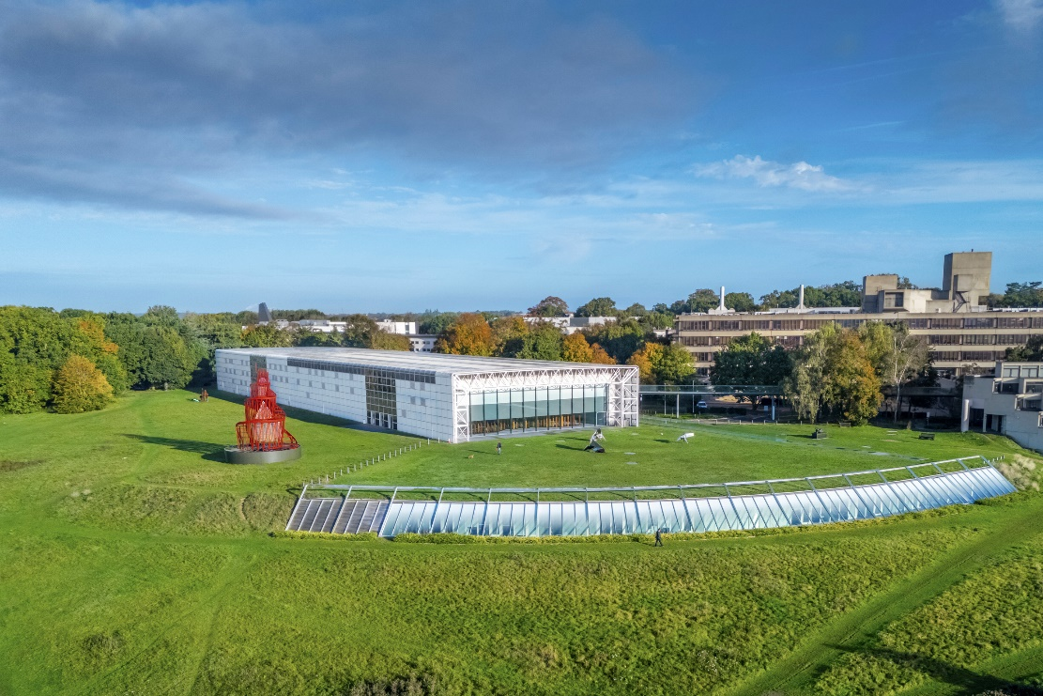

The Sainsbury Centre in Norwich, aerial view. Photo: Donovan Jones

The Sainsbury Centre has ranked as the most visited attraction in the East of England, in 2025.
The Association of Leading Visitor Attractions (ALVA) has released the visitor figures of its members for 2025. With 1,162,650 visitors in 2025, the Sainsbury Centre ranks above museums including Tate Britain, Royal Academy of Arts, and the Design Museum.
In total, 409 ALVA sites submitted their total visitor numbers for 2025, with the Sainsbury Centre ranking as the top visited attraction in the East of England, and 29th nationally.
ALVA’s Members are the UK's most popular, iconic and important museums, galleries, palaces, castles, cathedrals, zoos, historic houses, heritage sites, gardens and leisure attractions.
Since the Sainsbury Centre’s Living Art relaunch in 2023, visitors have increased dramatically, enthused by a radically different way of experiencing a world class art collection.
In 2026, the Sainsbury Centre continues its innovative series of investigative exhibitions engaging with fundamental questions of life with two new seasons. Currently, two exhibitions explore Can We Stop Killing Each Other. Later in 2026, What is the Meaning of Life?, launching in May, delves into the fundamental questions of human existence, from rule-making, to time and play; and How Do We Find Love?, opening in November, explores the profound complexities of human relationships, desire, and intimacy.
Sainsbury Centre director Jago Cooper said: “We are delighted that so many new visitors are travelling to the Sainsbury Centre and enjoying our captivating galleries, inspiring exhibitions and beautiful sculpture park. To be one of the most visited museums in the country outside of London is a huge privilege”

NOTES TO EDITORS

To view ALVA press releases, click here.
To view all press releases from the Sainsbury Centre, click here.

For more information, interviews and images:
Kate Wolstenholme
PR and Media Officer at the Sainsbury Centre
k.wolstenholme@uea.ac.uk
01603 592470

Download a high-resolution image here

Opening times
Tuesday – Friday 9am–6pm (exhibitions open 9.30am)
Saturday – Sunday 10am–5pm
Closed Mondays, including bank holidays

Entry
Tickets operate on a Pay Only If and What You Can basis, so you can choose the price from free through to full membership. A Universal Ticket grants access to the permanent collection, Lower and Mezzanine Galleries, and Sculpture Park.

The Sainsbury Centre is a world-class art museum with a unique perspective on how art can foster cultural dialogue and exchange. Following a radical relaunch in 2023 the Sainsbury Centre formally recognises the living lifeforce of art, enabling people to build relationships across an arts landscape.

The art of the Sainsbury Centre can help reframe and answer the most important questions people have in their lives. It is not a museum to only learn more about artists, cultures or movements like Francis Bacon, the Tang Dynasty or Modernism, it is a place of experience, where collections are animate, and visitors are emotionally connected.

One of the first museums in the world to display art from all around the globe and from all time periods equally and collectively, Sir Robert and Lady Lisa Sainsbury created one of the most sought after yet non-conformist art collections. In 1973 they donated their collection, which transcended traditional barriers between art, architecture, archaeology and anthropology, to the University of East Anglia, and created an entirely new type of museum. Housed in Sir Norman Foster’s revolutionary first ever public building, the space aimed for an interactive relationship between people, object and landscape, where art was placed within an open yet intimate ‘living area’.

Visit sainsburycentre.ac.uk and follow @sainsburycentre on Facebook, X, Instagram, TikTok and LinkedIn, as well as @TheSainsburyCentre on YouTube.

For ALVA, @alva_uk

