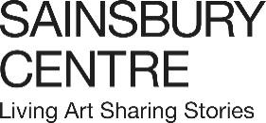

Press release

Play Power

An exhibition exploring the significance of play across human cultures, part of the Sainsbury Centre’s new season which delves into the fundamental question, What is the Meaning of Life?
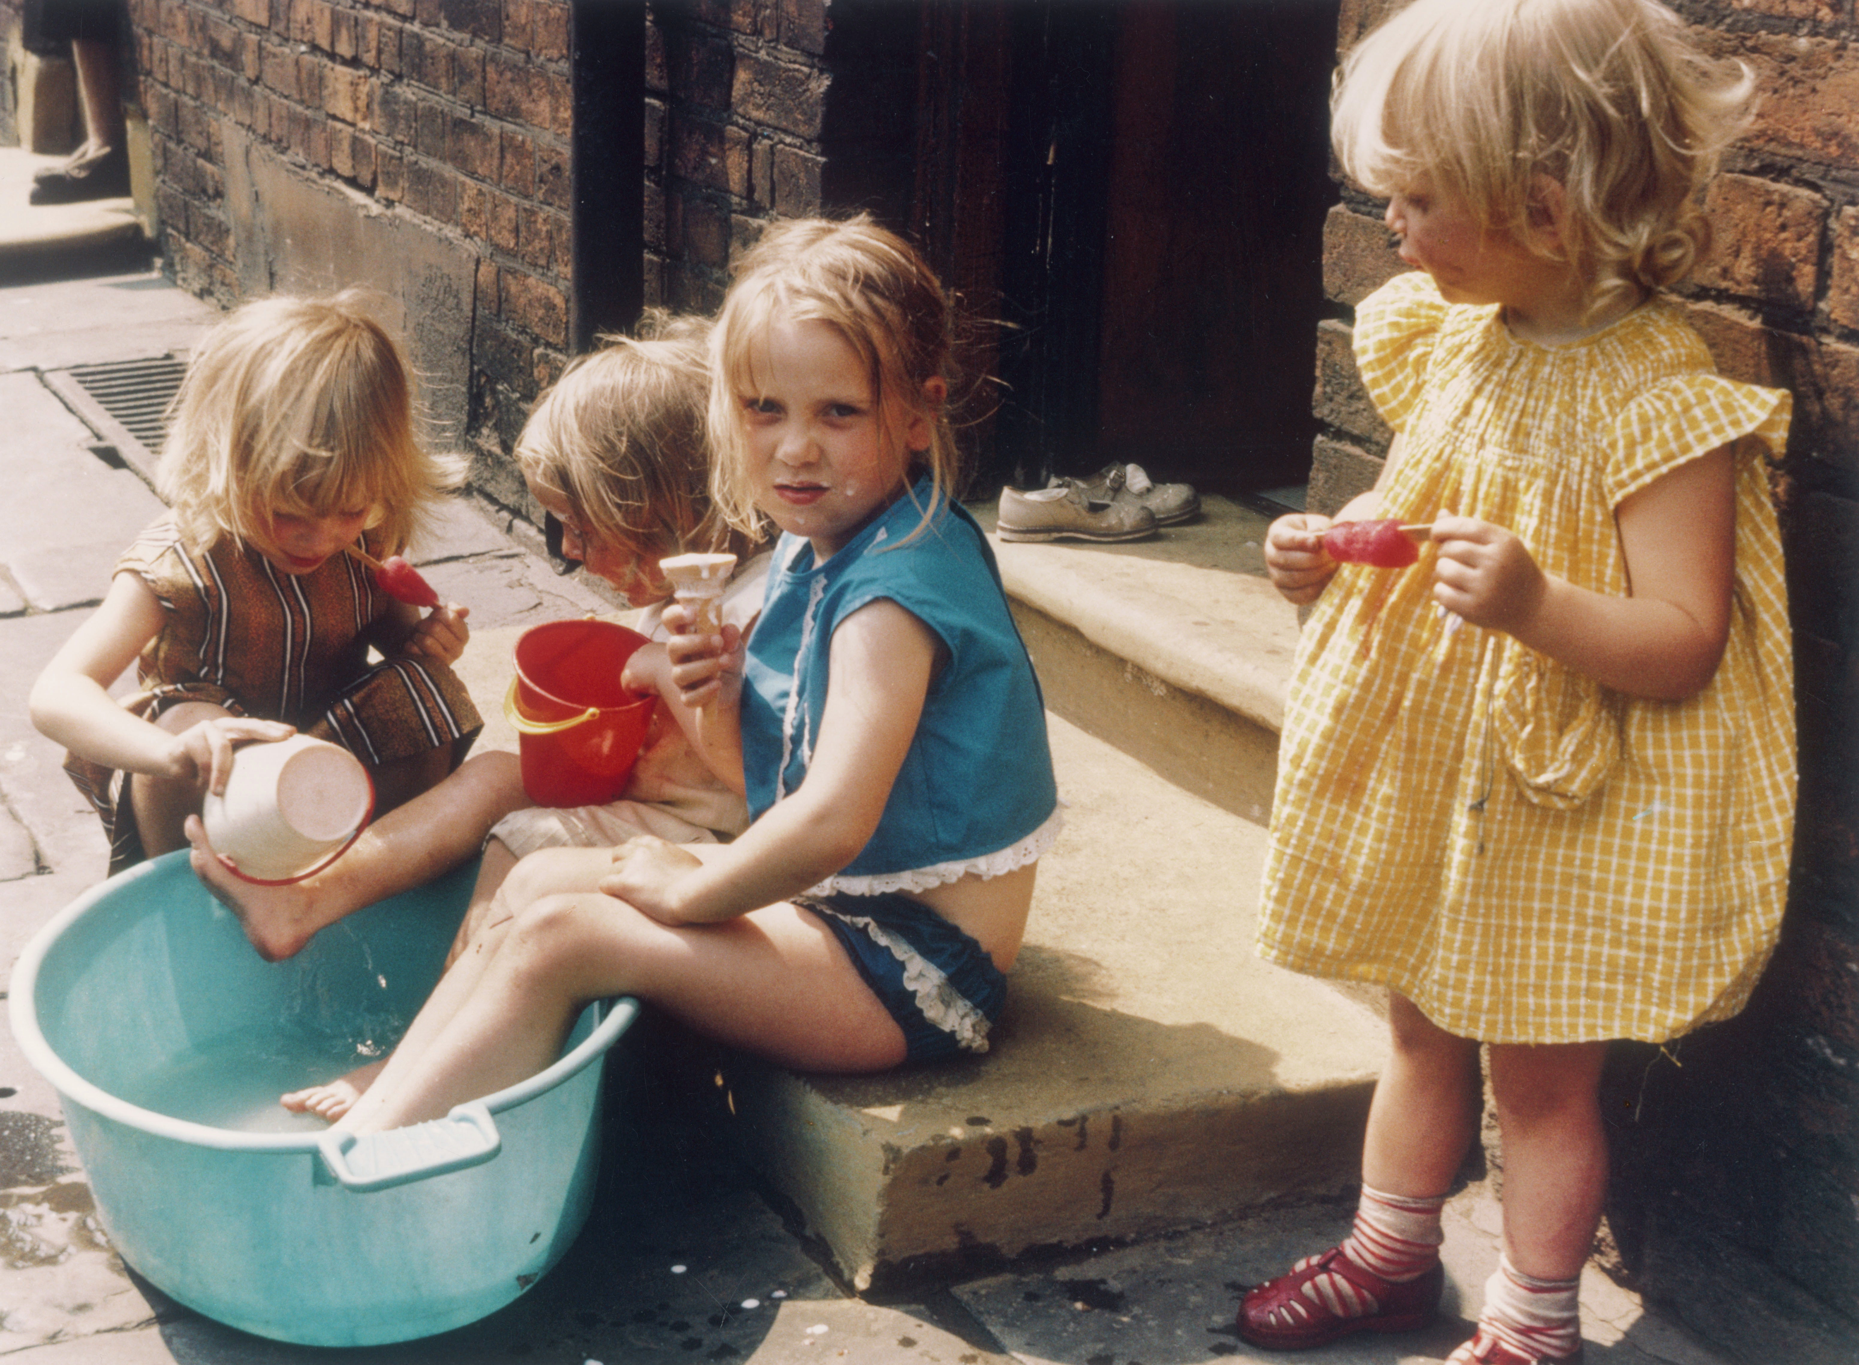

Shirley Baker, Four girls playing on pavement in Hulme, Manchester, 1965. Estate of Shirley Baker/Mary Evans Picture Library

16 May – 4 October 2026
Sainsbury Centre, Norwich

Encompassing rare artefacts, design objects and captivating artworks that bring play to life, this exhibition features 70 objects spanning a thousand years of human playfulness, including works by artists Eileen Agar, André Breton, Lygia Clark, L.S. Lowry, Yoko Ono and Germaine Richier. Play Power considers play not as trivial or escapist, but as a fundamental means by which humanity understands power, risk and meaning.

Though play is universal and cross-cultural, it takes on radically different forms. Tracing its significance from childhood learning to adult life in politics, war, and risk-based games like gambling, Play Power presents a rich reflection on how play structures human societies, reflecting social rules and modelling power.

Certain types of play are encouraged in childhood and have long been accepted by psychologists as important for early years development: teaching dexterity, cognition and ways of interacting with others. The exhibition includes an array of beautifully designed children’s toys, including Patrick Ryland’s Bird and Fish, icons of 1970s design, perfectly designed to stay upright in the bath; as well as Enzo Mari’s 16 fish, a later version his 16 animals, a toy which was amongst the influential furniture designer’s first designs.

Play Power brings these objects from design history together with visually resonant works. Works on display by Kandinsky, Klee and Feininger resonate with the simple geometric forms and block colour palette of children’s toys. Kandinsky and Klee were educated as young children in Friedrich Fröbel’s kindergartens, learning through his ‘Gifts’ – small geometric objects, which may have influenced the development of their pioneering abstract art. This story is explored in the exhibition through an interactive installation by Eamon O’Kane.

Lygia Clark’s series of Bichos sculptures are an example of the participatory art of the 1960s, which encouraged the audience to take an active role in composition, turning the gallery into a playground. Works by prominent figures of Surrealism André Breton and Eileen Agar demonstrate a keen interest in chance’s ability to illuminate the subconscious, exemplified in their popular Exquisite Corpse drawing game, examples of which are on display in the exhibition.

Across cultures, games have formed part of political, economic and ceremonial life, offering ways to manage conflict, as well as imagine the distribution of authority and wealth. Other chance-based games blur the boundary between play and ritual, with games acting as forms of divination. Board games often worked as models of fate and governance, placing individuals within larger social and cosmic systems: Senet, a popular boardgame in Ancient Egypt acquired deeply symbolic significance and became integrated in funerary rites. Gambling was pervasive in ancient Roman society, with dice games like the Duodecima Scripta being extremely widespread.

A range of artworks reference the popular formats of board games, card games, and chess – all of which involve strategy and chance to varying degrees. Chess pieces dated as early as the 7th –9th century, are a significant example of early abstract chess design, reflecting the cultural transformation of the game as it spread through the Islamic world from India. In a society portrait by Sir John Lavery a chess board signifies status through its requirement of skill; while in a figure of the founder of the Kuba kingdom in the Democratic Republic of Congo, a mancala board is the main symbolic attribute of his reign, again signalling intelligence.

In other contemporary artworks, games subvert the same societal rules they otherwise reflect. Power is rendered precarious in a contemporary work by French sculptor Germaine Richier, which positions chess pieces as if amid a game in which the outcome could change any moment, while in Yoko Ono’s work “Chess set for playing as long as you can remember where all your pieces are”, an all-white chess set breaks down differences between opposing sides, rendering chess a game based on trust and memory.

The exhibition will invite audiences to play, whether with Fröbel’s ‘Gifts’, the board games mancala and chess, or contemporary games in the virtual realm.

Curator of the show, Tania Moore, said: "Play is not just for children. As this exhibition demonstrates, play is integrated across societies and cultures in ways that we may not realise. If we played more freely, would we find more meaning in our lives?”

Director of the Sainsbury Centre, Jago Cooper, said: “I think play is how people learn the rules in the game of life. From childhood to old-age, playfulness in all its forms lets us probe human psychology, judge risk and see the game within the game. Ultimately play helps us develop the strategies we all need to navigate the complexities of life”

Play Power is curated by Tania Moore, Head of Exhibitions at the Sainsbury Centre, supported by Samuele Tacconi, PhD candidate in the Sainsbury Research Unit and with consultancy by Professor Ben Highmore at the University of Sussex.

Exploring how play manifests across and structures human societies, the exhibition is part of the Sainsbury Centre’s latest series of innovative exhibitions exploring the fundamental question, What is the Meaning of Life?. The season also includes the exhibitions Living by the Rule, launching 16 May, and Joy Like Time, opening 20 June and two new commissions: Life in the Multiverse: Libby Heaney, a participatory digital installation using quantum computing; and CATKINS FOREVER: Ruth Ewan, which sees the artist working with people to unearth their personal stories relating to plants and trees.

The season explores how art can help us uncover what it means to be human, from how we structure our lives to how play and games can reinforce or subvert our societal expectations, to finding meaning through creativity or after loss. Art encompasses the universality of human experience allowing us to explore meaning from across time and space.

NOTES TO EDITORS
HIGH RESOLUTION IMAGES FOR MEDIA USE CAN BE DOWNLOADED HERE
For more information, interviews and images:
Kate Wolstenholme
PR and Media Officer at the Sainsbury Centre
k.wolstenholme@uea.ac.uk
01603 592470

Exhibition details
Play Power
16 May – 4 October 2026
Sainsbury Centre, University of East Anglia,
Norfolk Road,
Norwich NR4 7TJ

The Sainsbury Centre continues its innovative series of investigative exhibitions in 2026 with a new programme that examines the fundamental questions of human existence, from rule-making, to time and play.

Concurrent exhibitions and interventions ask What is the Meaning of Life?, featuring:

- Living by the Rule: Contemporary meets Medieval, 16 May – 4 October 2026
- Play Power, 16 May – 4 October 2026
- Joy Like Time, 20 June – 15 November 2026
- Life in the Multiverse: Libby Heaney, 16 May – 4 October 2026
- CATKINS FOREVER: Ruth Ewan, 20 June – 15 November 2026

Opening times
Tuesday – Friday 9am–6pm (exhibitions open 9.30am)
Saturday – Sunday 10am–5pm
Closed Mondays, including bank holidays

Entry
Tickets operate on a Pay Only If and What You Can basis, so you can choose the price from free through to full membership. A Universal Ticket grants access to the permanent collection, Lower and Mezzanine Galleries, and Sculpture Park.

The Sainsbury Centre is a world-class art museum with a unique perspective on how art can foster cultural dialogue and exchange. Following a radical relaunch in 2023 the Sainsbury Centre formally recognises the living lifeforce of art, enabling people to build relationships across an arts landscape.

The art of the Sainsbury Centre can help reframe and answer the most important questions people have in their lives. It is not a museum to only learn more about artists, cultures or movements like Francis Bacon, the Tang Dynasty or Modernism, it is a place of experience, where collections are animate, and visitors are emotionally connected.

One of the first museums in the world to display art from all around the globe and from all time periods equally and collectively, Sir Robert and Lady Lisa Sainsbury created one of the most sought after yet non-conformist art collections. In 1973 they donated their collection, which transcended traditional barriers between art, architecture, archaeology and anthropology, to the University of East Anglia, and created an entirely new type of museum. Housed in Sir Norman Foster’s revolutionary first ever public building, the space aimed for an interactive relationship between people, object and landscape, where art was placed within an open yet intimate ‘living area’.

Visit sainsburycentre.ac.uk and follow @sainsburycentre on Facebook, X, Instagram, TikTok and LinkedIn, as well as @TheSainsburyCentre on YouTube.

