Monday 2 March 2026
For immediate release

Registration Now Open for Norfolk’s Heritage Open Days 2026: Be Part of the County’s Biggest Free Community Festival
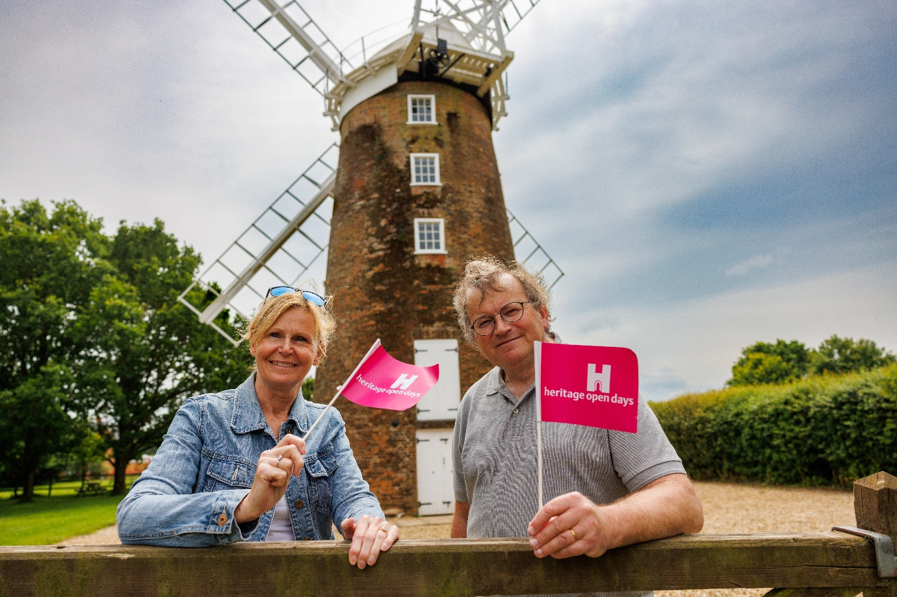
Visitors wave Norfolk Heritage Open Days flags in front of Dereham Windmill – Photographer: Luke Witcomb
Registration for the Heritage Open Days (HODs) festival is now open, inviting venues, organisations, and community groups across the county to take part in England’s largest free celebration of heritage and culture.
The national festival will run from Friday 11 – Sunday 20 September this year, with the help and participation of the community, Norfolk could once again deliver one of the most diverse and exciting local programmes in the country.
Norfolk’s contribution to the festival is coordinated by The Forum, which supports local organisers in developing events, promoting the county-wide programme, and producing the annual printed brochure.
In 2025, Norfolk’s HODs programme showcased 397 events, contributed by more than 200 local organisations, including Jarrolds, Carrow House (Norwich Unity Hub), Gressenhall Workhouse & Museum, to name a few. Norwich hosted the largest city-wide programme in England, and the county as a whole ranked second nationally for total event numbers, demonstrating the huge appetite for storytelling and the rich heritage in the county.
Survey responses from 2025 organisers demonstrated the festival’s exceptional reach and value:
- 100% said they would recommend taking part to other organisations.
- Over 80% estimated that more than half of their visitors during HODs were new to their venue or project.
Heritage Open Days welcomes an exciting and eclectic mix of event types, allowing organisers to showcase stories in the way that suits them best. Popular formats include guided walks, building tours, talks, and behind-the-scenes visits, as well as creative workshops, craft sessions, reenactments, performances, and family activities. Many venues choose to open their doors for free for the festival, offering visitors rare access to historic sites, private spaces, archives, or collections. From small community popups to large-scale experiences.
The national theme for 2026, Everyday Histories, encourages organisers to explore the working lives, skills, routines, and family traditions that shaped their communities. From craftspeople and traders to dockyard workers, gardeners, and home cooks, the theme invites stories from daily life — but participation in the theme is optional. Any heritage story is welcome.
Katie Ellis, Norfolk Heritage Open Days Event Producer, said,
“Heritage Open Days is a celebration shaped entirely by the people of Norfolk — their stories, their spaces, and their passion for sharing the county’s rich and varied history. Every year we’re amazed by the creativity and commitment of local organisers, and 2026 promises to be no different. With the theme of Everyday Histories, we’re excited to see communities shine a light on the working lives, skills, and traditions that have quietly shaped our county. Whether it’s a small community pop-up or a large-scale event, every contribution helps make Norfolk one of the most vibrant and engaging programmes in the country.”
How to Get Involved
Participation is free, and anyone with a story, place, collection, craft, or community archive to share is welcome to register as a Norfolk organiser.
Those wishing to appear in the Norfolk printed brochure — with 25,000 copies distributed across the region — must submit registrations by Sunday 31 May 2026.
Information, guidance, and registration details are available at:
norfolkheritageopendays.co.uk/get-involved
For enquiries, organisers can contact:
hods@theforumnorwich.co.uk
--Ends--
For Images: https://drive.google.com/drive/folders/1JYTWkAbJ04VwYL7umqO5xKd_OJ3nLATH?usp=drive_link
For more information contact Millie Batch, Events Marketing Producer, on millie.batch@theforumnorwich.oc.uk or 01603 727937
About Norfolk Heritage Open Days:
Norfolk Heritage Open Days returns from Friday 11 to Sunday 20 September 2026, inviting residents and visitors alike to explore the places, people and stories that shape our county. As part of Heritage Open Days (HODs) – England’s largest community-led festival of history and culture – the festival offers ten days of free events, experiences and discoveries across Norfolk.
Each September, Heritage Open Days celebrates the rich diversity of our local history, traditions and cultural heritage. Run by hundreds of organisations and volunteers nationwide, the festival opens doors to fascinating places, hidden gems and unique stories that are often overlooked or inaccessible the rest of the year.
Key dates
- Mon 2 Mar: Registration opens
- Sun 31 May (5pm): Registration deadline to be included in Norfolk listings brochure
- Mon 1 Jun: National online event directory goes live
- Fri 24 Jul: Deadline to request Norfolk HODs team to manage your ticketing
- Late Jul: Brochures printed and distributed
- Thu 13 Aug: Final registration deadline to participate
- Wed 26 Aug (10am): Booking opens for the majority of Norfolk events
- Fri 11 - Sun 20 Sep: Heritage Open Days festival
The Norfolk Heritage Open Days programme is coordinated and promoted by The Forum Trust.
norfolkheritageopendays.co.uk

About The Forum:
- The Forum is an iconic landmark in Norwich city centre.
- It’s a cultural hub for the city and county, providing fantastic free events year-round.
- It’s a public building, open seven days a week, throughout the year (except Christmas Day and Boxing Day).
- Everyone is welcome. Most of the public events, exhibitions and activities which take place at The Forum are free. Anyone can hire a space at The Forum to run their own event.
- The Forum presents and coordinates Norwich Science Festival, Norwich Games Festival, Norfolk Deaf Festival, Norwich Book Festival and Norfolk Heritage Open Days.
- The Forum is an independent charity, managed by The Forum Trust. The Forum receives no regular funding, and is self-financing, with income used to put on our free programme of events and festivals and reinvested in protecting the building for generations to come.

theforumnorwich.co.uk

About Heritage Open Days:
- Heritage Open Days is England’s largest festival of history and culture. Running for ten days every September, the festival offers free access to heritage events and activities across England.
- Heritage Open Days is brought to you by the National Trust, supported by players of People’s Postcode Lottery, and delivered locally by a large range of organisations (including civic societies, heritage organisations and local councils, community champions and thousands of enthusiastic volunteers)
- Heritage Open Days is England’s contribution to European Heritage Days, taking place across 50 countries. Other events in the UK are Doors Open Days in Scotland (www.doorsopendays.org.uk); Open Doors Days in Wales (Open Doors | Cadw); and European Heritage Open Days in Northern Ireland (www.communitiesni.gov.uk/articles/european-heritage-open-days).HeritageOpenDays.org.uk

