

Press Release
20 March 2026
Live Like a Local on a City Break in Norwich – Winner of Sunday Times Best Places to Live Guide 2026
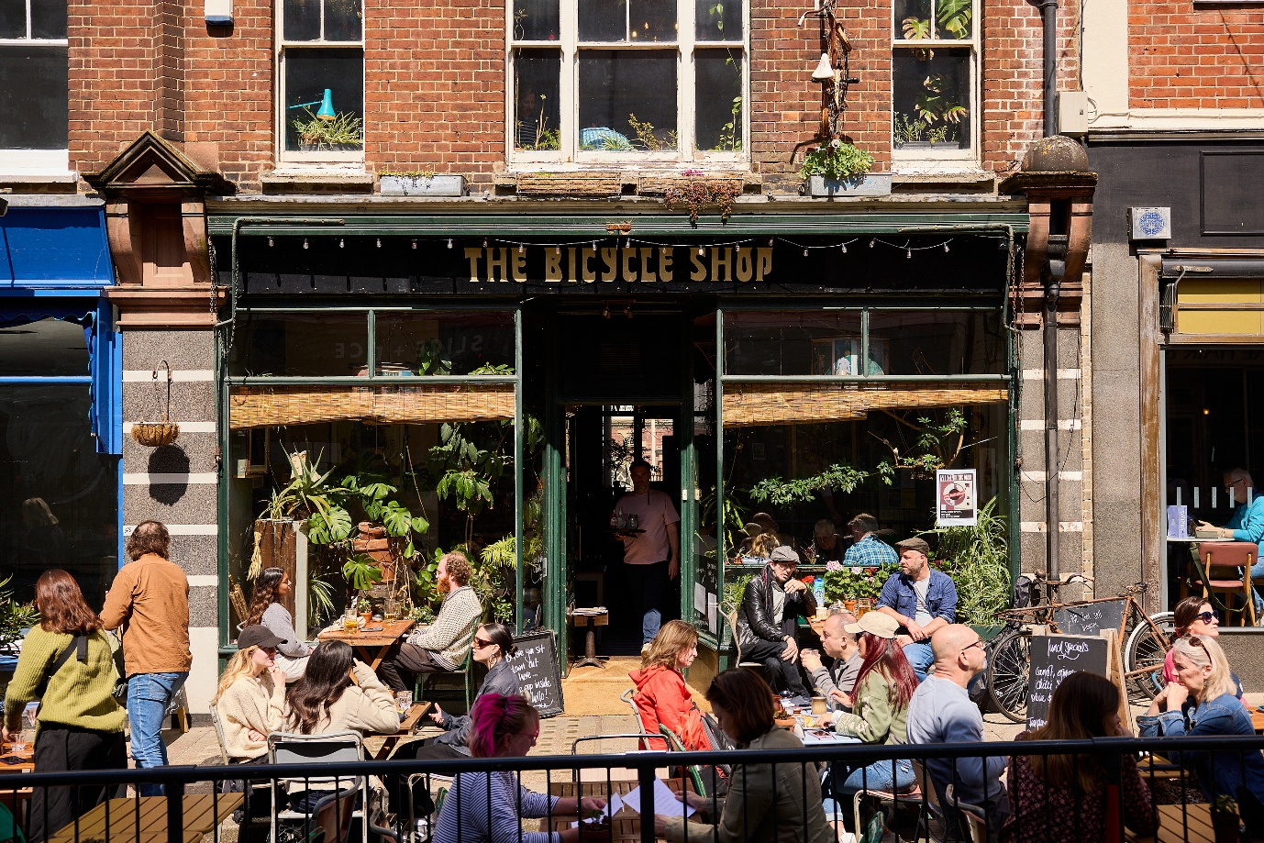
Image: St Benedicts Street, The Norwich Lanes. Credit Nick Warner.
- Norwich named as the national winner of the Sunday Times Best Places to Live
- In 14 editions of the Sunday Times Best Places to Live Guide, Norwich is the only location to have featured in all
- Judges described Norwich as a creative, cosmopolitan city
- Highlighted cultural riches included pioneering Sainsbury Centre, Norwich being the first English city to have a UNESCO City of Literature designation, six theatres, vibrant music venues and a newly revamped Norman castle.
The Sunday Times cited that Norwich was chosen for its unique blend of historic character, urban buzz and liveability. Described as cosmopolitan and full of creativity, yet with a distinctive, welcoming small-town feel.
Whilst you don’t have to uproot and move here just yet, living like a local on a city break in Norwich is the next best thing.
Creative and Cosmopolitan
Norwich is fearlessly independent, a city to find pavements lined with quirky outdoor seating for alfresco dining and drinks. Where cosy city pubs with real fires in winter open secret gardens in summer for local brews, art and gourmet food. See Shakespeare in a monastic cloister, dine in an Art Nouveau arcade with a DJ set, sauna on a riverside or paddle medieval trading routes through the city centre to be at one with nature.

Vibrant City Centre
Over 12-months Norwich presents a diverse calendar of live music, comedy, performance and installation art. Where full-on festivals from science and beer to history and literature are appealing to all ages. Then there are boundary pushing exhibitions and performances, people dancing in the streets, museum exhibits without glass and culture where you least expect it.
Historic Character
Norwich’s compact medieval street pattern means independent shops rub shoulders with high street favourites in striking distance to our two magnificent cathedrals- Romanesque and Gothic Revival. Where Norman Norwich Castle overlooks our 900-year-old market and views from the battlements include the river Wensum, medieval churches, verdant parks and contemporary builds.
Holly Bamford, Head of Marketing at VisitNorwich said: “It doesn’t take long to feel at home in Norwich. With its welcoming spirit and close-knit community, visitors quickly become part of the city’s story. Thanks to its walkable size, you can explore independent eateries, cultural hotspots and leafy picnic spaces with ease - experiencing the very best of Norwich without missing a moment. From one short trip, you’ll easily see why so many people choose to stay.”
Mel March, Senior PR & Marketing Manager VisitNorwich said: “I always recommend first time visitors do three things to help them feel at home. The first- take a walking tour of Norwich- there are plenty to choose from starting at around £9 to give you a sense of the city and the people who have helped make it what it is today.
“The second is have lunch on Norwich Market. See what catches your eye- Lucy’s Fish & Chips, Bodega’s New York style sandwiches or Churros for the People (delicious Spanish fare)?
“Finally, end with a drink- alfresco, at Norwich’s smallest bar Sir Toby’s Beers on the edge of the market opposite our 15th Century flint Guildhall. This is where you’ll find chatty locals keen to hear what you’ve been up to!”
<ends>
Notes to editors
For interviews and images contact Senior PR & Marketing Manager Mel March- mel.march@norwichbid.co.uk
For full information about the Sunday Times Best Places To Live Guide – https://www.thetimes.com/best-places-to-live
Images: https://show.pics.io/live-like-a-local_2026
Example things to do in Norwich
Creative & Cosmopolitan
- The Rumsey Wells
- The Bicycle Shop
- Benedicts
- Yalm – DJ sets in an Art Nouveau arcade
- The Shakespeare Festival
- Pub & Paddle
- Norwich Wine Week
- The Lions’ Den –sauna, connection and community
Vibrant City Centre
- Norwich Craft Beer Festival
- Norwich History Festival
- City of Literature Weekend
- Rock N Roll Circus
- Sainsbury Centre
- Norwich Summer Sessions
- Community East – skateboard in a medieval church
- Jarrolds (independent department store)
- The Royal Arcade
Historic Character
- Norwich Cathedral
- Cathedral of St John the Baptist
- Norwich Castle Museum & Art Gallery
- The Museum of Norwich
- Strangers’ Hall
- The South Asian Collection & Shop (in a Victorian skating rink)
- Norwich Market
- Walking Tours of Norwich
Where to stay
- The Assembly House (luxury boutique B&B, rooms from £170 a night)
- The Maids Head Hotel (4* historic) Hotel of the Year winner of 2026 Suffolk & Norfolk Tourism Awards)
About VisitNorwich
VisitNorwich is the Destination Marketing Organisation (DMO) for the Norwich area and is the not-for-profit tourism destination marketing function of Norwich Business Improvement District (BID) - www.visitnorwich.co.uk.
- VisitNorwich is a membership organisation within Norwich BID and its activities are funded by its members, public sector stakeholders including Norwich City Council and directly by Norwich BID.
- VisitNorwich’s sole focus is to promote and develop the destination and support its VisitNorwich members through collaborative marketing, PR, research, information and business advice.
- In 2025 VisitNorwich won in the category: ‘Integrated Campaign Of The Year under £500,000’ at the Travel Marketing Awards.
- Total value of tourism in Norwich is £801,905,450 up 4% from previous year - Destination Research: Economic Impact of Tourism Norwich report 2024.
- In 2020 Norwich, the City of Stories was shortlisted in the City Nation Place Awards for ‘Place Brand of the Year’.

