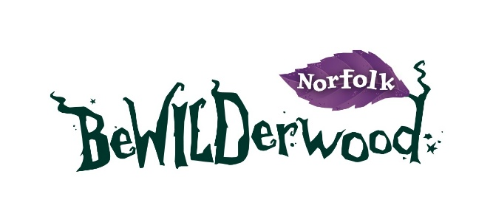

PRESS RELEASE
BeWILDerwood Norfolk Celebrates a New Chapter
with Buy One Get One Free Offer This May

Sent by BeWILDerwood Norfolk
27th April 2025

BeWILDerwood Norfolk Celebrates a New Chapter with Buy One Get One Free Offer This May
BeWILDerwood Norfolk is celebrating an exciting new chapter in its storytelling journey with a special Buy One Get One Free offer running throughout May weekends and school holidays when prebooking in advance.
To mark the launch of a brand-new BeWILDerwood book, A Holiday at BeWILDerville plus a shiny new edition of the original story, A Boggle at BeWILDerwood, the attraction is inviting families to experience twice the adventure for the price of one this May.
During weekends and school holidays in May, visitors to BeWILDerwood Norfolk can enjoy Buy One Get One Free entry, encouraging friends and families to step into the story together. From giant slides and towering treehouses to puzzling play areas and curious characters, the park offers an immersive experience inspired directly by the stories written by local Norfolk author and creator Tom Blofeld, who commented:
“I am so happy the long-awaited 4th book from the original BeWILDerwood book series is now available. A Holiday at BeWILDerville is all about Minty the Crocklebog who is Mildred’s niece. Mildred is always a hit with visitors and Minty is proving to be the same! So I really hope visitors will love this book as much as I loved writing it. 19 years later, we have also re-released the original A Boggle at BeWILDerwood which really was the beginning of BeWILDerwood and means so much to me.
We couldn’t just let the books be released without a bit of local celebration, so offering Buy One Get One Free throughout weekends and holidays in May felt like the perfect way to invite even more families to be part of the story and perhaps relive the story if you grew up visiting and now have children of your own.”

The offer is available at BeWILDerwood Norfolk during weekends and school holidays in May only. Tickets must be booked online in advance, with the discount automatically applied at checkout. Full T&Cs apply.
With limited availability across May, families are encouraged to book early to avoid disappointment, as its set to be a very popular offer. Book your adventure today.

Notes to Editors
Offer details:
- Offer: Buy One Get One Free
- Park: BeWILDerwood Norfolk
- Valid: May weekends (including bank holidays) and May school holidays
- Booking: Online pre-booking only
- Applies to: Almost WILD (92–102cm), BeWILD Now (105cm+) and Still WILD (65+) tickets
- Members: Eligible for the offer (one free ticket per membership)
Full T&Cs apply. Tickets are non-transferable, paid tickets are non-refundable, and the offer cannot be combined with any other discount.

About BeWILDerwood:
The award-winning attraction aims to encourage even more children and their families to enjoy traditional, imaginative, and healthy outdoor play.
The attraction is based on the book series by author and creator Tom Blofeld, with hints of his magical stories and curious characters throughout the forest.

Opening Date and Times:
See website for seasonal opening dates: https://bewilderwood.co.uk/plan-your-visit/opening-times-and-prices

Admission Prices (without offer):
Everything included in the ticket price (activities, crafts, stage shows etc.) Ticket prices vary based on season.
Born to BeWILD (under 92cm) Free
Almost WILD (92-105cm) £20.95
BeWILD Now (over 105cm) £22.95
Still WILD (65 years+) £17.95
Carer (proof required) Free
Address:
BeWILDerwood Norfolk,
Horning Road,
Hoveton,
Norwich,
Norfolk, NR12 8JW

Email: norfolk@bewilderwood.co.uk
Website: www.bewilderwood.co.uk

Press pack including an image gallery and logo can be found here.

For all press enquiries and exclusive interviews with Creator and Author Tom Blofeld please contact:
Lydia Downey, Head of Marketing and Media BeWILDerwood
lydia@bewilderwood.co.uk
01829 830730

