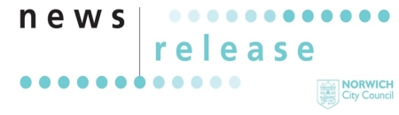
22 May 2026
For Immediate Release

Lord Mayor’s Weekend returns to Norwich this July

Get ready to celebrate Norwich at its most creative as the Lord Mayor’s Weekend returns from 10– 12 July with three days of free family fun, music and spectacle.

Friday night: start the weekend with something spectacular
Get your dancing shoes ready as The Halls joins the celebrations for the first time with an unmissable family-friendly rave, hosted by Big Fish Little Fish.
You can expect giant balloons, confetti cannons and bubbles galore – it’s set to be a party you won’t forget!

Saturday: bring the family, join the procession, celebrate Norwich
Saturday is the heart of the weekend, centred around the vibrant Lord Mayor’s Procession that celebrates the creativity and communities that thrive across Norwich. With more than 30 entrants already signed up, including schools, community groups and local charities, there’s still time to take your place.
This year’s theme, Wild about Norwich, invites participants to explore nature in all its forms – from wildlife and green spaces to hidden details of the city – and some have been working with local artists to bring their visions to life.
Before and after the procession, bring the kids to the Lord Mayor’s Garden Party in Chapelfield Gardens for a full afternoon of free family fun, including:

- Fabulous street theatre from Fraser Hooper and Dizzy O’dare
- Crafting and making with Fairyland Trust
- A high-energy DNA Kids Disco
- TheGameStation gaming van
- Face painting
- Interactive life-size computer games with Matthew Harrison
- Plus, more activities throughout the park.

Enjoy live music throughout the afternoon and evening
While the kids get stuck into activities, enjoy live local music on the Chapelfield Gardens main stage, featuring an exciting line-up of high-quality, local acts including:
- DH Temple
- May Gabriels
- Dr DJ’s Dad Dancing Dispensary
- The Mink
- Congratulations
- Guilty Pleasures
There’s even more music to discover at Hay Hill, with performances curated by Access Creative alongside LCR / Waterfront, spreading the festival atmosphere across the city.

Sunday: relaxed favourites to round off the weekend
Round off the weekend on Sunday with the return of two much-loved Norwich favourites: the Norwich Lanes Fayre, perfect for browsing and soaking up the atmosphere, and the ever-popular Norwich Duck Race, a joyful finale for families and spectators alike. The Adrian Flux Waterfront will also be bringing a showcase of the best of Norwich’s thriving alternative music scene to Hay Hill
Cllr Karen Davis, Lord Mayor of Norwich said: “This year’s Lord Mayor’s Weekend is shaping up to be another fantastic occasion for the city, and I am delighted to be playing my part as Lord Mayor.
“We are delighted to showcase an array of local groups and musicians while providing free, family fun that everyone can enjoy.”
As a Bronze Accredited Attitude is Everything Event provider, Norwich City Council is committed to providing a safe and welcoming event for all. Further details about accessibility will be available closer to the event.
With free events, hands-on activities, live music and spectacular moments around every corner, it’s a weekend designed to bring people together and celebrate everything that makes Norwich special.
Everything you need to do can be found on our dedicated Lord Mayor’s Weekend webpages, and you can keep up to date with more announcements across Norwich City Council’s social media channels.
ENDS

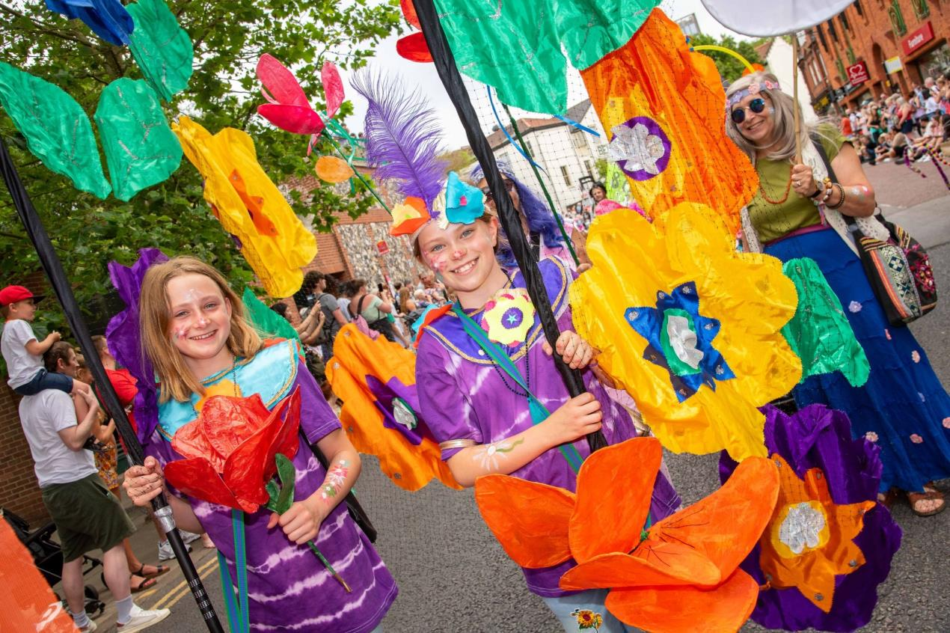
For more information contact:
Sarah Heeley, Communications Officer
Norwich City Council
t: 01603989429
e: SarahHeeley@norwich.gov.uk

