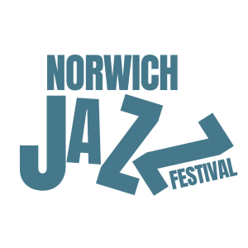
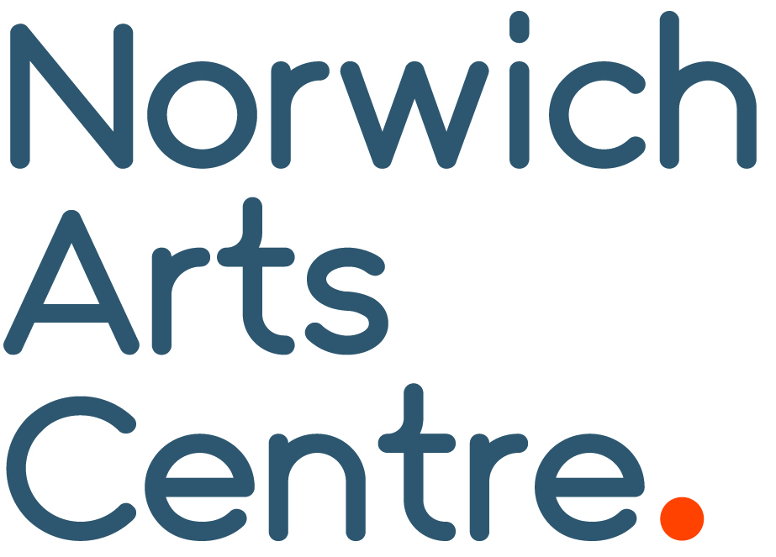
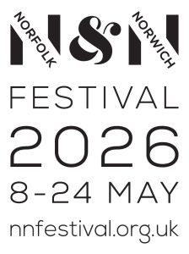

Norwich Jazz Festival 2026
Next month the Norwich Arts Centre brings back Norwich Jazz Festival (15–24 May), taking over venues across the Norwich Lanes and beyond with an inspiring programme of live performances, talks and film celebrating the very best of contemporary UK jazz.
Following a successful relaunch in 2025, the festival is back and proud be part of the Norfolk & Norwich Festival this year.
“Norwich Arts Centre is thrilled to be bringing back our fine city’s Jazz Festival. Building on the success of last year we believe we are bringing some of the most exciting UK jazz acts on the circuit. Looking forward to seeing you at a show soon.“ Bradley Glasspoole, Artistic Director, Norwich Jazz Festival.
The festival opens on Friday 15 May with the Balimaya Project at The Spiegeltent, followed by the Norwich Jazz Festival 2026 Launch Party, featuring Mondo DJs, Amy Nomvula and Easily Dunn, spinning a vibrant mix of jazz and worldbeat.
On 16 May, acclaimed tuba player and Sons of Kemet member Theon Cross brings his powerful trio to Norwich Arts Centre.
After being one of the standout performances of 2025, the National Youth Jazz Orchestra returns on 19 May to Epic Studios with a brand-new show celebrating the legacy of Abdullah Ibrahim and the sounds of South African township jazz.
The Neil Cowley Trio reunite to present music from their outstanding brand-new album, ‘Entity’ at Norwich Arts Centre on 21 May, showcasing their signature blend of original compositions and dynamic interplay.
Nubiyan Twist, the London-based jazz and Afrobeat collective known for their infectious energy and uplifting live shows, headline Epic Studios on 22 May, supported by Tara Lily and Tadi The Great.
On 23 May, Manchester trio GoGo Penguin bring their new album, ‘Necessary Fictions’, a fusion of jazz, classical and electronic music to Epic Studios, joined by special guest Daudi Matsiko.
The festival closes on 24 May with Gary Crosby’s Mingus Moves, a special performance celebrating the music of Charles Mingus, featuring Crosby’s sextet performing classic Mingus repertoire.
Beyond the main stages, the festival also features intimate pop-up events across the city including broadcaster and DJ Amy Nomvula in conversation with André Marmot author of ‘Unapologetic Expression: The Inside Story of the UK Jazz Explosion’ at The Book Hive, jazz trio ABNA performing in Cinema City’s courtyard followed by a screening of Whiplash, and a performance by London-based harpist Marysia Osu in the beautiful Anteros courtyard.
Tickets are on sale now.
For full listings and further details, visit norwichartscentre.co.uk.

END
NAC Contacts:
Kelly Robb and Grace Jackson Marketing & Communication Managers
E-mail: kelly@norwichartscentre.co.uk | grace@norwichartscentre.co.uk

