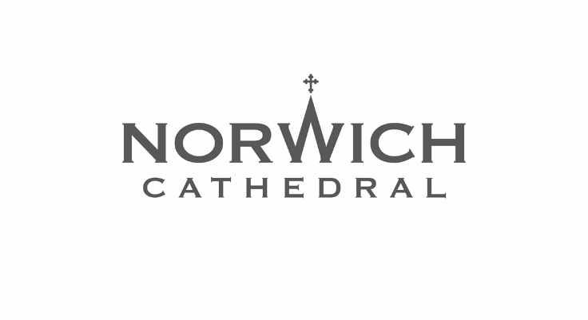
Press Release: For immediate release

Summer festival celebrates
Norwich Cathedral’s historic organ

Norwich Cathedral’s historic pipe organ is at the heart of the Cathedral’s musical life and this summer a special festival will be taking place to celebrate the magnificent instrument.

The Norwich Cathedral Summer Organ Festival kicks off with a five-day programme of events from 8 to 12 July followed by a series of evening concerts throughout summer 2026.

There is something for everyone to enjoy, ranging from A Night at the Movies with Odeon Leicester Square organist Donald MacKenzie, to a concert by Notre-Dame Cathedral’s titular organist Vincent Dubois, and a free Battle of the Organs musical extravaganza with Norwich Cathedral’s three organists, Ashley Grote, Graham Thorpe and Christopher Too.

The BBC Singers will be making a welcome return to Norwich Cathedral for a special performance recorded for broadcast on BBC Radio 3, and Norwich Cathedral Choir and Norwich Baroque will perform works by Handel and Bach in a concert entitled Baroque Masterpieces.

Ashley Grote, the Cathedral’s Master of Music, said: “Following the success of the Organ Reborn! festival in 2024, which celebrated the complete rebuilding of the Cathedral organ, we wanted to offer a similar celebration this summer.
“This year’s organ festival offers audiences the opportunity to hear the magnificent instrument in a variety of contexts.
“The festival will bring some of the world’s finest organists to Norwich, and with a silent movie, our Battle of the Organs, as well as concerts and recitals, there is something for everyone, with free tickets for under 18s.”

As always, all are welcome to attend daily worship at the Cathedral, and on the opening day of the festival, BBC Radio 3 will be broadcasting Choral Evensong live from Norwich Cathedral.

The Dean of Norwich, the Very Revd Dr Andrew Braddock, said: “This will be a brilliant festival showcasing the diversity of music the organ can offer with something for all ages.”

After the initial five days of musical celebration have drawn to a close, audiences can continue to enjoy a summer series of recitals on various Wednesday evenings throughout July, August and September.

Full details of the festival, including ticket prices and how to book, are available at cathedral.org.uk/organ-festival

Notes to editors
For more information, please contact Norwich Cathedral’s Marketing and Communications Manager Emma Knights via eknights@cathedral.org.uk or 07968 460963.

Below are the full details of the festival’s events in date order, followed by a brief history of the Norwich Cathedral organ.

NORWICH CATHEDRAL SUMMER ORGAN FESTIVAL EVENTS LIST

Choral Evensong with BBC Radio 3
Wednesday 8 July, 4pm
Norwich Cathedral Choir, led by the Cathedral’s Master of Music Ashley Grote, will sing this special Choral Evensong service which will be broadcast on BBC Radio 3.
Graham Thorpe will play the organ.
Free to attend and no ticket required. Please note the congregation must be seated by 3.45pm.

A Night at the Movies: silent films with improvised organ accompaniment
Wednesday 8 July, 8pm
One of Europe’s finest theatre organists, Donald MacKenzie has been Organist of the Odeon Leicester Square for 32 years. During this special festival performance, he will provide improvised accompaniment on Norwich Cathedral’s organ to films by Laurel and Hardy, Charlie Chaplin and Buster Keaton.
Tickets £15 plus booking fee. Under 18s free.

BBC Singers in Concert recorded for broadcast on BBC Radio 3
Thursday 9 July, 7pm
The BBC Singers, conducted by Ashley Grote, make a welcome return to Norwich Cathedral with works themed around two women central to the history of the city – Julian of Norwich and Edith Cavell. This special performance is recorded for broadcast on BBC Radio 3 and features Guy Johnston on ‘cello and David Dunnett on the organ.
Programme
Joanna Marsh: All shall be well
Ola Gjeilo: O magnum mysterium
Cecilia McDowall: Standing as I do before God
Cecilia McDowall: Church bells beyond the stars
Roxanna Panufnik: All shall be well
James MacMillan: A New Song
Parry: Fantasia and Fugue in G
Parry: Songs of Farewell
Tickets £15-£35 plus booking fee. Free for under 18s in the side aisles.

Choral Evensong
Friday 10 July, 5.30pm
Join Norwich Cathedral Choir for their daily service of Choral Evensong.
The choir will be conducted by Master of Music Ashley Grote, and Christopher Too will play the organ.
The service is free to attend and no tickets are required.

Celebrity Organ Concert: Vincent Dubois
Friday 10 July, 8pm
Vincent Dubois, one of the world’s leading virtuosos and Titular Organist at Notre-Dame Cathedral in Paris, will be performing a special concert for the Norwich Cathedral Summer Organ Festival.
Programme
J S Bach: Prelude and Fugue in A minor BWV 543
Franck: Choral No 1 in E
Saint-Saëns: Danse macabre
Liszt: Légende de Saint-François de Paule marchant sur les flots
Vierne: From Pièces de Fantaisie:
Feux-follets
Claire de Lune
Toccata
Dupré: Prelude and Fugue in G minor
Dubois: Improvisation
Tickets £15 plus booking fee. Under 18s free.

Family Concert: Battle of the Organs
Saturday 11 July, 11am
In this special concert for all ages, Norwich Cathedral’s organists Ashley Grote, Graham Thorpe, Christopher Too will play three organs all at once - the Cathedral’s newly re-built pipe organ and one-manual chamber organ, and a digital touring organ generously supplied by Allen organs.
Bring your family along to hear some of the most famous and best-loved works in the organ repertoire!
Admission free and no tickets are required. A retiring cash collection will be taken.
The performance will last 45 minutes.

Baroque Masterpieces
Saturday 11 July, 7pm
Norwich Cathedral Choir and Norwich Baroque present a concert of Baroque Masterpieces, featuring Ashley Grote as conductor and organ soloist.
Programme
Bach: Toccata and Fugue in D minor
Handel: O Praise the Lord with one consent (Chandos anthem No 9)
Bach: Brandenburg Concerto No 3
Bach: Magnificat in D
Tickets £15-£35 plus booking fee. Free for under 18s in the side aisles.

Sung Eucharist: The Liturgy of St Benedict
Sunday 12 July, 10.30am
Norwich Cathedral Choir leads worship on the final Sunday of the choir year, celebrating the Feast of St Benedict. Music will include Vierne’s Messe solennelle
Free admission and no ticket required.

Festal Evensong with Choir Valedictions
Sunday 12 July, 3.30pm
Join us for the last Evensong of the academic year in which we bid farewell to members of the choir who have completed their final year.
Free admission and no ticket required.

Summer Evening Organ Concert Series
Various Wednesdays throughout July to September, 7pm-8.15pm
- Wednesday 22 July - Christopher Too, Assistant Organist, Norwich Cathedral
- Wednesday 5 August - James O’Donnell, Yale Institute of Sacred Music, Former Organist and Master of the Choristers, Westminster Abbey
- Wednesday 19 August - Stephen Farr, International Concert Organist
- Wednesday 2 September - Graham Thorpe, Assistant Master of Music and Sub-Organist, Norwich Cathedral
- Wednesday 16 September - Isabelle Demers, McGill School of Music, Canada, and International Concert Organist
- Wednesday 30 September - Ashley Grote, Organist and Master of Music, Norwich Cathedral
Tickets for each concert are £12 plus booking fee. Under 18s free.

To book tickets for Norwich Cathedral Summer Organ Festival events, visit cathedral.org.uk/organ-festival

THE HISTORY OF THE NORWICH CATHEDRAL ORGAN

An organ has been one of the musical centrepieces of Norwich Cathedral’s worship for centuries and the current organ is among the biggest in the country.

The organ has an incredible 5,767 pipes and they range in size from about the length of a pencil to 32ft (almost 10 metres).

There are references to an organ at Norwich Cathedral dating back to the 14th century. Today’s organ was originally built by the Norwich firm of Norman and Beard and first installed in 1899.
It was devastated by a fire that broke out during an Evensong in April 1938 but, despite the outbreak of the Second World War, a project to rebuild the organ was completed in the 1940s.

Eight decades on, the £1.8m Norwich Cathedral Organ Rebuild Project saw the magnificent instrument undergo a complete overhaul to enable people to continue enjoying its music for many generations to come.

The project saw most of the organ’s several thousand pipes removed and taken to organ specialists Harrison and Harrison’s base in Durham for further work.

Most of the organ’s working pipes were returned to the Cathedral in early 2023 before each and every one of the 5,767 pipes was ‘voiced’ – or tuned – by Harrison and Harrison in situ between May and July 2023.

A special series of Organ Reborn! concerts took place in November 2023 to celebrate the return of the organ.

