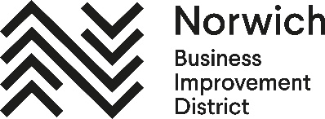
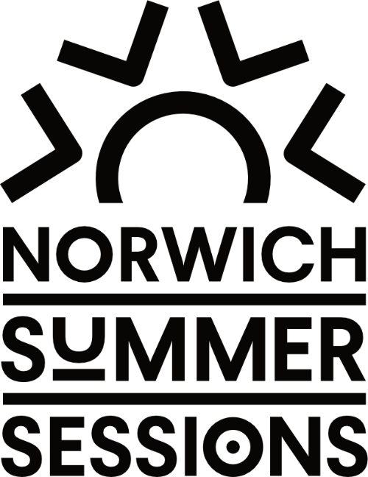

Press Release
3 June 2026

Norwich Summer Sessions Returns for 2026 with Free Live Entertainment Across the City

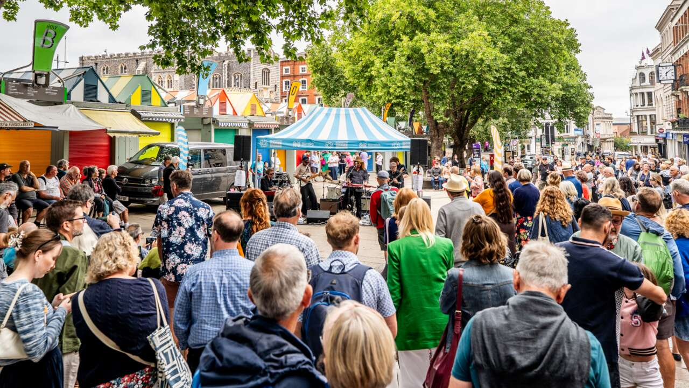

A much-loved city favourite is back. Norwich Summer Sessions returns this August, bringing four weeks of free live music, street theatre and community performances to the heart of the City of Stories.
Now in its 13th year, the popular event will once again transform Norwich city centre every Sunday throughout August (2–30 August, 12.30pm–4.30pm). Four pop-up stages at Hay Hill, Westlegate, St Gregory’s Green and Gentleman’s Walk will create a vibrant, festival-style atmosphere - inviting visitors to explore, discover and enjoy the city in full summer swing.
Delivered by Norwich Business Improvement District (BID) and Norfolk Community Arts (NORCA), the programme blends professional performers, emerging talent and community participation. From live bands and acoustic sets to street theatre and interactive dance, Norwich Summer Sessions offers something for everyone - whether you’re stopping by for a drink, shopping in the city, or simply soaking up the sunshine.
This year’s line-up features an eclectic mix of genres including folk, jazz, funk, blues, country and rock and roll. Highlights include street theatre at Hay Hill curated with Covent Garden Entertainment, featuring acclaimed escapologist Rob Roy Collins, and a genre-blending set from LFay in association with Wild Paths. New for 2026, the Lawrence Kingston Band brings their signature country sound, alongside returning crowd favourites Pangaea and Big Black Cadillac.
Visitors can also get involved, with swing dance sessions on 16 August and Latin dance on 23 August at Gentleman’s Walk, while three local choirs and dedicated Platform stages - delivered with New Noise and Access Creative College - spotlight the next generation of Norwich talent.
With deck chairs at Westlegate and picnic spaces at St Gregory’s Green, the sessions offer the perfect way to relax and enjoy the city’s unique character and creativity.
Norwich Summer Sessions continues to be a standout moment in the city’s cultural calendar - celebrating local talent, supporting city centre businesses and creating a welcoming, inclusive experience for all.
Free, accessible and full of energy, it’s an unmissable highlight of the summer - and a showcase of everything that makes Norwich a city to be proud of.
Marcus Patteson, Executive Director, NORCA said: “We’re delighted to be bringing Norwich Summer Sessions back for another summer of free live entertainment in the heart of the city. This year’s programme once again celebrates an exciting mix of local and national music acts, world class street theatre, emerging local talent and community participation, creating a welcoming and inclusive experience for everyone to enjoy.”
Stefan Gurney, Executive Director, Norwich Business Improvement District said: “Norwich Summer Sessions creates a fantastic atmosphere across the city centre every summer, encouraging people to spend time in Norwich and enjoy everything our city has to offer. It’s a brilliant showcase of local creativity and culture, while also supporting our hospitality, retail and leisure businesses during the busy summer months.”
Norwich Summer Sessions is made possible thanks to the support of 2026 main sponsor The Garage, alongside stage sponsors YALM, Rock N Roll Circus, Grosvenor Fish Bar and Point Roofing.

For full details and timings, visit:
https://norwichsummersessions.co.uk/
<ends>
Notes to Editors:

For interviews please contact:
Mel March, senior PR & marketing manager, Norwich BID mel.march@norwichbid.co.uk

High resolution images: https://show.pics.io/norwich-summer-sessions-2026-pr-selection

Download the DL leaflet and location map:
https://cdn.visitnorwich.co.uk/app/uploads/2026/01/NSS-2026-DL-Orange-AW-FINAL.pdf

View the full Norwich Summer Sessions line-up online:
https://norwichsummersessions.co.uk/
Share your Summer with us!
#NorwichSummerSessions | #CityofStories | #Norwich
@NorwichBIDUK @VisitNorwich

About Norwich BID
Established in November 2012, Norwich BID is run for local businesses by local businesses. The BID covers a defined area of Norwich where businesses plan how to improve their trading environment, identifying additional projects and services that develop the city centre and trade. Investment in the BID area aims to enhance and promote the local environment for businesses, employees, customers and tourists. The overarching vision is to make a clear positive impact on the vitality of our city centre and the success of the businesses within it.

About Norfolk Community Arts (NORCA)
NORCA’s mission is to improve lives and communities through culture. We work to create a world where arts and culture are an active part of everyone’s lives, and the people and communities we work with can live creative, healthy lives, and fulfil their potential, regardless of background. We achieve this through developing opportunities to experience or get involved in arts and culture.

