
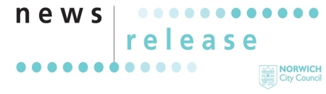
02 July 2026
For Immediate Release

Norwich gets wild as Lord Mayor’s Weekend returns

Thousands expected as one of Norwich’s biggest and most-loved annual events takes over the city centre
Norwich is preparing to come alive with colour, music and community spirit as Lord Mayor’s Weekend returns from on Saturday 11 and Sunday 12 July, bringing two days of free entertainment, family activities, live performances and the city’s iconic Lord Mayor’s Procession.
This year’s theme, “Wild About Norwich,” celebrates the city’s creativity, communities and natural beauty, with events taking place across the city centre throughout the weekend.
At the heart of the celebrations is the spectacular Lord Mayor’s Procession, when colourful floats, performers, community groups and local organisations will fill the streets in a vibrant showcase of everything that makes Norwich unique. Participants include Bignold Primary School, Norfolk Wildlife Trust and The Feed – and many more. An accessible viewing area is available to book in advance by emailing events@norwich.gov.uk
Alongside the procession, residents and visitors can enjoy live music, arts and entertainment across the city, family-friendly activities in Chapelfield Gardens, the popular Lanes Summer Fayre, comedy, street theatre and a packed programme of events designed to appeal to all ages.
The Lord Mayor of Norwich, Councillor Karen Davis, said:
"I am delighted to welcome you to this year’s Lord Mayor’s Weekend. Whether you are taking part or cheering from the sidelines, there is something for everyone to enjoy.
“This special event celebrates the creativity, community spirit and diversity that make Norwich such a vibrant city.
“Thank you to everyone involved for bringing the event to life. We look forward to seeing you there."
Saturday is expected to be the busiest day of the festival, with the Lord Mayor’s Procession joined by city-wide celebrations, free family activities in Chapelfield Gardens, Norwich Market and The Halls, as well as live entertainment at Hay Hill. Sunday’s programme includes the Lanes Norwich Summer Fayre, the Great Norwich Duck Race and another day of music and performances on Hay Hill.
Lord Mayor’s Weekend is one of Norwich’s longest-standing civic traditions, bringing together community groups, charities, businesses, performers and residents in a celebration of civic pride and local culture.
Visitors are encouraged to plan ahead, with full event details, procession information, accessibility guidance and travel advice available online.

Event details
Lord Mayor’s Weekend 2026
Dates: Saturday 11 – Sunday 12 July 2026
Location: Norwich city centre
Theme: Wild About Norwich
Information: www.norwich.gov.uk/lmw

Media opportunities
Media interviews can be arranged with:
- The Lord Mayor of Norwich
- Event organisers
- Community groups taking part in the procession
- Performers and entertainment providers
- Civic charity representatives
ENDS
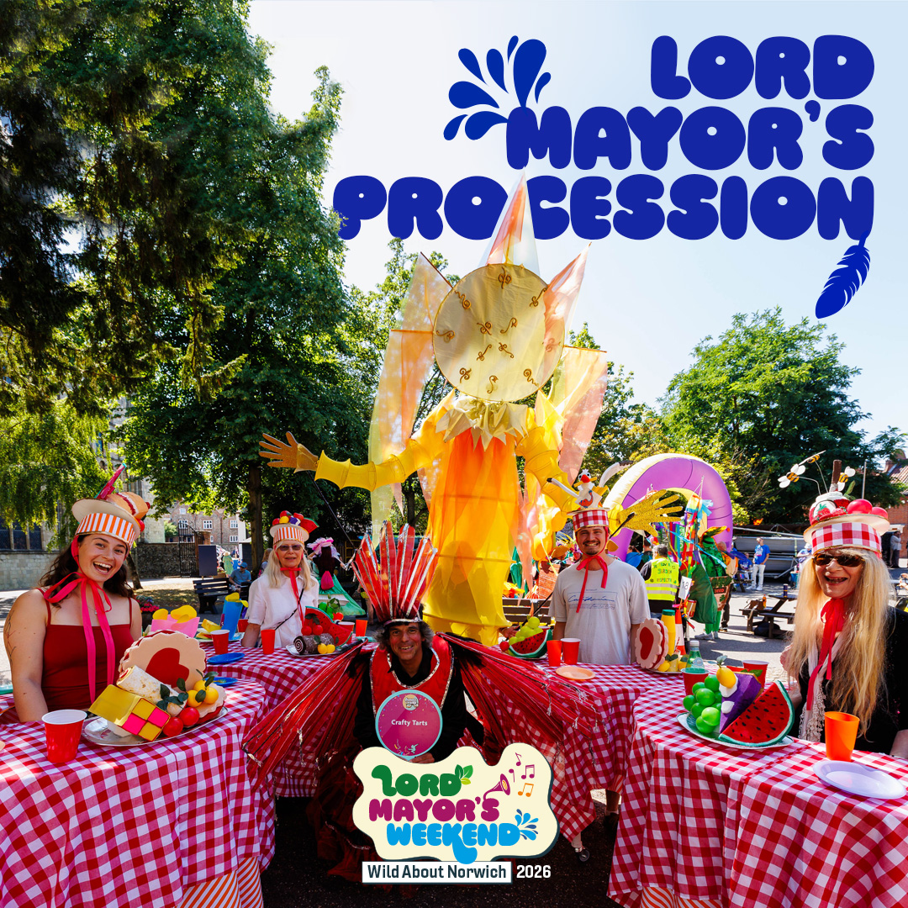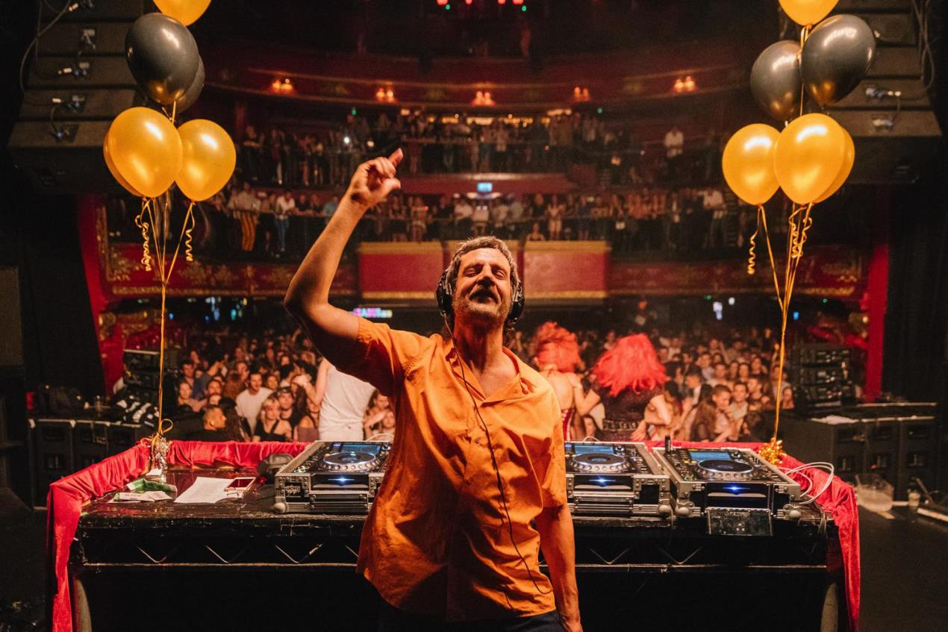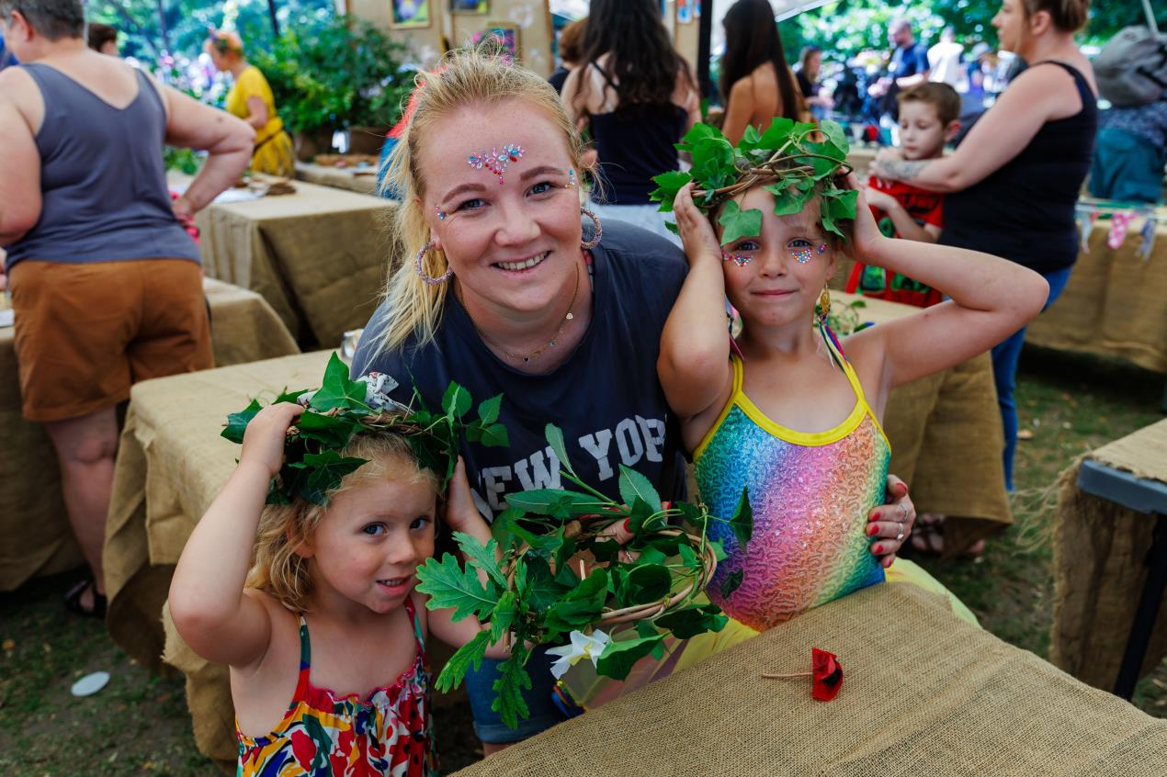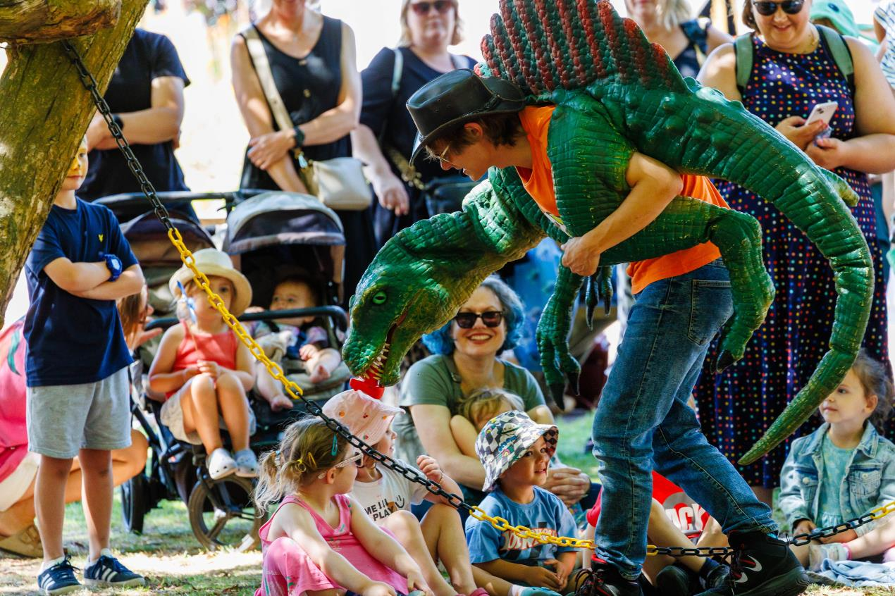
This project is funded by the Greater Norwich Growth Board through the Infrastructure Investment Fund.
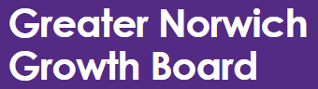
For more information contact:
Communications
Norwich City Council
t: 01603989429
e: communications@norwich.gov.uk

