Thursday 30th July 2026
For immediate release
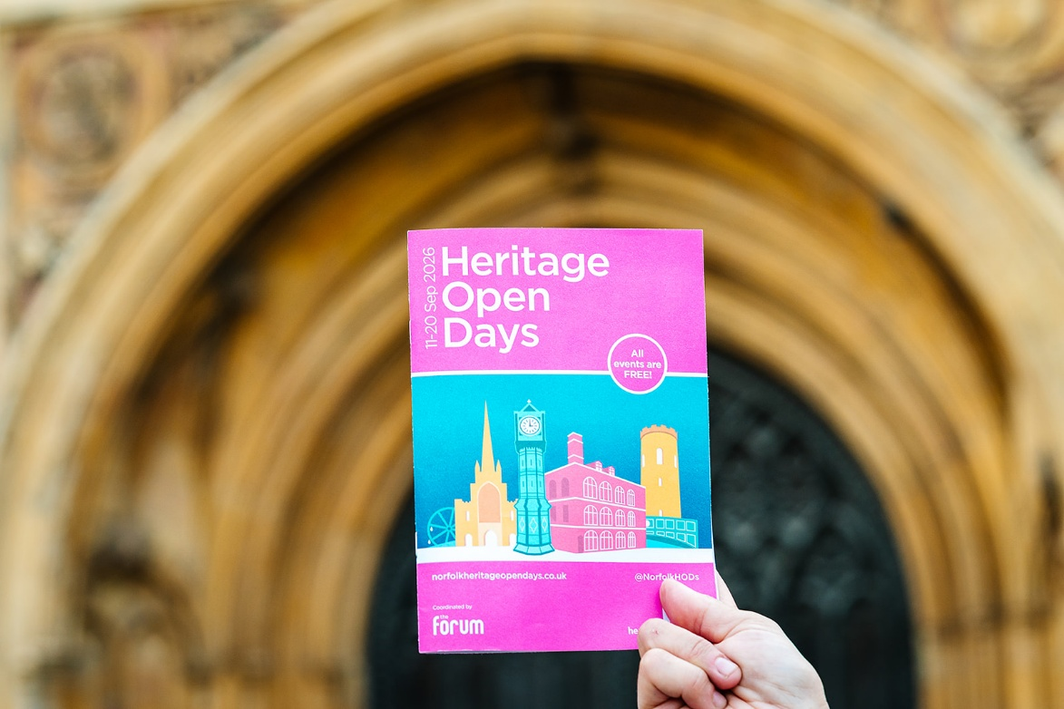
Explore Norfolk for free: 2026 Norfolk Heritage Open Days brochure out now
The 2026 Norfolk Heritage Open Days listings brochure is out now, helping locals and visitors plan ten days of free events across the county from Friday 11 to Sunday 20 September.
Heritage Open Days is England’s largest festival of history and culture, bringing communities together each September to celebrate local stories, historic places and cultural traditions. In Norfolk, the festival opens up special access to buildings, spaces and experiences that are often hidden, closed to the public or offer a fresh perspective on familiar places.
Thousands of brochures are being distributed across Norfolk and can be picked up from The Forum, Norfolk libraries, participating venues, museums, restaurants, shops, tourist attractions and more. The brochure features 230 events from this year’s programme, with more than 320 events now registered as part of Norfolk Heritage Open Days.
Katie Ellis, Norfolk Heritage Open Days Producer said,
"We're thrilled to have over 300 events in the Norfolk programme for visitors to enjoy. It's a testament to all the organisers and volunteers who share their heritage stories and bring this festival to life".
Across the festival, visitors can enjoy exhibitions, open doors, tours, talks, performances, family-friendly activities, workshops and special events in towns, villages and communities across the county. From Norwich landmarks and coastal heritage to Broads waterways, historic houses, theatres, cemeteries, museums and railway stories, the programme offers a wide-ranging celebration of the places, people and traditions that make Norfolk distinctive. Every Norfolk Heritage Open Days event is free to attend.
The 2026 programme includes:
- Historical Tours of Old Carrow House, Norwich – 14 and 16 September at 10.30am, 11.45am and 1.30pm. Step back in time with a taster tour of Old Carrow House, once home to the Colman family.
- Cromer Pier and Pavilion Theatre backstage tours – 13 September, drop-in from 10am to 3pm. Explore refurbished dressing rooms and discover the theatre’s rich history.
- Oxburgh Estate, near King’s Lynn – 18 and 19 September, drop-in from 9.30am to 5pm. Enjoy free entry to the estate, with Victorian Gothic interiors, woodland walks and gardens.
- Great Yarmouth Minster Bell Tower – 19 and 20 September, drop-in from 10am to 3pm. Visit the ringing chamber, see the twelve bells and learn about bell ringing.
- King’s Lynn Heritage Open Day programme – 13 September from 10am to 4pm. Enjoy re-enactors, family activities, music, dancing, miniature trains, boats, classic cars and exhibitions.
- Portraits of Life, The Forum, Norwich – 11-20 Sep: Drop-in 10am-4pm. Visit this very popular exhibition, with an extended collection of photographs by professional photographer Jack Roberts, whose photos of Norwich post World War Two.
Booking opens for the majority of pre-book Norfolk events at 10am on Wednesday 26 August. Some events have limited capacity and are expected to be popular, so visitors are encouraged to browse the programme, plan ahead and book early where required. In some cases, you are required to book directly with the venue online, by phone or by email - individual event listings include details.
Often, tickets are completely booked up within 20 minutes of booking opening, but don’t worry, there are over 180 brilliant drop-in events part of the festival programme to enjoy!
Pick up a brochure, start planning your free festival itinerary and book your place for pre-book events from 10am on Wednesday 26 August.
--Ends--
For Images and credits: https://drive.google.com/drive/folders/1JYTWkAbJ04VwYL7umqO5xKd_OJ3nLATH?usp=drive_link
For more information contact Millie Batch, Events Marketing Producer, on millie.batch@theforumnorwich.oc.uk or 01603 727937
About Norfolk Heritage Open Days:
Norfolk Heritage Open Days returns from Friday 11 to Sunday 20 September 2026, inviting residents and visitors alike to explore the places, people and stories that shape our county. As part of Heritage Open Days (HODs) – England’s largest community-led festival of history and culture – the festival offers ten days of free events, experiences and discoveries across Norfolk.
Each September, Heritage Open Days celebrates the rich diversity of our local history, traditions and cultural heritage. Run by hundreds of organisations and volunteers nationwide, the festival opens doors to fascinating places, hidden gems and unique stories that are often overlooked or inaccessible the rest of the year.
About The Forum:
- The Forum is an iconic landmark in Norwich city centre.
- It’s a cultural hub for the city and county, providing fantastic free events year-round.
- It’s a public building, open seven days a week, throughout the year (except Christmas Day and Boxing Day).
- Everyone is welcome. Most of the public events, exhibitions and activities which take place at The Forum are free. Anyone can hire a space at The Forum to run their own event.
- The Forum presents and coordinates Norwich Science Festival, Norwich Games Festival, Norfolk Deaf Festival, Norwich Book Festival and Norfolk Heritage Open Days.
- The Forum is an independent charity, managed by The Forum Trust. The Forum receives no regular funding, and is self-financing, with income used to put on our free programme of events and festivals and reinvested in protecting the building for generations to come.

theforumnorwich.co.uk

About Heritage Open Days:
- Heritage Open Days is England’s largest festival of history and culture. Running for ten days every September, the festival offers free access to heritage events and activities across England.
- Heritage Open Days is brought to you by the National Trust, supported by players of People’s Postcode Lottery, and delivered locally by a large range of organisations (including civic societies, heritage organisations and local councils, community champions and thousands of enthusiastic volunteers)
- Heritage Open Days is England’s contribution to European Heritage Days, taking place across 50 countries. Other events in the UK are Doors Open Days in Scotland (www.doorsopendays.org.uk); Open Doors Days in Wales (Open Doors | Cadw); and European Heritage Open Days in Northern Ireland (www.communitiesni.gov.uk/articles/european-heritage-open-days).HeritageOpenDays.org.uk
- The public facing event directory goes live on June 1st.
- Tailored lists of events (by topic or location) with images are available on request (press@heritageopendays.org.uk).

