

14 July 2026
For Immediate Release
Six Norwich green spaces recognised among the UK's best in Green Flag Awards 2026

Norwich is celebrating after six of its parks and green spaces have once again been recognised among the very best in the country, receiving prestigious Green Flag Awards for 2026.
The internationally recognised quality mark, awarded by Keep Britain Tidy, celebrates well-managed parks and green spaces that are welcoming, safe and maintained to the highest standards.
The following Norwich sites have retained Green Flag Award status:
- Eaton Park
- Waterloo Park
- Jenny Lind Park
- Mousehold Heath
- Heigham Park
- Kett's Heights
In addition, Eaton Park, Waterloo Park and Kett's Heights have achieved Green Heritage Site Accreditation, recognising the excellent management and promotion of their historic features. This is the first time Kett's Heights has received the Green Heritage accreditation is a real credit to the Friends of Ketts Heights who have driven this award.
The awards come as the Green Flag Award scheme celebrates its 30th anniversary, with a record-breaking 2,391 parks and green spaces across the UK achieving the accolade this year.
The recognition highlights the dedication and hard work of Norwich City Council's parks team, volunteers and community groups who help care for the city's treasured green spaces, ensuring they remain welcoming places for residents and visitors to enjoy.
Paul Rabbitts, Norwich City Council’s joint head of service for environmental services, said:
"We are incredibly proud that six of Norwich's parks and green spaces have once again achieved Green Flag Award status, demonstrating the high standards we continue to maintain across the city.
"Our parks are vital community spaces that support health and wellbeing, provide opportunities for recreation and help people connect with nature. This recognition is a testament to the commitment of our parks staff, volunteers and local communities who work so hard to keep these spaces looking their best."
Paul Todd MBE, Green Flag Award Scheme Manager at Keep Britain Tidy, said:
"Parks are essential public spaces that support our wellbeing, our communities and our economy. Yet for millions of people, particularly in the most deprived areas, local parks simply don't feel safe or welcoming.
"With public services under pressure, investing in parks is not a luxury, it's a practical, preventative solution and one of the most visible ways to improve people's quality of life.
"Norwich City Council has shown what can be achieved when parks are properly supported and managed. As we celebrate 30 years of the Green Flag Award, we want every community to have access to green spaces that are safe, welcoming and maintained to a high standard.
The Green Flag Award scheme is managed by environmental charity Keep Britain Tidy on behalf of the Ministry of Housing, Communities and Local Government. The award is recognised internationally as the benchmark standard for the management of parks and green spaces.
ENDS
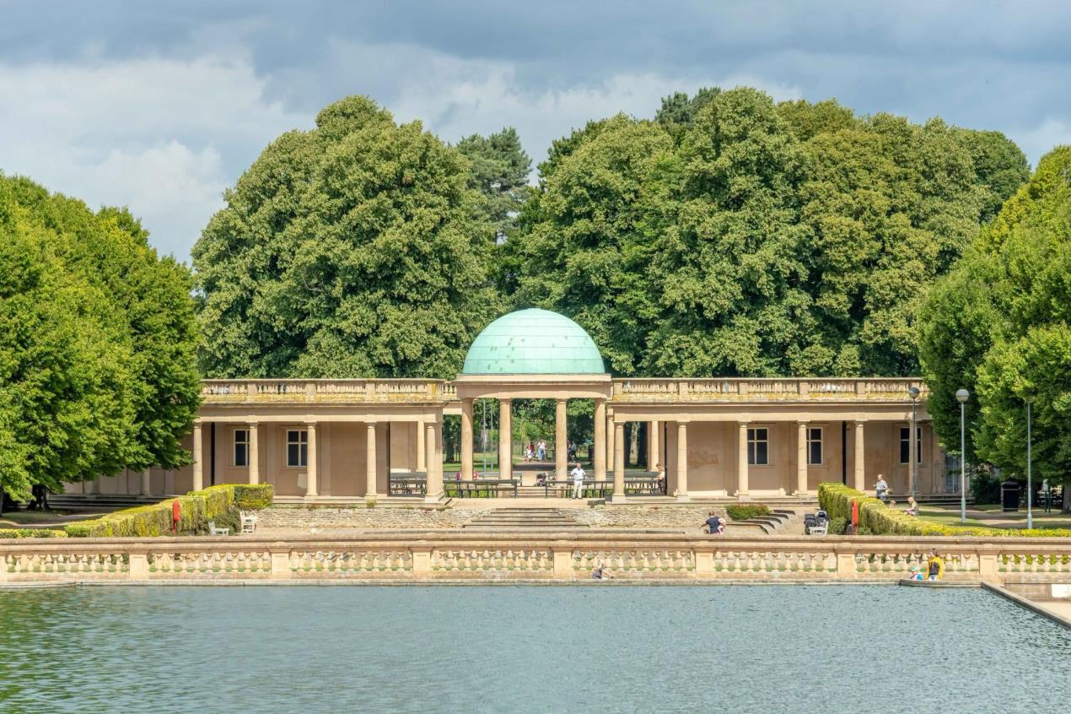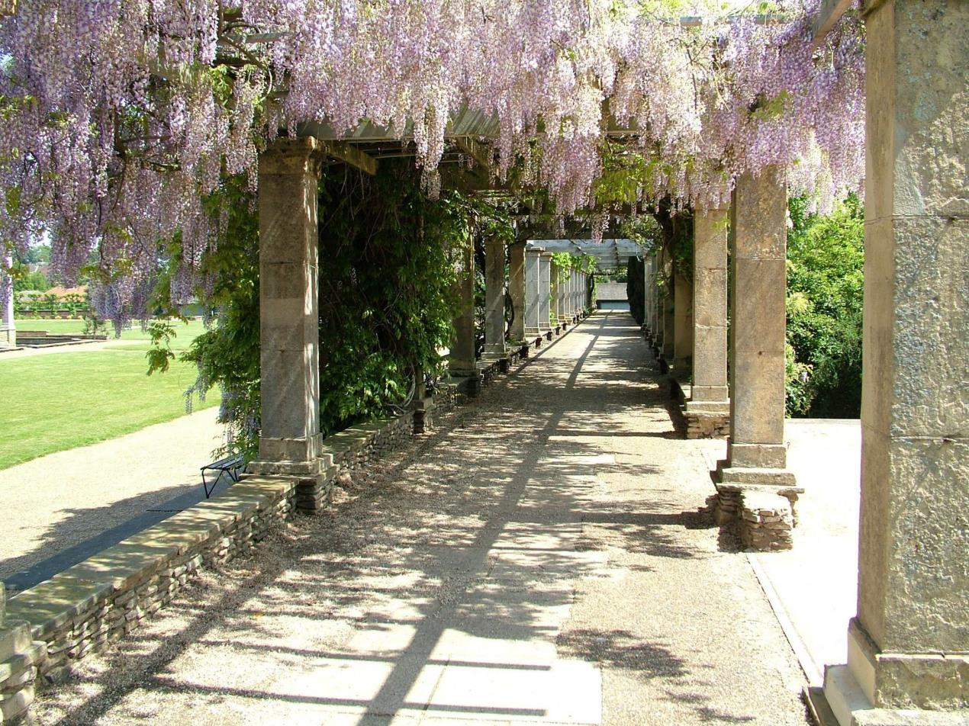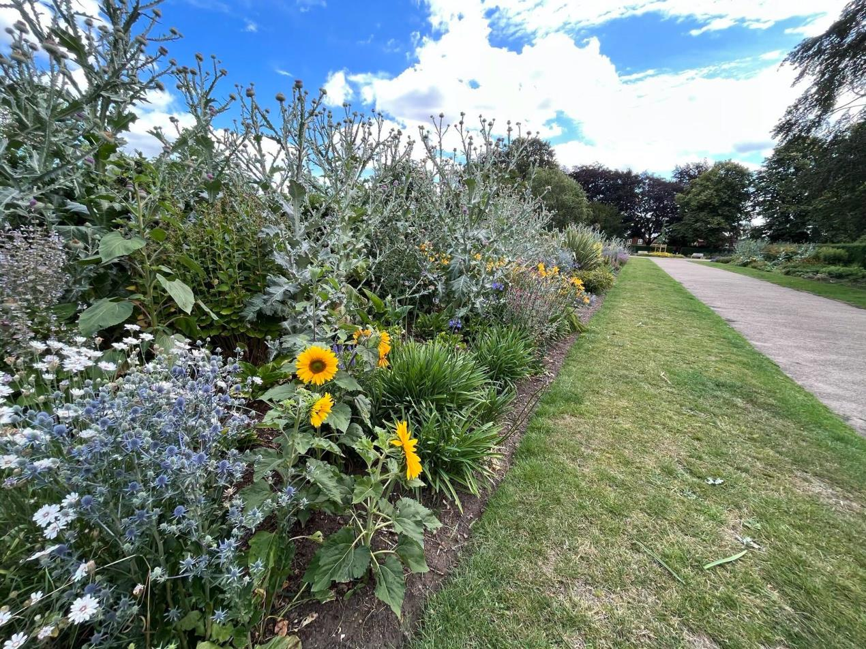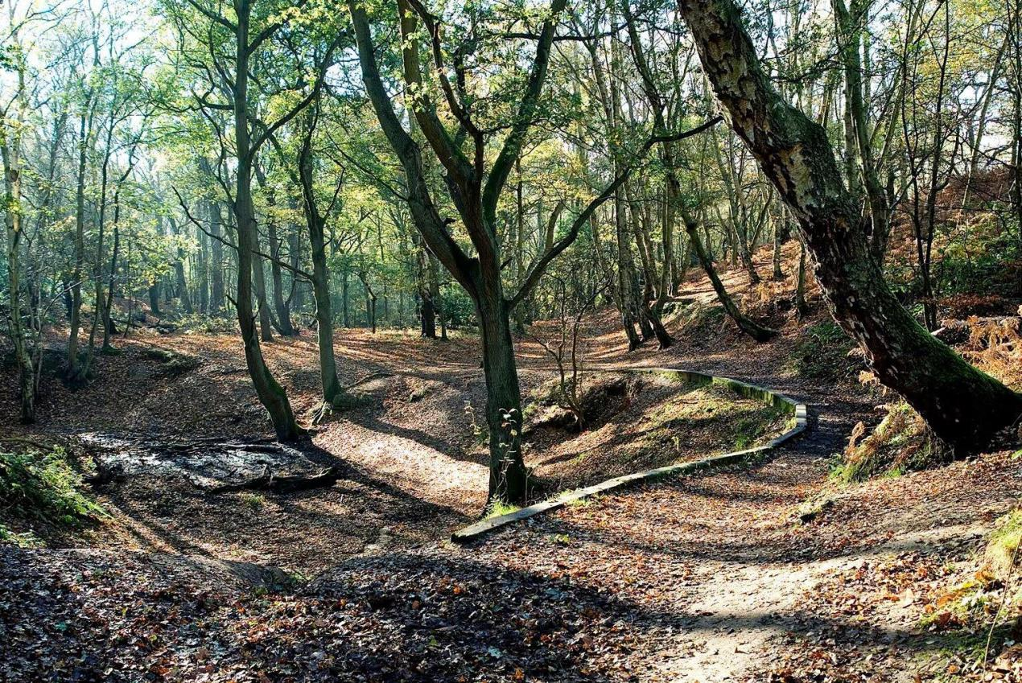
For more information contact:
Amy Maxwell, communications officer
Norwich City Council
t:01603 989473
e: amymaxwell@norwich.gov.uk

