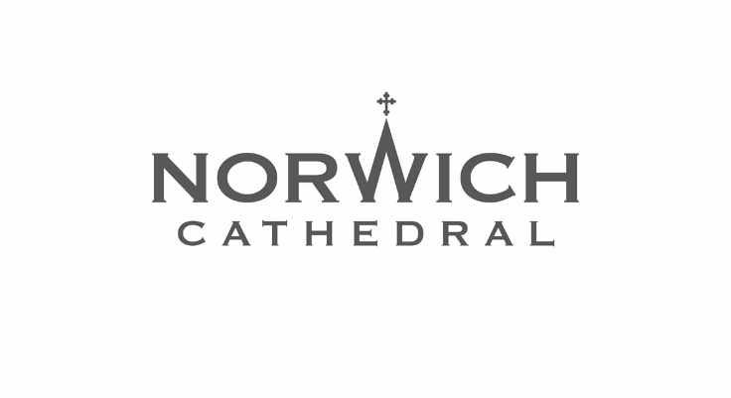
Press Release: For immediate release

Norwich Cathedral launches new Upper Level Tour

Norwich Cathedral has launched a new Upper Level Tour giving visitors the chance to see the historic landmark from an entirely different perspective and enjoy breathtaking views over the east end of the centuries-old building.

The new tour offers a unique opportunity to take a peek behind the scenes of the Cathedral’s ancient architecture and experience areas not usually open to the public.

Visitors ascend one of the Cathedral’s spiral staircases and enjoy stunning views from the first-floor gallery, an area which in centuries past would have regularly been used by the Benedictine monks as part of their daily rhythm of prayer and worship.

The Revd Dr Peter Doll, Canon Librarian and Vice Dean, and the Revd Canon Liz Leaver, Canon Pastor, have overseen the opening of the new Upper Level Tour with Norwich Cathedral’s team of volunteer guides.

Canon Liz said: “Visitors often ask about the upper levels of the Cathedral, and it is wonderful to now be able to give people the chance explore part of the first floor of the Cathedral and enjoy the incredible views.
“The tours have proven extremely popular and many of the tours are already sold out throughout August. Thank you to our brilliant team of volunteer guides for helping to make the tours such a success.”

The Upper Level Tour usually takes place twice a week, on Wednesday and Saturday at 10.30am and is open to visitors aged 16 and over. Tickets cost £10 plus booking fee.

To book tickets for the Upper Level Tour, visit www.cathedral.org.uk

Back on ground level, the Cathedral also runs a series of specialist tours on different subjects each month.

Tours taking place in August include:
- Saturday 1 August, 11.15am – Julian of Norwich
- Wednesday 5 August, 11.15am – The Cloister of Norwich Cathedral
- Wednesday 5 August, 2.15pm – The Cathedral Close
- Wednesday 5 August, 3pm – In Quires and Places Where They Sing
- Saturday 15 August, 11.15am – The Graffiti of Norwich Cathedral
- Wednesday 19 August, 2pm - Broderers’ Guild Workshop
- Friday 28 August, 2.30pm - Norwich Cathedral Library

For full details of all of Norwich Cathedral’s tours visit www.cathedral.org.uk

Notes to editors
For more information, please contact Norwich Cathedral’s Marketing and Communications Manager Emma Knights via eknights@cathedral.org.uk or 07968 460963.

Pictures of the Upper Level Tour accompany this press release. Please ensure the photo credit Bill Smith/Norwich Cathedral is used with the images.

About Norwich Cathedral
For more than 900 years Norwich Cathedral has played a key role in the life of the city and county as a place of worship, a historic treasure and an iconic landmark.

From its beginnings as a Benedictine monastery founded by Bishop Herbert de Losinga in 1096, to its role as a modern-day Cathedral, there is lots for visitors old and new to explore, and the Cathedral welcomes more than 600,000 people every year.

Norwich is known as the City of Stories and there are many to share at Norwich Cathedral – from having the second tallest Cathedral spire (96m) and the largest monastic Cloister in the country, to being decorated with an amazing collection of medieval roof bosses (carvings) which is the biggest of its kind in the world.

All are welcome to join the Cathedral’s daily services including beautiful Choral Evensong sung by Norwich Cathedral Choir on most term time evenings. Throughout the year many special services take place at the Cathedral to mark key moments in the life of Norwich and Norfolk.

Norwich Cathedral is open daily from 7am to 6.30pm.
For more information visit cathedral.org.uk

