

Press release

HOW DO WE FIND LOVE?

The Sainsbury Centre announces autumn 2026 exhibition programme

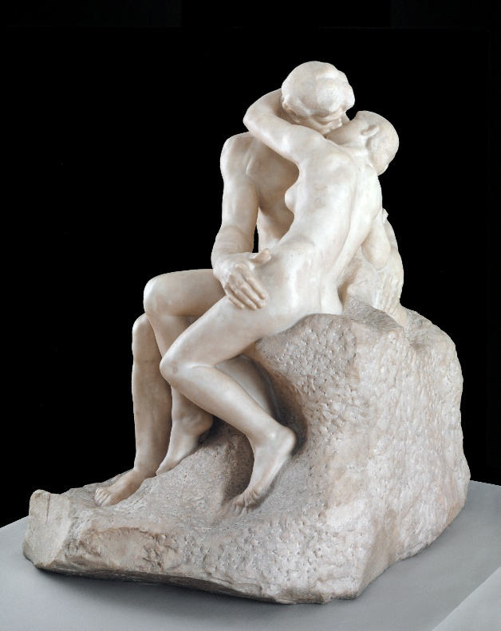

Auguste Rodin, The Kiss, 1901-4. Courtesy: Tate

The Sainsbury Centre continues its radical programme of exhibitions engaging with life’s most fundamental questions. The latest season, How Do We Find Love?, explores the profound complexities of human relationships, desire, and intimacy.

- The Last Human Kiss, 13 November 2026 – 11 April 2027
- Ecstasy and the Aftermath, 13 November 2026 – 11 April 2027
- Love Stories, 18 December 2026 – 30 May 2027

Love has always been one of art’s great subjects but is rarely its most seriously examined. This season moves beyond romantic clichés to explore love through encounters which are sexy and seductive; bodily and emotional; symbolic and intellectual. Spanning painting, sculpture, photography, textiles, moving image and sound, the exhibitions continually return to the same unresolved questions: what does it mean to be loved, and to love well?

Together, the exhibitions propose that art is the sharpest tool we have for thinking about intimacy. At a moment when human connection is increasingly mediated by screens, How Do We Find Love? asks audiences to sit with love’s complexities and contradictions: as wound and remedy, as sacred and profane, as private and political.

The season's programme approaches How Do We Find Love? from different curated perspectives: including an exhibition exploring what a kiss can tell us about being human, tracing the fleeting gesture across cultures; an exhibition exploring the risks and rituals of falling in and out of love, repositioning communities as a radical strategy for collective survival; and a photography exhibition capturing the raw reality of intimacy and everyday relationship dynamics.

Jago Cooper, Sainsbury Centre Director, said: “Art is a gateway to the human soul and these exhibitions create the perfect bridge to journey across. Love, in all its power and enigma, is given material form in the museum for people to explore and define their own relationship with it. This is definitely one of the most exciting and life-enhancing exhibition seasons we have ever done at the Sainsbury Centre.”

The Last Human Kiss
13 November 2026 – 11 April 2027

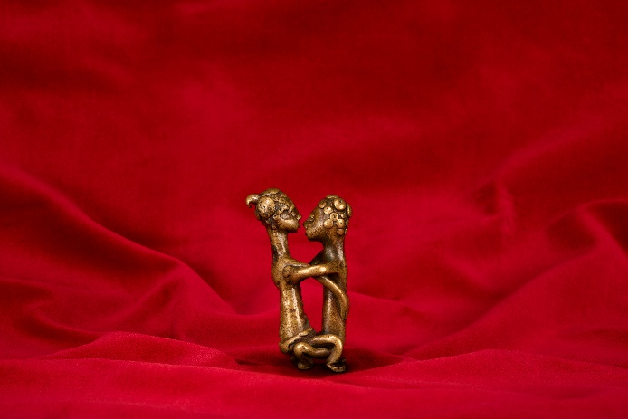
The Last Human Kiss explores how the kiss has shaped human ideas of love, intimacy, devotion, betrayal and belonging, and traces how artists have returned to the kiss as a way of thinking about human connection and condition. The exhibition features representations of the kiss between two people to its digital and beyond-human expressions in the 21st century. ‘The First Kiss’ lingers in the fragile space where attraction becomes attachment and strangers become companions; ‘The Divine Kiss’ explores the Baroque fascination with love’s power to disrupt; in ‘The Social Kiss’ intimacy reflects political or collective dynamics; ‘The Romantic Kiss’ explores desire’s euphoric charge, while ‘The Trickster Kiss’ brings us to the present, where kissing takes on mediated, digital, and post-human forms, at once everywhere and strangely absent.

Spanning painting, sculpture, photography and film, the exhibition features work by Anthony Van Dyck, Auguste Rodin, William Blake, Tracey Emin, Wolfgang Tillmans, Shilpa Gupta, Sophie Barber, Patty Chang and Dorothy Cross.

The Last Human Kiss is curated John Kenneth Paranada, formerly Curator of Art and Climate Change at the Sainsbury Centre.

Ecstasy and the Aftermath
13 November 2026 – 11 April 2027

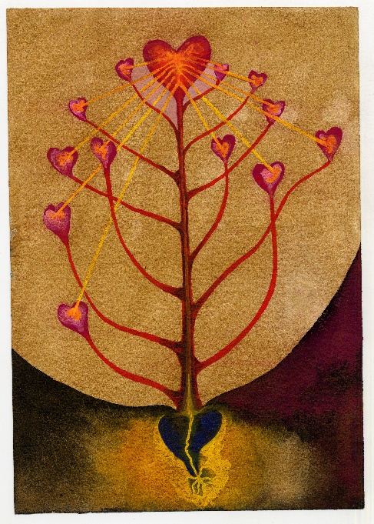
What does it mean to love and be loved in return? Reflecting on how deep connections are formed, broken, remembered and mourned, the exhibition asks whether love ever truly ends.

Moving beyond the themes of private desire and heartbreak, the exhibition reframes love as a subversive force for change and a way of building the world anew. Selected artworks address how identity, self-worth and a sense of belonging are negotiated within contemporary culture and society. Works by such artists as Jonathan Baldock, Bex Wade, Somaya Critchlow, Vanessa Raw, Dyana Gravina, Judy Chicago, Marina Abramović and Ulay and Phoebe Boswell give voice and visibility to LGBTQIA+ communities and trans care networks and engage intersectional feminist politics.

Ecstasy and the Aftermath is guest-curated by Huma Kabakci, in collaboration with Vanessa Tothill, Curator of Transhistorical Narratives at the Sainsbury Centre.

Love Stories
18 December 2026 – 30 May 2027

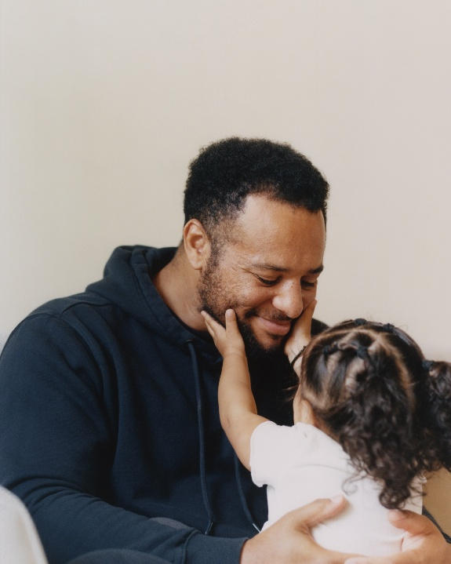
Love Stories is an exhibition of photography that explores love as it shapes our everyday lives. Bringing together the work of ten internationally acclaimed photographers, the exhibition moves beyond traditional romantic narratives to reveal intimate stories of friendship, family, partnership, community and selfhood, capturing the complex mix of mundane, humorous, painful and joyful emotions at the heart of human relationships.

Works on show range from Richard Billingham’s series documenting the lives of his parents, Ray and Liz, in their flat in England’s Black Country, to Martin Parr’s sardonic Bored Couples, exploring how individual assumptions and context influence how we interpret photographs. shown for the first time in the UK, Akihito Yoshida’s tender series documents the relationship between his grandmother and her grandson, the photographer’s cousin, Daiki. A series of striking self-portraits by Zanele Muholi reclaim Black identity, while Sunil Gupta and Charan Singh’s Lovers Revisited presents an intergenerational dialogue celebrating queer love and visibility.

The exhibition also includes work by, Masahisa Fukase, Ollie Adegbayo, Isabel Okoro and Carol Allen-Storey.

Love Stories is curated by Tafadzwa Makwabarara, Curator of Cultural Empowerment at the Sainsbury Centre.

The season is accompanied by a book published by the Sainsbury Centre with Artworld Projects, which features new art historical texts by Huma Kabakci, Tafadzwa Makwabarara, John Kenneth Paranada and Vanessa Tothill and an interview between Rosy Gray and artist Seyi Adelekun. The book also includes creative writing by Victoria Cantons, Chantal Powell, Bea Prutton and artist duo Hylozoic/Desires (Himali Singh Soin and David Soin Tappeser) as well as a newly commissioned short story by celebrated author Oyinkan Braithwaite.

-END-

NOTES TO EDITORS

For more information, interviews and images:

Kate Wolstenholme
PR and Media Officer at the Sainsbury Centre
k.wolstenholme@uea.ac.uk
01603 592470

HIGH RESOLUTION IMAGES CAN BE FOUND HERE
- Auguste Rodin, The Kiss, 1901-4. Courtesy: Tate
- Goldweight representing human couple, c.1700 – 1899, brass, Ghana, Africa. Donated by Robert and Lisa Sainsbury, 1973 © Sainsbury Centre. Photograph: Denisa Ilie
- Ithell Colquhoun, The Tree of Veins, 1940-41. Copyright of the artist. Courtesy: Tate
- Ollie Adegboye, Theo Collard-Peters, London 2022. Copyright and courtesy of the artist

Opening times
Tuesday – Friday 9am-6pm (exhibitions open 9.30am)
Saturday – Sunday 10am-5pm
Closed Mondays, including bank holidays

Entry
Tickets operate on a ‘Pay Only If and What You Want’ basis, so you can choose the price from free through to full membership. A Universal Ticket grants access to the permanent collection, Lower and Mezzanine Galleries, and Sculpture Park.

The Sainsbury Centre is a world-class art museum with a unique perspective on how art can foster cultural dialogue and exchange. Following a radical relaunch in 2023 the Sainsbury Centre formally recognises the living lifeforce of art, enabling people to build relationships across an arts landscape.

The art of the Sainsbury Centre can help reframe and answer the most important questions people have in their lives. It is not a museum to only learn more about artists, cultures or movements like Francis Bacon, the Tang Dynasty or Modernism, it is a place of experience, where collections are animate, and visitors are emotionally connected.

One of the first museums in the world to display art from all around the globe and from all time periods equally and collectively, Sir Robert and Lady Lisa Sainsbury created one of the most sought after yet non-conformist art collections. In 1973 they donated their collection, which transcended traditional barriers between art, architecture, archaeology and anthropology, to the University of East Anglia, and created an entirely new type of museum. Housed in Sir Norman Foster’s revolutionary first ever public building, the space aimed for an interactive relationship between people, object and landscape, where art was placed within an open yet intimate ‘living area’.

Visit sainsburycentre.ac.uk and follow @sainsburycentre on Facebook, X, Instagram, TikTok and LinkedIn, as well as @TheSainsburyCentre on YouTube.

