Press Release
26 August 2026

Norwich Cocktail Week returns this September with more venues,
£7.50 cocktails and new city-wide trails

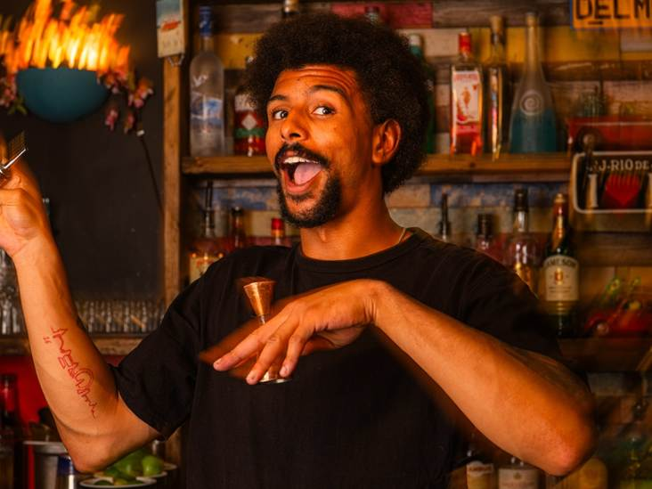
Norwich Cocktail Week is back from 25 September to 4 October, transforming the city into a celebration of exceptional cocktails and unforgettable experiences.
For ten days, Norwich's cocktail bars, restaurants and independent hospitality venues will come together to showcase the city's vibrant cocktail scene, with more than 40 venues already confirmed.
At the heart of the week is the chance to enjoy exclusive signature cocktails for just £7.50, with mocktails available for £6, making it easy to try somewhere different, discover a new favourite drink or simply make a night of it with friends.

More ways to explore Norwich
This year, Norwich Cocktail Week is adding even more ways to turn a night out into a city-wide adventure. New cocktail trails will take visitors across Norwich, encouraging them to explore participating venues, discover drinks and collect digital stamps along the way.
Complete a trail and you can earn a limited-edition Norwich Cocktail Week T-shirt (subject to availability), with further rewards and prizes available through the week.
Everything is managed through the free Norwich Food & Drink Weeks app, making it easy to see participating venues, browse the cocktail and mocktail menus, discover events, follow trails and keep track of your progress.

How to Take Part
- Download the Norwich Food & Drink Weeks app via the Apple App Store or Google Play.
- Explore the Cocktail Week map to discover participating venues, exclusive cocktails, events and trails.
- Check in and collect digital stamps as you visit venues.
- Complete trails and unlock rewards, including the limited-edition Norwich Cocktail Week T-shirt (subject to availability).

More than 40 venues taking part
More than 40 venues are already confirmed for Norwich Cocktail Week 2026, including four venues operated by i2i Hospitality: Ten Bells, Three Stories, The Drawing Rooms and The Wildman.
Steve Mantle, Managing Director of i2i Hospitality, said: “Norwich has a brilliant hospitality scene, with so many different venues and experiences to discover. Cocktail Week is a great opportunity for us to showcase what our venues have to offer, while being part of a bigger celebration across the city.”
Other confirmed venues include Beer Hatch, Chambers, Copa Cubana, Dick's Bar, J.Doe & Co, Sir Toby's Beers, The Last, The Tipsy Anchor and YALM, with more set to join in the coming weeks.
Alongside the trails and exclusive cocktails, the programme will feature cocktail-themed events, masterclasses, tastings and one-off experiences, offering plenty of opportunities to discover the craft behind Norwich's cocktail scene.

A city-wide celebration of hospitality
Norwich Cocktail Week rounds off Norwich Business Improvement District (BID)'s 2026 programme of city-wide food and drink celebrations, following Norwich Food Week in February and Norwich Wine Week in June.
Stefan Gurney, Executive Director, Norwich Business Improvement District (BID), said: “We’re delighted to be bringing Norwich Cocktail Week back for 2026. Supporting the businesses that make Norwich such a buzzing city to live and visit is at the heart of what we do."
The Norwich Food & Drink Weeks app is available to download via the Apple App Store and Google Play.
<ends>

Notes to Editors:
For interviews please contact:
Mel March, Senior PR & Marketing Manager, Norwich BID - mel.march@norwichbid.co.uk
Hero image credit: Eht. Regulars - Norwich Cocktail Week 2026 - Credit ©Nathan Neeve
High resolution images: https://show.pics.io/cocktail-week-2026-pr-selection
Website / Social Links:
- https://norwichcocktailweek.co.uk/
- https://www.instagram.com/norwichcocktailweek/
About Norwich BID
Established in November 2012, Norwich BID is run for local businesses by local businesses. The BID covers a defined area of Norwich where businesses plan how to improve their trading environment, identifying additional projects and services that develop the city centre and trade. Investment in the BID area aims to enhance and promote the local environment for businesses, employees, customers and tourists. The overarching vision is to make a clear positive impact on the vitality of our city centre and the success of the businesses within it.

