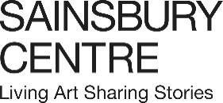

Press release

The Last Human Kiss

A new exhibition that celebrates one of humanity’s most enduring acts, launching as part of the Sainsbury Centre’s new season, which asks the timeless question, How Do We Find Love?

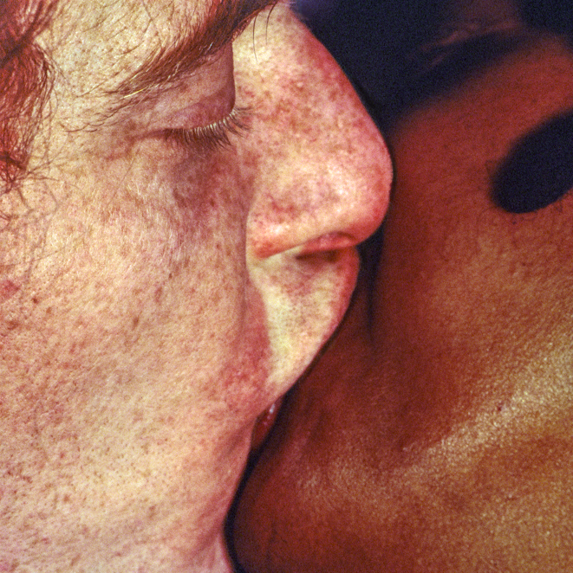
Sonia Boyce, Mm…, 1995. © Sonia Boyce. All Rights Reserved, DACS Images

13 November 2026 – 11 April 2027
Sainsbury Centre, Norwich

The Last Human Kiss brings together contemporary artworks by some of the world’s leading artists including Tracey Emin, Wolfgang Tillmans, Sally Mann, Sonia Boyce, Shilpa Gupta, Patty Chang, Dorothy Cross, Ty Locke, Sophie Barber, Oliver Beer and Zheng Bo, as well as new works on display for the first time by Ṣọlá Olúlòde and Paula Turmina and a painting created especially for the exhibition by Benjamin Spiers, together with historical objects and artworks to explore the kiss as a symbol through which societies have imagined intimacy, negotiated power, and given form to love itself.

From historical representations of the kiss between two people to a digital world of beyond-human expressions in the 21st century. The Last Human Kiss explores the kiss as a universal language through which desire, power, vulnerability and transcendence have been expressed and contested. Few gestures appear more natural, yet across cultures the meeting of lips has consecrated monarchs, sealed treaties, betrayed lovers, and quietly altered the course of history. The exhibition asks: if the kiss is not simply instinctive, but one of humanity’s most enduring cultural inventions, what might it reveal about the fragile, contradictory and deeply social nature of being human?

Unfolding across five thematic chapters, The First Kiss, The Social Kiss, The Divine Kiss, The Romantic Kiss and The Trickster Kiss, the exhibition traces how artists have returned to the kiss as a way of thinking about connection and the human condition.

Opening the exhibition, The First Kiss lingers in the fragile space where attraction becomes attachment and strangers become companions. The Social Kiss turns to the public life of intimacy. Parents kiss children goodnight; in many cultures, friends greet one another with kisses; while lovers might kiss one another in celebration, secrecy, protest or defiance. Each society establishes the boundaries of who may kiss, and under what circumstances. Works by Sonia Boyce, Oliviero Toscani, Sally Mann and Sir Hamo Thornycroft reveal how the kiss becomes entangled with public life. The kiss can both affirm belonging and test the limits of what is permissible.

The Divine Kiss considers that, long before it became the emblem of romantic love, the kiss belonged to a sacred context. Across religious traditions, pilgrims have pressed their lips to relics, scriptures, icons and holy images in an act of devotion, believing that this intimate gesture might momentarily collapse the gap between earthly life and divine presence. This section includes paintings by Anthony Van Dyck and in the style of Guercino and a sculpture by John Gibson, which present the kiss not as a sign of affection, but of grace and spiritual kinship, while William Blake transforms the biblical vision of Mercy and Truth meeting in a kiss into an image of reconciliation.

The Romantic Kiss asks how the kiss came to embody our idea of romantic love. By the nineteenth century, it had emerged as one of Western art’s most enduring symbols of passion. Auguste Rodin’s The Kiss frames love as both union and dissolution, while contemporary works by Neil Stokoe, Wolfgang Tillmans, Ty Locke, Joanna van Son, Christina Kimeze, Paula Turmina, Benjamin Spiers, Omar El Lahib and Shilpa Gupta extend this inheritance, suggesting that the romantic kiss is never simply an image of love: it can be intimate and deeply personal, yet also performative, shaped by the ideals, conventions and fantasies of its age.

The Trickster Kiss concludes by exploring the kiss as a potential site of ambiguity, insincerity and misrecognition. In works by David Teniers the Younger, Bob Law, Dorothy Cross, Dorothea Saykaly and Emil Dam Seidel, Sophie Barber, Tracey Emin, Oliver Beer and Patty Chang, intimacy is redirected, misunderstood or turned into comedic performance and conceptual art, revealing how unstable even the most familiar expressions of love can become.

The Last Human Kiss moves beyond the human in the work of Zheng Bo and Uta Kögelsberger. As the climate crisis reshapes how we understand life on Earth, the exhibition concludes by asking whether the future of intimacy might require new forms of kinship, not only with each other, but with the living world itself. The kiss is expanded as a metaphor for attachment, dependence and care, suggesting that love may be far stranger, and more expansive, than romantic convention allows.

Head of Exhibitions, Tania Moore, said: “The seemingly simple act of the kiss has wide-reaching political, social and cultural significance whilst being deeply personal and intimate. By speculating on a ‘last human kiss’, this exhibition allows us to consider the importance of human connection and finding love in an increasingly tumultuous world.”

Director of the Sainsbury Centre, Jago Cooper, said: “There is no greater moment of hope and human vulnerability than the instant before your lips touch another’s for the first time. The Last Human Kiss immerses you in the raw beauty and fragility of this universal human connection. You have to see this exhibition because it helps you find love in the world all around us.”

The Last Human Kiss is curated by John Kenneth Paranada, formerly Curator of Art and Climate Change at the Sainsbury Centre.

Asking what the kiss can tell us about being human, the exhibition is part of the Sainsbury Centre’s latest series of innovative exhibitions exploring fundamental and timeless questions. This season, which asks How Do We Find Love, also includes the exhibitions Ecstasy and the Aftermath, launching 13 November, and Love Stories, launching 18 December.

The season explores the profound complexities of human relationships, desire and intimacy, from classical depictions of romantic gestures to contemporary, photographic projects looking at close relationships – whether they be romantic, familial, or platonic. Timeless and universal in its scope, the exhibition series proposes that art is the sharpest tool we have for thinking about intimacy and asks audiences to sit with its complexities and contradictions.

NOTES TO EDITORS

For more information, interviews and images:
Kate Wolstenholme / PR and Media Officer, Sainsbury Centre
k.wolstenholme@uea.ac.uk / 01603 592470

Exhibition details
The Last Human Kiss
13 November 2026 – 11 April 2027
Sainsbury Centre, University of East Anglia,
Norfolk Road,
Norwich NR4 7TJ
The Sainsbury Centre continues its innovative series of investigative exhibitions in 2026 with a new programme that examines love and intimacy.

Five concurrent exhibitions and interventions ask How Do We Find Love?, featuring:

- The Last Human Kiss, 13 November 2026 – 11 April 2027
- Ecstasy and the Aftermath, 13 November – 11 April 2027
- Love Stories, 18 December 2026 – 30 May 2027

HIGH RESOLUTION IMAGES CAN BE FOUND HERE
- Sonia Boyce, Mm…, 1995. © Sonia Boyce. All Rights Reserved, DACS Images

Opening times
Tuesday – Friday 9am–6pm (exhibitions open 9.30am)
Saturday – Sunday 10am–5pm
Closed Mondays, including bank holidays

Entry
Tickets operate on a Pay If and What You Can basis, so you can choose the price from free through to full membership. A Universal Ticket grants access to the permanent collection, Lower and Mezzanine Galleries, and Sculpture Park.

The Sainsbury Centre is a world-class art museum with a unique perspective on how art can foster cultural dialogue and exchange. Following a radical relaunch in 2023 the Sainsbury Centre formally recognises the living lifeforce of art, enabling people to build relationships across an arts landscape.

The art of the Sainsbury Centre can help reframe and answer the most important questions people have in their lives. It is not a museum to only learn more about artists, cultures or movements like Francis Bacon, the Tang Dynasty or Modernism, it is a place of experience, where collections are animate, and visitors are emotionally connected.

One of the first museums in the world to display art from all around the globe and from all time periods equally and collectively, Sir Robert and Lady Lisa Sainsbury created one of the most sought after yet non-conformist art collections. In 1973 they donated their collection, which transcended traditional barriers between art, architecture, archaeology and anthropology, to the University of East Anglia, and created an entirely new type of museum. Housed in Sir Norman Foster’s revolutionary first ever public building, the space aimed for an interactive relationship between people, object and landscape, where art was placed within an open yet intimate ‘living area’.

Visit sainsburycentre.ac.uk and follow @sainsburycentre on Facebook, X, Instagram, TikTok and LinkedIn, as well as @TheSainsburyCentre on YouTube.

