FOR IMMEDIATE RELEASE
Thursday 27th August 2026

More than 4,000 tickets booked on release day for Norfolk Heritage Open Days 2026
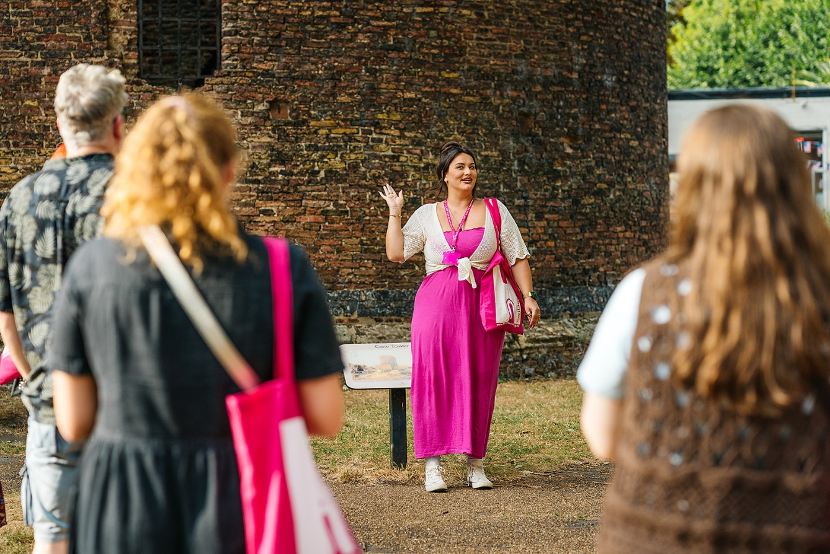
Credit Beth Moseley Photography
Ahead of the upcoming Norfolk Heritage Open Days festival in September, more than 4,000 tickets were issued on the day booking opened, underlining strong public demand for the county’s annual celebration of history and culture.
Heritage Open Days (HODs) is England’s largest festival of history and culture, bringing communities together each September to celebrate local stories, historic places and cultural traditions. Running from Friday 11 to Sunday 20 September 2026, the festival will offer exhibitions, open buildings, tours, talks, performances, workshops, family activities and special events across Norfolk. The programme, of 350+ events, spans Norwich landmarks, coastal heritage, the Broads, historic houses, theatres, cemeteries, museums and railway stories. Every event is free to attend.
Some limited-capacity events require advance booking and many are now fully booked, but some spaces remain for selected talks and other events. Visitors can also choose from more than 200 drop-in events throughout the festival. Returned tickets will be released online, so audiences are encouraged to check individual listings regularly for availability and booking details.
Katie Ellis, Norfolk Heritage Open Days Event Producer said,
"The popularity of our ticketed events shows just how much people value Norfolk's incredible heritage, but there are still so many opportunities to take part. Across the county, visitors can enjoy a huge range of free drop-in events, meaning nobody misses out on the chance to experience and celebrate local history, culture and community during Heritage Open Days."
Some of the drop-in event highlights include:
- Time & Tide Museum – Great Yarmouth
Sat 12 & Sun 13 Sep: 10am-4.30pm.
Housed in a beautifully converted Victorian herring curing works, the museum offers an immersive experience where history lingers in the air, along with the unmistakable aroma of the smokehouse.
- Getting Into a Spin – Aylsham Heritage Centre
Tue 15 & Sun 20 Sep: 12.30pm-1.30pm, Fri 18 Sep: 10am-1pm. No booking required.
Echoing the traditional everyday histories of many of the inhabitants of Aylsham, the Worstead Guild of Weavers, Spinners and Dyers will be in the centre to demonstrate a spinning wheel and a loom and invite visitors to have-a-go.
- Oxburgh Estate – Oxborough
Fri 18 & Sat 19 Sep: 9.30am-5pm. No booking required.
Explore Victorian Gothic interiors, peaceful woodland walks and colourful gardens. Especially for HODs, discover the Everyday Histories of staff who worked on the estate in the early 20th century. Guided tours bookable on arrival.
- Routes to Roots – Wymondham Abbey Station
Sat 19 Sep: 10am-4.30pm. No booking required
Explore Norfolk's stations' histories and hear the stories of the people who, from 1846, served their communities, working on, living in or being connected with the railway line from County School to Wymondham and beyond. Tour the signal box and enjoy a fun-packed day of railway living histories at this family-friendly event.
- How Hill Trust – How Hill House, Ludham
Sun 20 Sep: 10am-3pm. No booking required.
Experience a captivating open day at the How Hill Trust, a stunning Edwardian estate nestled in the Norfolk Broads. Highlights include open gardens, house tours, woodland walks and heritage displays including marshman and thatching tools.
- Top to Toe, Cloche Hats to Tango Heels – Museum of Norwich at the Bridewell
Sat 19 Sep, 10am-2pm. No booking required.
Create your own designer-inspired bookmark and learn about flappers and titfers. A Costume & Textile Association drop-in session for all ages and abilities with a 1920s theme to celebrate the centenary of the Museum of Norwich at the Bridewell.
- King’s Lynn Heritage Day
Sun 13 Sep: 10am-4pm. No booking required.
Experience a jam-packed programme in King’s Lynn featuring exciting events, lively re-enactors, family-friendly activities, music, dancing, miniature trains, boats, classic cars and exhibitions!

Portraits of Life returns to The Forum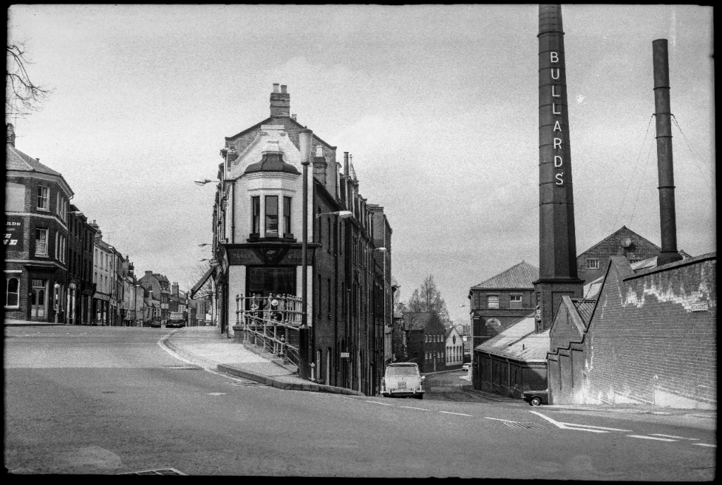
Credit Jack Roberts Archive

As part of the Norfolk HODs programme, The Forum will bring back the popular Portraits of Life exhibition, featuring photographs by Jack Roberts that document Norwich after the Second World War and before the city’s redevelopment in the early 1970s. The exhibition will include previously unseen photographs, archive films and recorded stories from people who lived and worked in the city.
“We welcomed more than 3,500 visitors to the exhibition in 2019 and we’re delighted to bring it back with unseen photographs, stories and films, so more people can discover Norwich’s past through the people who lived it.”
said Katie Ellis, Event Producer for Norfolk Heritage Open Days.
The exhibition was made possible by Derek James and Bill Smith, custodians of the Jack Roberts Archive, who scanned and preserved Roberts’ original negatives. Digital photographs, recorded stories and a film featuring 90 images have been deposited at the Norfolk Record Office for future access.
“Jack was the forgotten photographer, and it has been an honour to share his work with the people of Norwich and Norfolk,” said Derek James. “His battered old box of negatives proved to be a treasure chest of memories, capturing long-lost roads and neighbourhoods rarely photographed.”
Bill Smith added:
“We are so pleased to have been able to save Jack’s work for the future, and to underline how important old photographic negatives can be in retrieving every last detail from a professional photographer’s work.”
The exhibition will be displayed within The Forum for the duration of the Heritage Open Days festival Friday 11 until Sunday 20 September, 10am-4pm, free and open to everyone.
Remaining tickets can be booked via norfolkheritageopendays.co.uk, alongside helpful guides and information for planning your HODs experiences and drop-in events. Printed brochures are still available from The Forum, Norfolk Libraries, and selected venues across the county.

— ENDS —

Media enquiries
Millie Batch, Events Marketing Producer
millie.batch@theforumnorwich.co.uk | 01603 727937
Images and credits: Download press images

Notes to editors

About Norfolk Heritage Open Days
Norfolk Heritage Open Days returns from Friday 11 to Sunday 20 September 2026, inviting residents and visitors to explore the places, people and stories that shape the county. It forms part of Heritage Open Days, England’s largest community-led festival of history and culture, and offers ten days of free events and experiences across Norfolk.

About The Forum
The Forum is an independent charity and cultural landmark in Norwich city centre. Open seven days a week except Christmas Day and Boxing Day, it provides a year-round programme of predominantly free public events, exhibitions and activities. The Forum presents and coordinates Norwich Science Festival, Norwich Games Festival, Norfolk Deaf Festival, Norwich Book Festival and Norfolk Heritage Open Days. Visit theforumnorwich.co.uk.

About Heritage Open Days
Heritage Open Days is England’s largest festival of history and culture, offering free access to heritage events and activities for ten days each September. It is brought to you by the National Trust, supported by players of People’s Postcode Lottery and delivered locally by organisations, councils, community groups and volunteers. It is England’s contribution to European Heritage Days, which takes place across 50 countries. Visit HeritageOpenDays.org.uk.

