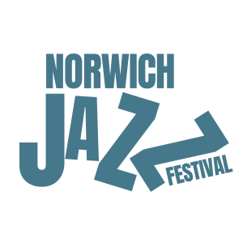
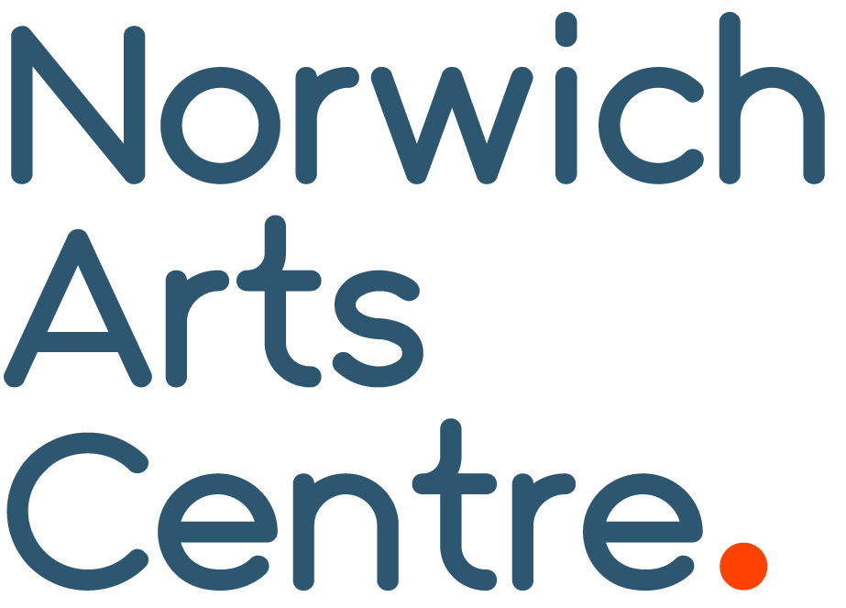

Norwich Jazz Festival Returns in May 2027
The Norwich Jazz Festival returns for its third year in May 2027, building on the success of its 2025 revival by Norwich Arts Centre after a 25-year break.
Bringing a vibrant programme of live music, talks and film to venues across the city, the festival showcases some of the most exciting voices in contemporary UK jazz.
The first artists to be announced include Mercury Prize 2026 nominees Knats, with their distinctive blend of "Geordie Jazz", trip-hop jazz pioneers Red Snapper, acclaimed tenor saxophonist Emma Rawicz and award-winning Scottish pianist Fergus McCreadie.
"We're delighted to bring Norwich Jazz Festival back for 2027. Definite highlight is Mercury Prize nominees Knats, a trio from Newcastle who are one of the most exciting new bands in the UK right now."
Bradley Glasspoole, Artistic Director, Norwich Jazz Festival
Tickets go on sale at 10am on Friday 9 October.
Festival-goers can take advantage of early bird savings, with 10% off when booking three or more festival events and 15% off when booking all four shows. Discounts are applied automatically at checkout when eligible events are added to your basket.

Visit norwichartscentre.co.uk for details.

END
NAC Contacts:
Kelly Robb and Grace Jackson Communication and Development Managers
E-mail: kelly@norwichartscentre.co.uk | grace@norwichartscentre.co.uk

