

Press release

Ecstasy and the Aftermath

A new exhibition exploring the risks and rituals of falling in and out of love, launching as part of the Sainsbury Centre’s new season asking the timeless question How Do We Find Love?

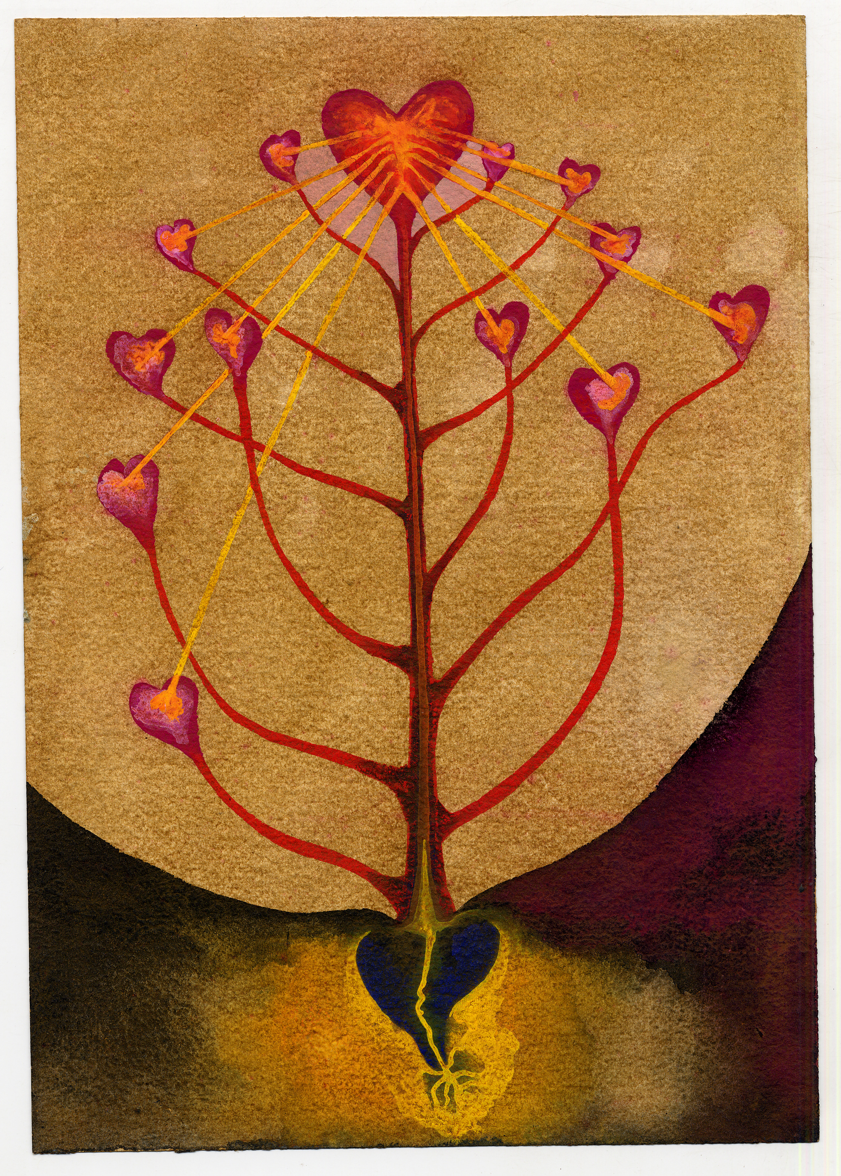
Ithell Colquhoun, The Tree of Veins, 1940–41. Copyright of the artist. Courtesy: Tate

13 November 2026 – 11 April 2027
Sainsbury Centre, Norwich

Ecstasy and the Aftermath considers relationships beyond the exhilarating early days, asking what is left after love has ended. The exhibition draws on feminist politics and queer ecologies to examine love not merely as a private vulnerability, but as an essential strategy for survival and radical act of resistance. Works by celebrated artists including Francis Bacon, Somaya Critchlow, Judy Chicago, Marina Abramović and Jonathan Baldock will sit alongside artists including Dyana Gravina, Ingrid Berthon-Moine and Polly Penrose, for whom this is their first institutional show.

Love has long been imagined through myth and symbol: as union and rupture, longing and transformation, a force that simultaneously destroys and creates. As part of the Sainsbury Centre’s latest investigative season, How Do We Find Love?. Ecstasy and the Aftermath takes love not as romantic sentiment but as a political, mythic and collective force, repositioning connection as a radical strategy for survival. The exhibition unfolds across three sections: ‘Erotic Entanglements and Risk’, ‘Loss, Grief and Growth’ and ‘Kinship and Chosen Families’.

The first section, ‘Erotic Entanglements and Risk’, centres on the experience of falling in love – noting that art often frames this erotic charge through the lens of appetite, transgression or altered states in imagery that is seductive, grotesque or dreamlike. Ithell Colquhoun’s Diagrams of Love (1940–41) map hidden connections between the body, nature and spirit, while Chantal Powell’s new cast glass works Votives: Milk and Seed (2025–26), made especially for the exhibition, similarly suggest that desire is fulfilled through magic, ritual and trials that carry risk. Somaya Critchlow’s self-portrait Untitled (2019) and Bex Wade’s photographs of queer nightlife Christeene (2012) and Damn Van Dam (2011) explore the mechanics of desire and arousal, indulging our fantasies while questioning our assumptions. Underscoring these works is the notion that after closeness comes pleasure and vulnerability, but also the fear of loss.

Heartbreak, a form of intense grief, is the focus of ‘Loss, Grief and Growth’. Francis Bacon's painting Study for Portrait of P.L., no. 2 (1957) depicts Peter Lacy, the most destructive love of Bacon’s life, who died several years after it was painted. What began as desire becomes a kind of haunting: the beloved's face outliving the love itself. İnci Eviner’s video performance Under One Body (2024) and Ghada Amer‘s life-sized embroidery work Barbie Loves Ken, Ken Loves Barbie (1995–2002) suggest that in love the physical and psychological boundaries of the self are under constant negotiation. Paloma Proudfoot’s ceramic Gossip (2025) and Francisca Sosa López’s embroidery work Incessant ranting of a persistent love affair (about my country) (2019) remind us that talking about our emotions is part of how we heal. The works in this section propose that, despite the initial pain of heartbreak, the happy memories of falling in love and being loved in return can enable us to recover and find love again.

Finally, ‘Kinship & Chosen Families’ explores the many ways of loving that extend beyond romantic pairings or biological kinship. Many people learn how to love from the care they receive in childhood from their parents, caregivers and siblings; outside of the home, people create networks of support in friends and loved ones. Phoebe Boswell’s Ballad of the Spirits (2025) drawings explore the physical intimacy between parent and child, while Jonathan Baldock’s sculptural assemblage Eating Feelings (a conversation) (2020) and Judy Chicago’s lithographic series Voices from the Song of Songs (1999–2000) treat communication as the grounds of any loving connection. Across sensual, spiritual, poetic and political dimensions, these works speak to the transformative power of love.

Ultimately, Ecstasy and the Aftermath asks whether love really ends, or does it remain and transform into something else? Stripping away its idealised fantasies, the exhibition traces affection’s full arc from fierce erotic charge to collective care and the long reckoning of grief. The exhibition invites visitors to ask what remains once love has shifted or dissolved. The exhibition suggests that navigating the aftermath of loss is what teaches us to heal, to build meaningful communities, and to risk giving ourselves to one another again.
Curator Huma Kabakcı said: “Over the years, love is the question I keep returning to, personally, spiritually and professionally. This exhibition grew from my own experience of loss, the end of a relationship with my then ex-fiancé, and the slow, serendipitous rebuilding that followed. What began as something private opened outward into something urgent and universal through shared vulnerability, pain and healing process. We are living through a moment of profound collective fracture and uncertainty, and I believe love, in all its forms, is one of the few forces capable of holding us together. Especially rituals around love, commitment and healing play a significant role in my curatorial practice and personal life including collectively painting my unused wedding dress.”

Director of the Sainsbury Centre, Jago Cooper, said: “Finding and falling out of love is the ultimate rollercoaster of life. This is a thrilling show that takes you on that ride and helps you feel the velocity and fear along the way.”

The exhibition includes works by the artists Marina Abramović and Ulay, Ghada Amer, Francis Bacon, Jonathan Baldock, Ingrid Berthon-Moine, Phoebe Boswell, Judy Chicago, Ithell Colquhoun, Somaya Critchlow, İnci Eviner, Penny Goring, Dyana Gravina, Jane Hayes Greenwood, Blair Hughes-Stanton, Anna Perach, Polly Penrose, Chantal Powell, Paloma Proudfoot, Vanessa Raw, Miriam Schapiro, Francisca Sosa López, Holly Stevenson, Maya Weishof and Bex Wade.

Ecstasy and the Aftermath is curated by guest curator Huma Kabakcı, in collaboration with Vanessa Tothill, Curator of Transhistorical Narratives at the Sainsbury Centre.

Asking how deep connections are formed, broken and remembered through the concepts of myth and ritual, the exhibition is part of the Sainsbury Centre’s latest series of innovative exhibitions exploring fundamental and timeless questions. This season, which asks How Do We Find Love?, also includes the exhibitions The Last Human Kiss, launching 13 November, and Love Stories, launching 18 December.

The season explores the profound complexities of human relationships, desire and intimacy, from classical depictions of romantic gestures to contemporary, photographic projects looking at close relationships – whether they be romantic, familial, or platonic. Timeless and universal in its scope, the exhibition series proposes that art is the sharpest tool we have for thinking about intimacy and asks audiences to sit with its complexities and contradictions.

NOTES TO EDITORS

For more information, interviews and images:
Kate Wolstenholme
PR and Media Officer at the Sainsbury Centre
k.wolstenholme@uea.ac.uk
01603 592470

HIGH RESOLUTION IMAGES CAN BE FOUND HERE

Exhibition details
Ecstasy and the Aftermath
13 November 2026 – 11 April 2027
Sainsbury Centre, University of East Anglia,
Norfolk Road,
Norwich NR4 7TJ

The Sainsbury Centre continues its innovative series of investigative exhibitions in 2026 with a new programme that examines love and intimacy.

Three concurrent exhibitions ask How Do We Find Love?, featuring:

- The Last Human Kiss, 13 November 2026 – 11 April 2027
- Ecstasy and the Aftermath, 13 November – 11 April 2027
- Love Stories, 18 December 2026 – 30 May 2027

Opening times
Tuesday – Friday 9am–6pm (exhibitions open 9.30am)
Saturday – Sunday 10am–5pm
Closed Mondays, including bank holidays

Entry
Tickets operate on a Pay If and What You Can basis, so you can choose the price from free through to full membership. A Universal Ticket grants access to the permanent collection, Lower and Mezzanine Galleries, and Sculpture Park.

Huma Kabakcı is a British-Turkish independent curator, writer, creative consultant, and custodian of a private art collection in Turkey. Currently based in London, she is recognised for curatorial projects that bridge cultures, disciplines, and communities through the lenses of diaspora, gender, and identity politics. Her work frequently engages food, hospitality, and rituals as mediums of exchange, positioning art as a space for collective inquiry and cultural translation. Kabakci is the former founding director of Open Space (2014-22), an itinerant arts organisation she established to promote dialogue in the arts through annual, research-led programming in unexpected and non-traditional locations. Her experience spans over a decade of work across galleries, museums, biennials, and auction houses in the UK, Turkey, and internationally, foregrounding inclusivity, dialogue, and cross-pollination between art and everyday life. Educated in Advertising and Marketing at the London College of Communication, Kabakci went on to complete both a Master of Arts and a Master of Philosophy in Curating Contemporary Art at the Royal College of Art, and she is currently pursuing a second MA in the Anthropology of Food at SOAS, University of London, continuing her long-standing interest in the social and symbolic roles of food within art and culture.

The Sainsbury Centre is a world-class art museum with a unique perspective on how art can foster cultural dialogue and exchange. Following a radical relaunch in 2023 the Sainsbury Centre formally recognises the living lifeforce of art, enabling people to build relationships across an arts landscape.

The art of the Sainsbury Centre can help reframe and answer the most important questions people have in their lives. It is not a museum to only learn more about artists, cultures or movements like Francis Bacon, the Tang Dynasty or Modernism, it is a place of experience, where collections are animate, and visitors are emotionally connected.

One of the first museums in the world to display art from all around the globe and from all time periods equally and collectively, Sir Robert and Lady Lisa Sainsbury created one of the most sought after yet non-conformist art collections. In 1973 they donated their collection, which transcended traditional barriers between art, architecture, archaeology and anthropology, to the University of East Anglia, and created an entirely new type of museum. Housed in Sir Norman Foster’s revolutionary first ever public building, the space aimed for an interactive relationship between people, object and landscape, where art was placed within an open yet intimate ‘living area’.

Visit sainsburycentre.ac.uk and follow @sainsburycentre on Facebook, X, Instagram, TikTok and LinkedIn, as well as @TheSainsburyCentre on YouTube.

